Dear Parents and Carers,
Reception
I would like to say a great big ‘thank you’ and ‘well done’ to your child for working so hard on the daily School at Home tasks. Also, a huge ‘well done’ to you for supporting them in their learning throughout this very difficult situation we all find ourselves in. It has been wonderful to see the outcomes of many of the tasks your child has completed through the photographs and messages so many of you have been e-mailing me.
As the Easter break approaches, the last daily School at Home tasks for this term will be set on Friday 3rd April. There will then be a two-week break, during which time teachers, myself included, will not be accessing e-mails or online learning links. The Summer Term School at Home tasks will then be set daily again from Monday 20th April when I will be back in touch with you.

Although there will be no School at Home tasks set during the two-week Easter break, there are still lots of fun activities available that you can access through various websites until School at Home commences again. Here are just a few:

With schools now closed to a majority of pupils, Dudley have pulled together a list of over 80 fun and educational resources, which can be used to keep children and young people busy over the coming weeks.

On https://www.dudley.gov.uk/media/14410/educational-and-fun-resources.pdf, you will find some useful online resources to help support the emotional wellbeing of children during this difficult time along with educational resources and ideas to keep children fit and active! From virtual museum tours to exercise classes and learning new skills such as British Sign Language…and all for FREE!
Dudley are also inviting you to share your rainbows in windows as a symbol of hope and unity during the corona virus outbreak.
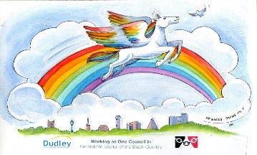

To get involved, post your rainbow pictures on social media with the hashtag #rainbowsinwindows.

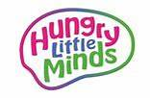
https://hungrylittleminds.campaign.gov.uk/

Simple, fun activities from newborn to age five.

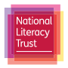
https://literacytrust.org.uk/family-zone/
Split up by age group below, you will find ideas and guidance for simple activities that will engage your children at home, while also benefiting their reading, writing and language development.
You'll be able to access free reading and writing resources, audiobooks, videos, competitions and reading challenges. Every resource is available for free, although to access some you may need to create a free account.

https://www.edinburghzoo.org.uk/webcams/

24-hour live views of the animals made available through webcams! Watch penguins, tigers, koalas and pandas eat, play and sleep. Just scroll through the cameras to find out what they are up to!

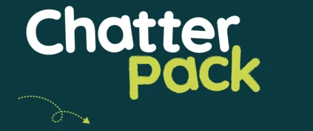
https://chatterpack.net/blogs/blog/list-of-online-resources-for-anyone-who-is-isolated-at-home

A list of free, online, boredom-busting resources including arts and culture, learn a new skill, entertainment, music, virtual tours and more!

Stay home, keep safe but enjoy this family time together. I shall be in touch again on Monday 20th April when our daily School at Home learning tasks will start again.
Mrs Macdonald

