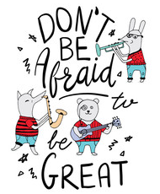
Hello class 3!
How are you?
I hope you are all well. Are you having a nice week? I have been trying hard to make sure that I get exercise each day. Have you?
Today, it would normally be singing assembly, so we are going to start off with a song. I love singing and it always makes me feel happy
Today’s song is here…I know that you will enjoy it.
https://www.youtube.com/watch?v=sxl6UX6piNE

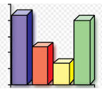
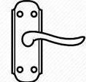
Our first lesson today is maths.
Today we are going to revisit statistics.
First, I want you to count all the handles in each room of the house.
This is my house –
Lounge – 7
Kitchen – 17
Bedroom – 11
Then plot a bar chart to show which room has the most handles.

19
18
17
16
15
14
13
12
11
10
9
8
7
6
5
4
3
2
1
 | Lounge | Kitchen | Bedroom

Which room has the most handles?
Which room has the least handles?

Tell me something else about what you have found out.

Handwriting
In your exercise book, practise these joins. Remember…3 by the tree

nonsense | nobody | none
name | nail | nation
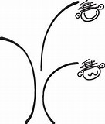
Think carefully about the size of each of your letters.

Next up is English.
I was so impressed with all your hard work with homophones yesterday. I would love to see you complete some more. Remember, even though homophones sound the same they have a different meaning, and most are spelt differently.
Carefully write a sentence using each of these homophones.

- piece peace

- new knew

- too to two

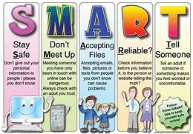
Our final lesson is ICT. I know you all love going on the computer! Remember, when ever we use technology, we need to be safe, be smart and think…
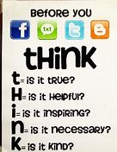
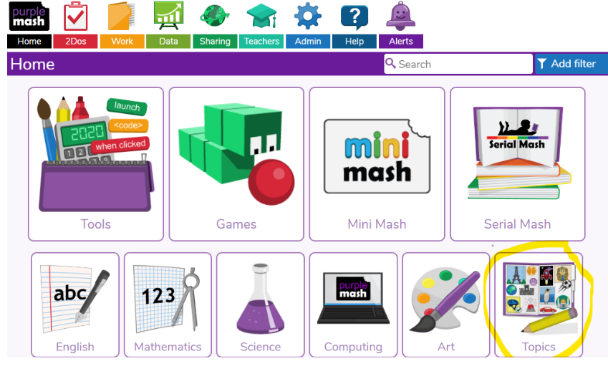
Go onto to purple mash and click on the topic button.

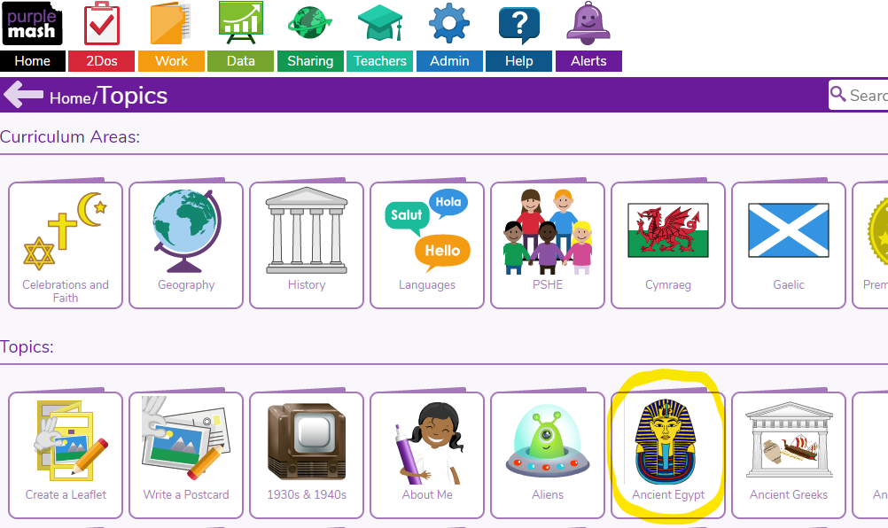
Then click on Ancient Egypt.

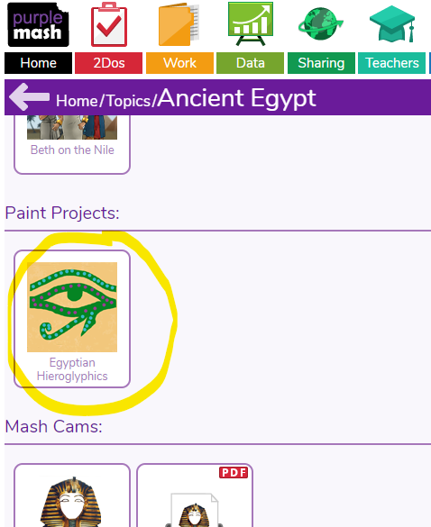
Scroll down and find paint projects and click on Egyptians hieroglyphics.

Then create your own hieroglyphics.

I cannot wait to see some of your hieroglyphics. Can you write your name? Can anybody write my name? 5 Dojos for anyone who can!

Don’t forget….any problems, you can email me.
Have a really lovely day. Remember to go outside for some fresh air and do a little bit of exercise!
Enjoy! From Mrs Martin
