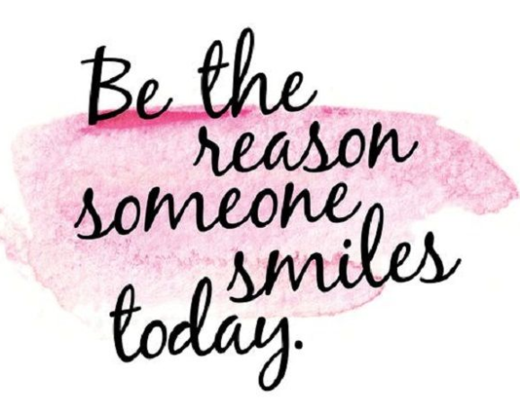
Wednesday 3rd June.
E-mail: reception@blowers.dudley.sch.uk
Good morning reception, I hope you had a good night’s sleep and are ready to do some fun learning.

I felt a bit sad yesterday because I miss you all, so to cheer myself up I put on some music. Can you remember this song? We used to play it to get our body ready for writing. See if you can dance along to the music. Move your shoulders, arms, wrists, hands and fingers, so we are ready to write. https://safeYouTube.net/w/BJgI

Writing
Yesterday we read the story ‘Mr Gumpy’s Motor Car’. Can you retell the story to an adult? What was the problem in the story? How was the problem solved? Did the animals what to help Mr Gumpy?
“Not me,” said the goat. “I am too old.”
“Not me,” said the rabbit. “I am not very well.”
Not me. I am too old.

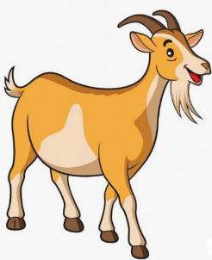

Not me. I am not very well.
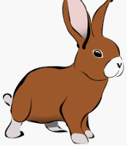

Can you pick three animals and write an excuse for them, so they don’t have to help Mr Gumpy.

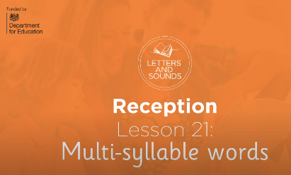
Phonics
Here is another Letters and Sounds lesson where we learn to read words with more than one syllable.
https://safeYouTube.net/w/YBhI

Number Challenge
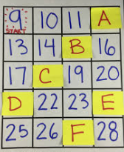
Can you work out which what numbers are missing?
A =
B =
C =
D =
E =
F =
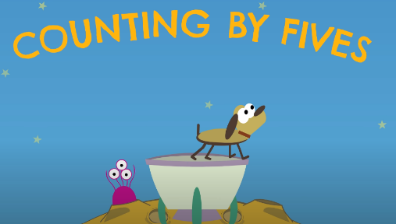
Play this song and try and count along in fives. https://safeYouTube.net/w/6nsI

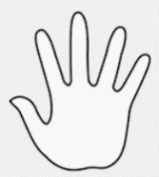
Can you count how many fingers?
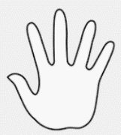
1)

2)

3)

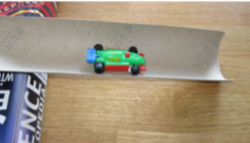
Investigation
Place half-tube on the floor and place the toy car in it – does it move? How can we get the car to move without pushing the car?
Place a book under one end of the roll – a piece of plasticine or blu-tack may be needed to keep it in place. Put the toy car at the top of the tube. Predict how far it will roll along the ground. Then let it go (just release it, do not push it). Measure how far it goes using cubes. How could we make it roll further? How can we make it roll faster?
Have a race with some one in your house, make your own ramp and see who can make their car roll the furthest.
