Blowers Green Primary: School at Home - Reception
Tuesday 2nd June.
E-mail: reception@blowers.dudley.sch.uk
What a busy day we had yesterday. I had lots of videos and pictures sent to me. You are all working so hard. Miss Wood and I love to see all the work you doing.
Don’t forget to practice the names of the month. You still have time to win 20 Dojo points. https://www.youtube.com/watch?v=5enDRrWyXaw

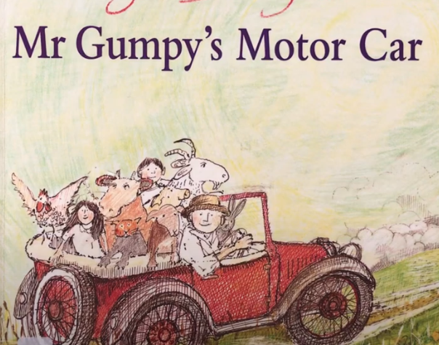
Our story today is ‘Mr Gumpy’s Motor Car’. Listen to the story and see if you can answer these questions. How many animals got into Mr Gumpy’s car? Why did Mr Gumpy tell the animals to get out? https://www.youtube.com/watch?v=WjVJ9ytVT90
Can write a list of everyone in the car?

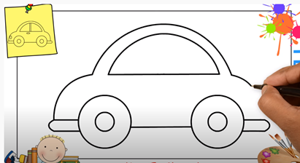
Draw a car
Here is a link to help you to draw a car. Follow the step by step instructions. Take a photograph of it and send it to me. https://www.youtube.com/watch?v=b9S7Oys9BZM

You could try and make your own car out of kitchen roll and milk bottle tops.

Phonics
Here is another Letters and Sounds lesson, reviewing those tricky phonemes, air, ure and er.
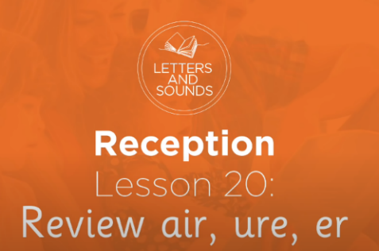
https://www.youtube.com/watch?v=9trjxKwC0xY

If you are not able to watch all this link can you look at these pictures and see if you can write the word.
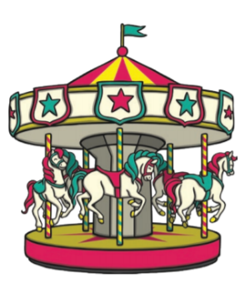
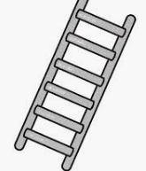
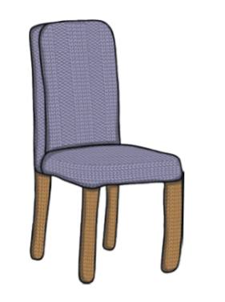

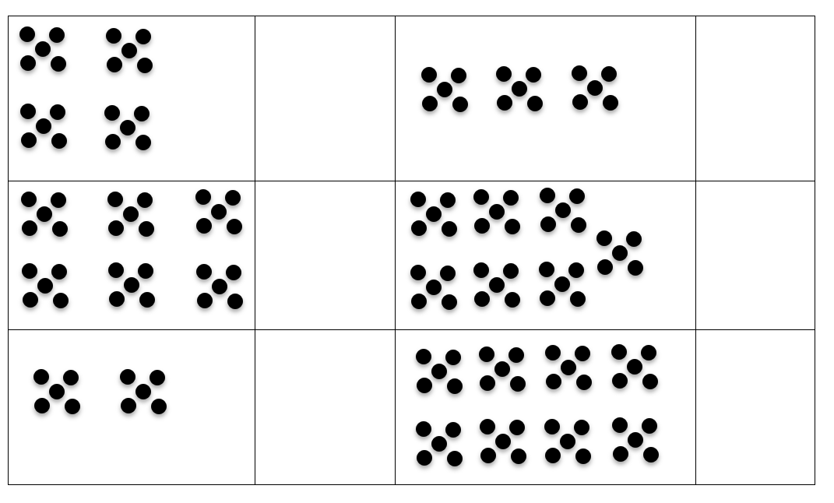
Number Can you count in 5s to work out how many there are in each box?
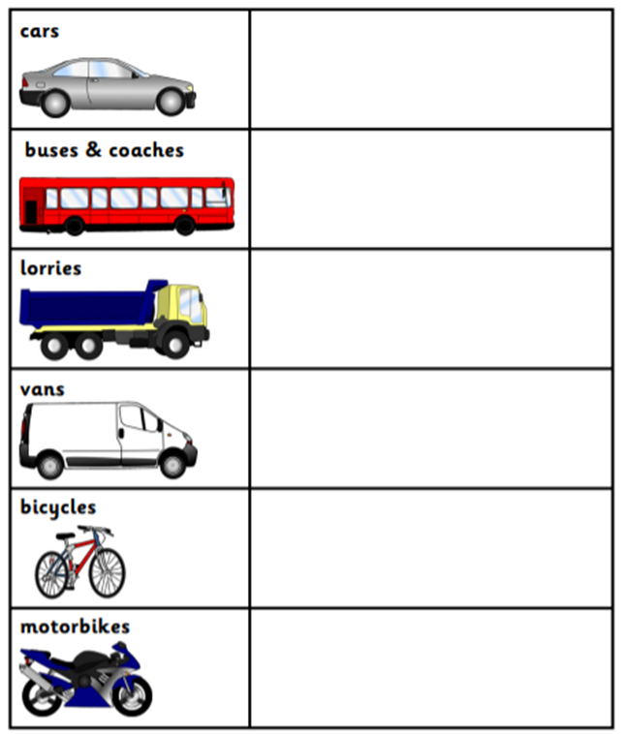
Challenge.
We are going to conduct a traffic survey. You will need to look out of your window for 5 minutes? Count how many different types of vehicles drive past your house. Each time you see one put a mark; this is called a tally. When you get to 5 you must put a line across. When the 5 minutes is up count how many of each vehicle you saw.
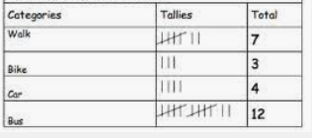
Example of how to complete a tally chart.

