Tuesday 2nd June
Yesterday’s answers:
23 x 10 = 230  45 x 10 = 450  310 ÷ 10 = 31  20 x 4 = 80  472 + 120 = 592  194 + 203 = 397  24 + 300 = 324  605 + 30 = 635  893 – 121 = 771  573 + 123 = 696 | 5.32 x 100 = 532  8.2 ÷ 10 = 0.82  34 x 52 = 1768  132 x 6 = 792  8901 + 12304 = 21,205  1298 + 262 = 1560  6456 ÷ 4 = 1614  7161 ÷ 7 = 1023  9801 – 1672 = 8129  6831 – 2999 = 3832 | 50.02 x 1000 = 50,020  0.3 ÷ 100 = 0.003  472 x 68 = 32,096  8921 x 43 = 383,603  24,999 + 1832 = 26831  1993 + 4901= 6894  9233 ÷ 8 = 1154.125  9301 ÷ 4 = 2325.25  40321 – 37,099  15321 + 2313 = 30456 - 12822

Today’s work:
English
Today we are learning to use synonyms and antonyms. Synonyms are words that have the same meaning whereas antonyms have the opposite meaning to the original word. For example, freezing is a synonym for cold whereas hot is the antonym for cold.
All/Most
List the synonyms and antonyms for the given words.

Some

Maths
13 x 10 =  22 x 20 =  31 x 40 =  44 x 20 =  11 x 30 =  24 x 30=  31 x 20 =  41 x 20 =  22 x 30 =  23 x 30 = | 593 x 4=  467 x 6 =  8 x 567 =  34 x 78 =  56 x 72 =  62 x 48 =  89 x 23 =  89 x 67 =  89 x 89 = | 567 x 34 =  792 x 45 =  381 x 34 =  618 x 46 =  782 x 67 =  892 x 56 =  893 x 97 =  783 x 89 =  893 x 76 =

Science
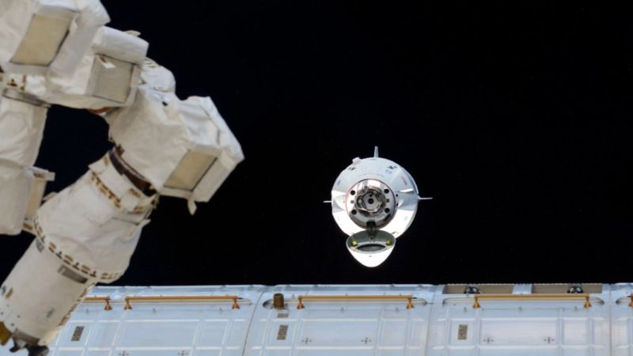
Space X (a private American company) have just sent people to the International Space Station. Thi made news because it is the first time American’s have sent astronauts to space without using a Russian Soyuz rocket. This new rocket is also less wasteful and the rocket lands itself on the ground so it can be reused. Follow this link for more information: https://www.bbc.co.uk/newsround/52526849
I would like you to create a news article in your book about the rocket launch. All information you need can be found on that website.

