**Thursday 25th June 2020 Blowers Green at Home – Nursery**

E-mail: [nursery@blowers.dudley.sch.uk](mailto:nursery@blowers.dudley.sch.uk)

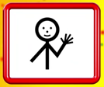Hello Nursery!

Thank you to everyone who has shared their learning with us. I have had some super e-mails which Mrs Dhoot and I have thoroughly enjoyed reading. Here are some of the activities that your friends have been up to. Aren’t they amazing?

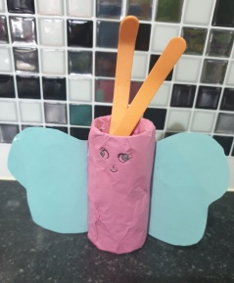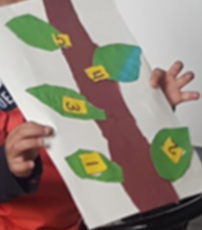

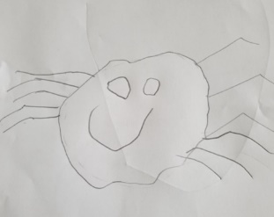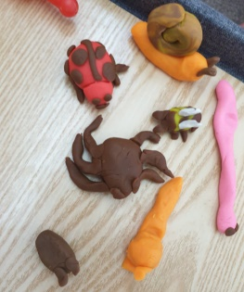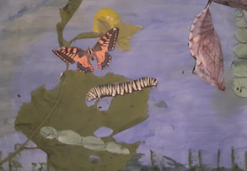

This makes us so proud! Mrs Dhoot and I love to send certificates and stickers so please share your super home learning with us!

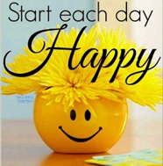**Keep on Moving!**

Keep practising your yoga moves. You will find the yoga cards on Wednesday’s home learning page. I’ve been practising at home and I’m feeling stronger and happier already!

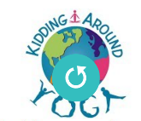This morning to help us begin a happy day, join in with our yoga song, Every Little Cell in my Body is happy.

[**https://safeyoutube.net/w/5HtM**](https://safeyoutube.net/w/5HtM)

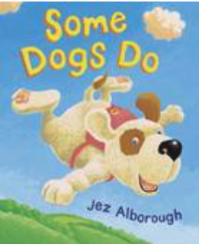**Story Time**

This is another of my favourite rhyming stories. It’s all about Sid, a dog who learns to do something very special. I hope you enjoy Some Dogs Do by Jez Alborough.

[**https://www.booktrust.org.uk/books-and-reading/have-some-fun/storybooks-and-games/some-dogs-do/**](https://www.booktrust.org.uk/books-and-reading/have-some-fun/storybooks-and-games/some-dogs-do/)

What feeling filled Sid up so much that he could fly?

Why couldn’t Sid fly when he got to school?

How did Sid’s Dad help him?

**Happy Feelings**

Draw a smiley face and talk to an adult about all the things that make you happy. You could even draw some pictures to show your family.

Playing on the beach with my family, dancing with my friends and Nando’s chicken make me very happy.

**Funky Fingers and Maths – Pasta Feed**

You will need an empty plastic bottle and some pasta. Hold the bottle steady with one hand and a teaspoon in the other. Put on your favourite happy tune. Now, spoon the pasta into the bottle for one minute. Have a competition with an adult or sibling. Who has more pasta in their bottle? Who has fewer pieces of pasta? Or, do you have the same amount of pasta?

**Challenge**

Is your bottle full? Is it half full? Is it almost full or almost empty?

**Listening Activity**

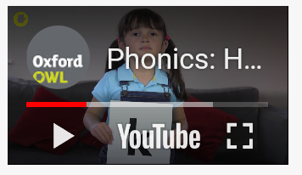**Note to parents**

In nursery, children learn to say phonic sounds (the sounds in words) correctly. This is important because children will go on to use phonic sounds to learn to read and write. In this video a little girl demostrates how to pronounce each phonic sound correctly.

[**https://safeyoutube.net/w/rbuM**](https://safeyoutube.net/w/rbuM)

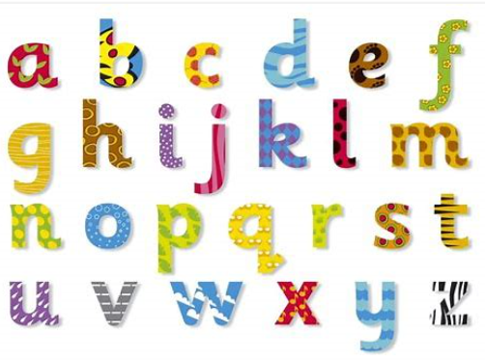

**Sound Scrap Book**

We have been listening to the aaa sound in words.

a

Look through magazines, junk mail, photographs and packaging

for objects which start with the aaa sound. Cut them out and

stick them into the second page of your book. If you can’t find any

photographs you could draw a picture. Keep your book safe, ready

for the next sound.

**Senses Challenge**

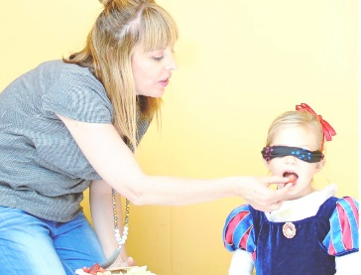**Blindfold Tasting Game**

Play this guessing game with your family. Ask an adult to collect some food or drink items that you have at home. Try to include food items with different tastes and textures such as, jam, ice cream, jelly, lemon, hard and soft fruit, spinach or other vegetables, crackers, crisps, marmite or cheese. Now cover your eyes and taste each item separately. Can you guess what it is?

**Keep practising your Makaton signs!**

Click on the link below and then scroll across to the correct sign, where Mr Tumble will show you what to do.

<https://www.bbc.co.uk/cbeebies/watch/playlist-something-special-really-useful-makaton-signs#playlist>

**hello please thank you goodbye**

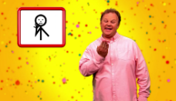

**Have a great day!**

**Miss Meads**