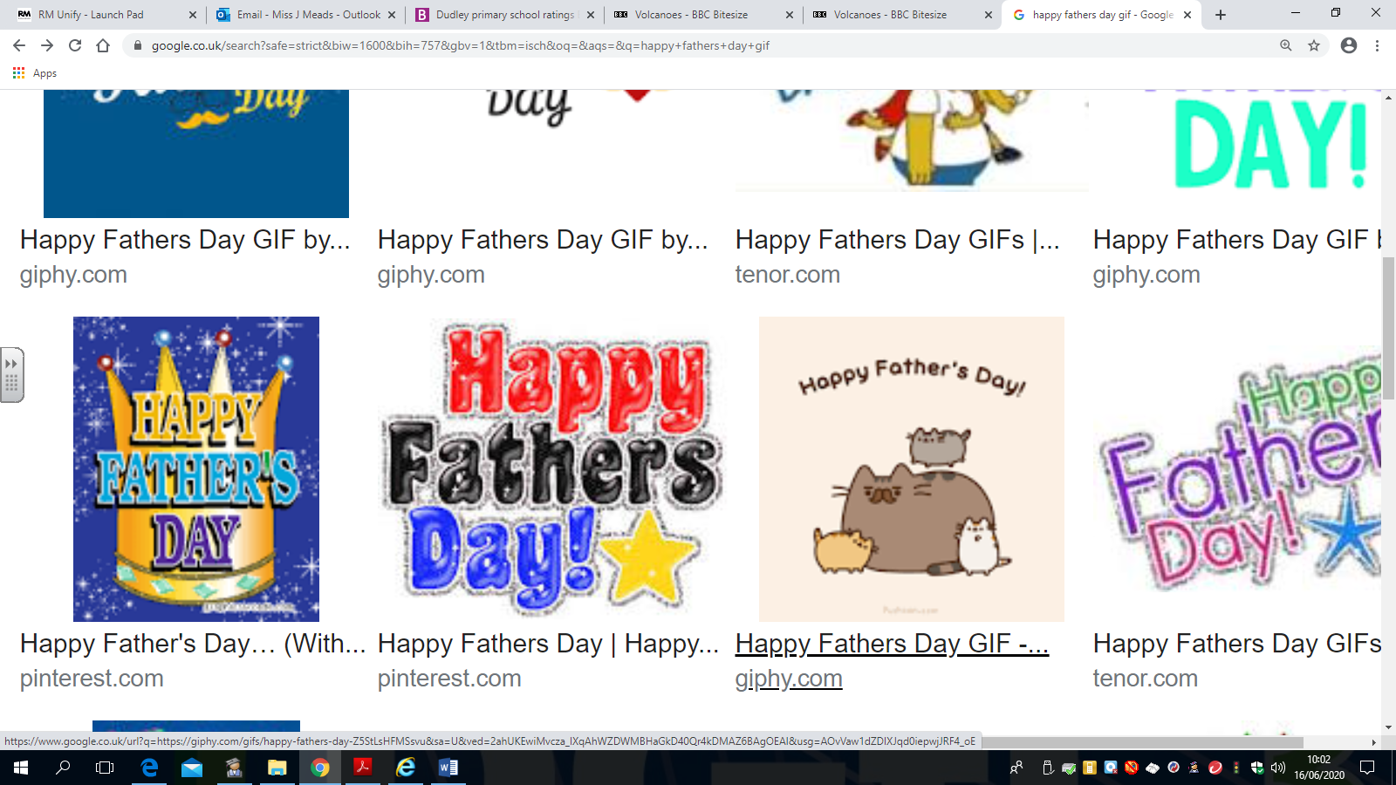**Friday 19th June 2020 Blowers Green at Home – Nursery**

E-mail: [nursery@blowers.dudley.sch.uk](mailto:nursery@blowers.dudley.sch.uk)

Happy Friday everybody!

We have had a busy week! Thank you to everyone who has e-mailed me their drawing. Look out for our poster on Tuesday’s home learning page. Have a super weekend!

Miss Meads



**Keep on Moving!**

Happy Friday everyone. Have fun dancing to Move and Freeze! Remember to stop when Jack says freeze!

[**https://safeyoutube.net/w/2s1L**](https://safeyoutube.net/w/2s1L)

**Phonics**

**Sound Scrap Book**



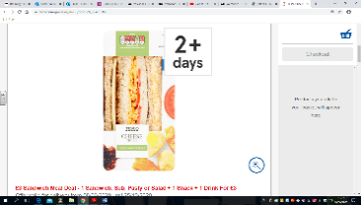You will need at least two sheets of A4 paper or card. Fold your sheets of paper in half to make a book and decorate your front cover.

This week, we have been listening to the sss sound in words.

Look through magazines, junk mail, photographs and packaging

for objects which start with the sss sound. Cut them out and

stick them into the first page of your book.

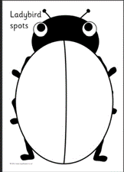Keep your book safe, ready for the next sound.

**Number Time**

Choose one of the following activities.

**Challenge 1**

Ask an adult to help you draw a ladybird. You will need some objects such as, buttons or pasta to use as spots. Roll a dice and count the spots on the dice. Then, put the correct number of spots on your ladybird.

**Challenge 2**

Ask an adult to help you draw a ladybird. You will need some objects such as, buttons or pasta to use as spots. Count out 4 spots and put them on 1 wing. How many spots does your ladybird have? Now move 1 spot to the other wing. How many spots does your ladybirds have now? Repeat by moving 2, 3 or 4 spots to the other wing.

Choose another number and have another go.

Note to Parents

The focus for learning is, however many times we move the spots the total is still the same.

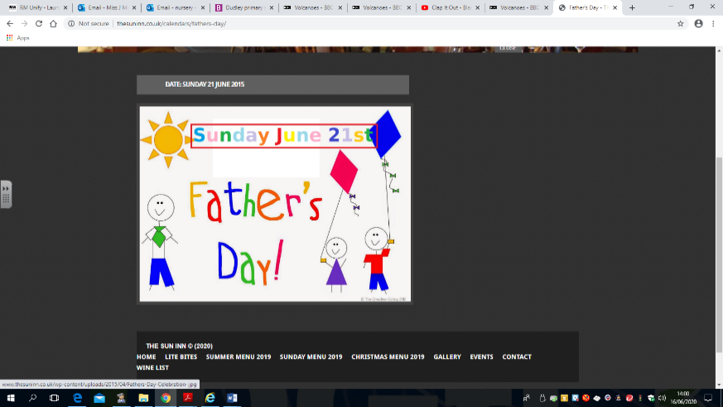

**Father’s Day**

It is Father’s Day on Sunday. This is a special day to say thank you and I love you to all the father figures in our lives.

**Share a Story – Can’t You Sleep Little Bear by Martin Waddell**

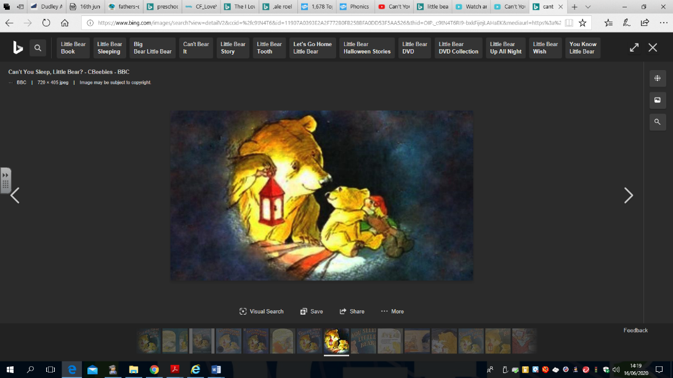

This book is a favourite in my house. It reminds my children, James and Joel, of their grandad; he loved to read it to them when he came to visit.

[**https://safeyoutube.net/w/ul8L**](https://safeyoutube.net/w/ul8L)

**Something Special**

Make something special for a father figure in your life. Here are some ideas.

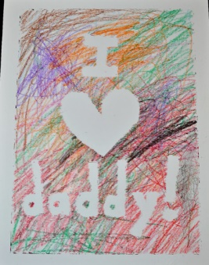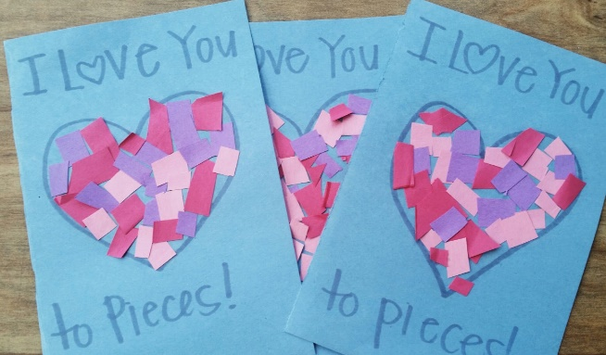

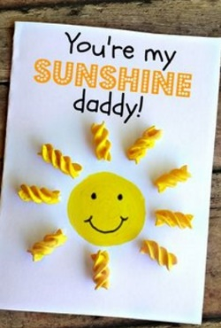

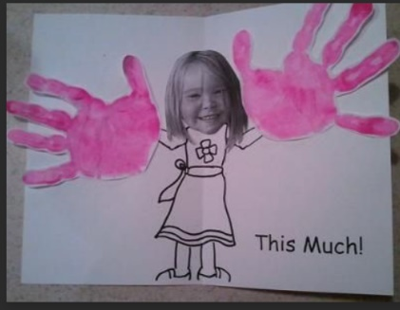

I love you

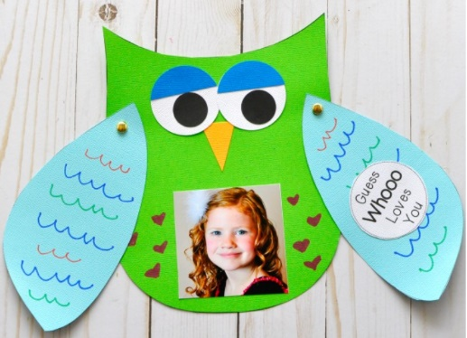

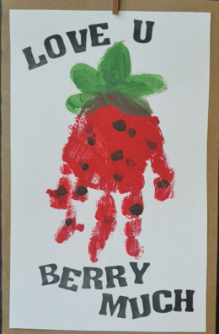

Photo



Have a super weekend!

Miss Meads