Hello Class 5

As it’s a Thursday, let’s start our day with a sing song.
https://safeYouTube.net/w/ca7K

Our first lesson today is maths.
Today we are going to practise using the written method for all 4 operations.
52 ÷ 4 =  49 x 2 =  1638 +854 =  2763 – 1435 =  101 ÷ 8 =  36 x 6 =  2475 + 1369 =  4518 – 3556 =  90 ÷6 =  83 x 5 =  4853 + 2526 =  3950 – 1442 =  51 ÷ 3 =  67 x 4 =  3167 + 748 =  7426 – 3762 = | 385 ÷ 11 =  295 x 6 =  43675 + 15859 =  25846 – 12475 =  590 ÷6 =  429 x 4 =  37649 + 14631 =  19523 – 7398 =  629 ÷8 =  873 x 9 =  58595 + 25274 =  40750 – 35383 =  775 ÷8 =  364 x 7 =  26828 + 13457 =  28259 – 10748 = | 2637 ÷ 7 =  1962 x 9 =  367657 + 145897 =  122940 – 13472 =  3744 ÷4 =  2589 x 3 =  295738 + 245984 =  536017 – 329643 =  2919 ÷11 =  5967x 6 =  549546 + 372855 =  851329 – 257082 =  5267 ÷8 =  4896 x 12 =  298399 + 145786 =  374806 – 209877 =

Handwriting
In your exercise book, practise these joins.

category | cemetery | committee
communicate | community | competition

Next is English.
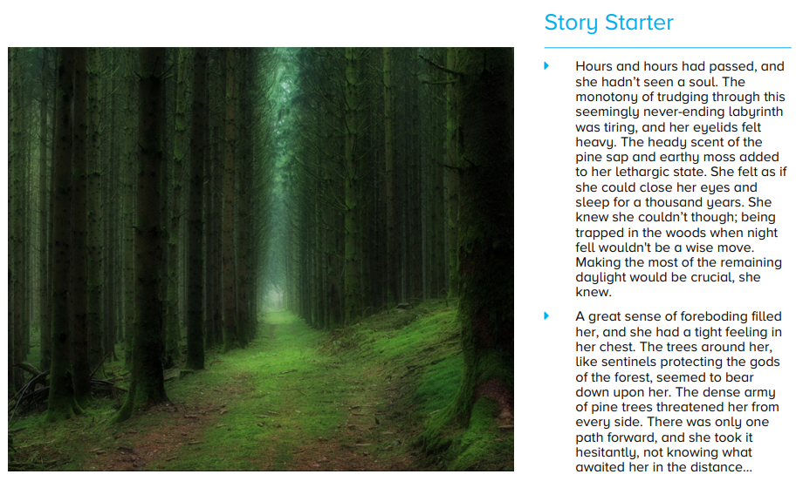
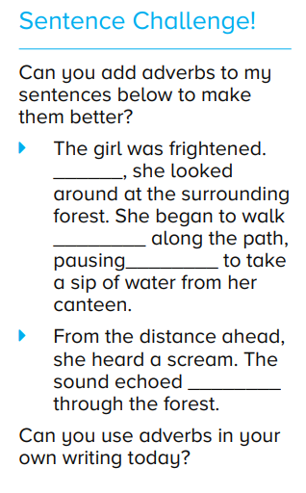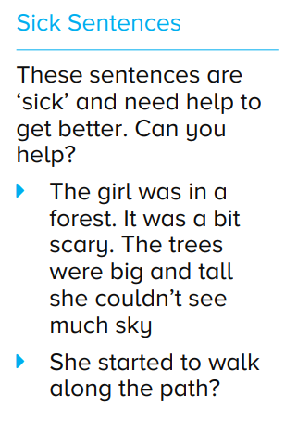

Our next lesson is geography.
As we have had plenty of rain recently, I would like you to complete the activities below on the water cycle.

Water cycle

Activity 1

A puddle forms in a playground on a rainy day. When the rain stops and the Sun comes out, what do you predict will happen to the puddle?
Tick the answer you think is right.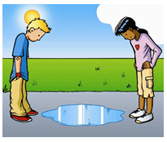

o The puddle will get bigger.
o The puddle will gradually disappear.
o The puddle will stay the same.
o The puddle will gradually get bigger and then get smaller.

Give a reason for your answer.

Activity 2

Below is a picture of the water cycle.
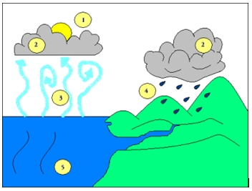

Which number shows evaporation?

Why is the Sun important in the water cycle?

Activity 3

Explain how rain forms, using some or all the following words:

water vapour evaporation condensation

Activity 4

What are the best conditions for washing to dry quickly? Tick the appropriate words. Or write them in your exercise book.
Condition
Wet
Dry
Hot and sunny
Cold and cloudy
Day
Night
Windy

Maths answers
52 ÷ 4 = 13  49 x 2 = 98  1638 +854 =2492  2763 – 1435 = 1328  101 ÷ 8 = 12r6  36 x 6 = 216  2475 + 1369 = 3844  4518 – 3556 = 962  90 ÷6 = 15  83 x 5 =415  4853 + 2526 =7379  3950 – 1442 = 2508  51 ÷ 3 = 17  67 x 4 =268  3167 + 748 =3915  7426 – 3762 =3664 | 385 ÷ 11 = 35  295 x 6 = 1770  43675 + 15859 =59534  25846 – 12475 = 13371  590 ÷6 = 98r3  429 x 4 = 1716  37649 + 14631 = 52280  19523 – 7398 =12125  629 ÷8 =78r6  873 x 9 = 7857  58595 + 25274 =83869  40750 – 35383 = 5367  775 ÷8 = 96r8  364 x 7 = 2548  26828 + 13457 =40285  28259 – 10748 =17511 | 2637 ÷ 7 = 376r 7  1962 x 9 = 17658  367657 + 145897 =513554  122940 – 13472 = 109468  3744 ÷4 = 936  2589 x 3 = 7767  295738 + 245984 = 541722  536017 – 329643 = 206374  2919 ÷11 = 265r3  5967x 6 = 35802  549546 + 372855 =922401  851329 – 257082 = 594247  5267 ÷8 = 658r4  4896 x 12 = 58752  298399 + 145786 =444185  374806 – 209877 =164929

