
Good Morning Year 5
Let’s start our day with yoga. Start your day by completing some Cosmic Kids yoga. Find a yoga video that you would like to do today.

Next up is maths.
You will need to apply the strategies below so that you can add and subtract mentally. Look at the 4 strategies to help you add and subtract mentally. Choose the most appropriate one for each question and USE these to help you answer the questions below. Try not to use a written method. It may help you to make jottings or to write the strategy that you used to help you solve the problem.
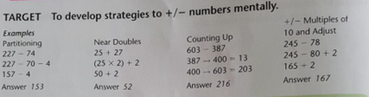
Choose your chilli challenge below.
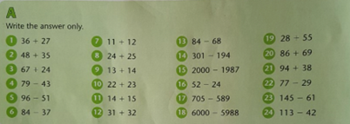
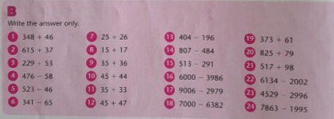
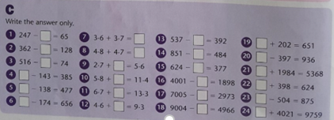

Our next lesson is English. 
Today we are going to be revisiting, fronted adverbials. To refresh your memory on what is a fronted adverbial watch this short video. https://safeYouTube.net/w/Z1HL
Then answer the questions below. Each question gets harder each time so make sure you read the question carefully.
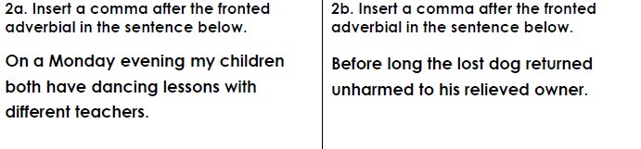
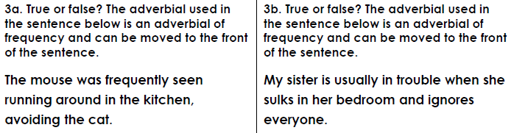
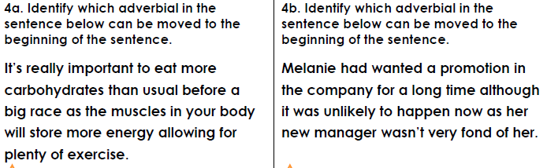
The final lesson is French.
Today I want you to practise saying words in French. Today we are going to be looking at vocabulary associated with school. Click on the video below and repeat each word that Alexa says in French.
https://safeYouTube.net/w/ljAL
Challenge – can you create your own flash cards to help you remember the words?
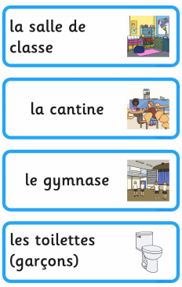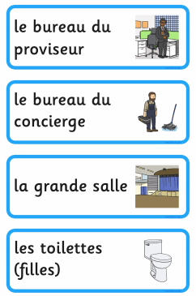

Remember to have time to yourself and to do something you enjoy. Also complete your daily reading.

Maths answers
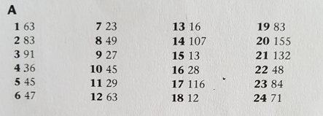
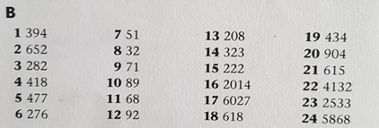
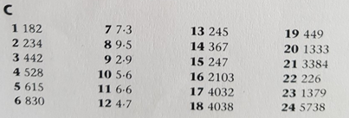

English answers

