Dear Parents and Carers,
Year 5
It has been a real pleasure to hear from so many children in Class 5 during this unusual situation. We would both like to say a huge ‘thank you’ to your child for working so hard on the daily School at Home tasks that we have been setting, and to you for supporting them in their learning throughout this very difficult situation we all find ourselves in. We are both very proud of the work that so many children have produced and emailed in.
As the Easter break approaches, the last daily School at Home tasks for this term will be set on Friday 3rd April. There will then be a two-week break, during which time teachers, ourselves included, will not be accessing e-mails or online learning links. The Summer Term School at Home tasks will then be set daily again from Monday 20th April when we will be back in touch with you. Please encourage your children to continue to keep in touch using their school email when the Summer Term commences (emails to be sent to yearfive@blowers.dudley.sch.uk).

Although there will be no School at Home tasks set during the two-week Easter break, there are still lots of fun activities available that you can access through various websites until School at Home commences again. Here are just a few:


With schools now closed to a majority of pupils, Dudley have pulled together a list of over 80 fun and educational resources, which can be used to keep children and young people busy over the coming weeks.

On https://www.dudley.gov.uk/media/14410/educational-and-fun-resources.pdf, you will find some useful online resources to help support the emotional wellbeing of children during this difficult time along with educational resources and ideas to keep children fit and active! From virtual museum tours to exercise classes and learning new skills such as British Sign Language…and all for FREE!

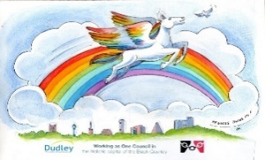
Dudley are also inviting you to share your rainbows in windows as a symbol of hope and unity during the corona virus outbreak.

To get involved, post your rainbow pictures on social media with the hashtag #rainbowsinwindows.

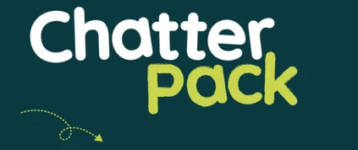
https://chatterpack.net/blogs/blog/list-of-online-resources-for-anyone-who-is-isolated-at-home
A list of free, online, boredom-busting resources including arts and culture, learn a new skill, entertainment, music, virtual tours and more!

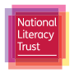
https://literacytrust.org.uk/family-zone/
Split up by age group below, you will find ideas and guidance for simple activities that will engage your children at home, while also benefiting their reading, writing and language development.
You'll be able to access free reading and writing resources, audiobooks, videos, competitions and reading challenges. Every resource is available for free, although to access some you may need to create a free account.

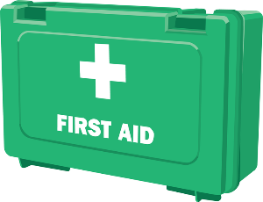
https://www.youtube.com/watch?v=Q3y_WE75UJs&app=desktop

On Friday 3rd April, starting at 10:30am, Green Box First Aid training are launching a Free, Live, First Aid Course for Kids. They hope to inspire children to learn some amazing life-saving skills and have a lot of fun along the way!


https://www.edinburghzoo.org.uk/webcams/

24-hour live views of the animals made available through webcams! Watch penguins, tigers, koalas and pandas eat, play and sleep. Just scroll through the cameras to find out what they are up to!

https://www.nhm.ac.uk/take-part.html
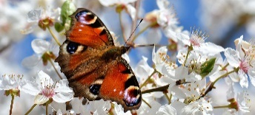
With nature being sighted in our now more deserted streets, it is a great chance for you to take part in the Natural History Museum’s City Nature Challenge. Here you can record sightings of wildlife in your garden or surrounding area and your results are used by real scientists to track biodiversity. The website also include lots of activity ideas as well as virtual tours of the museum.

Enjoy this time together as a family, but above all else, stay safe. We wish you all the very best over the Easter break and we will be in touch with you on Monday 20th April when our daily School at Home learning tasks will start again.
Mr Brown and Mrs Francis

