Dear Parents and Carers,
Year 4
I hope you are all keeping safe and well. The past two weeks have been very strange and certainly very different for all of us, but I would like to say thank you for all your support and encouragement and also a very big well done to your child for working so hard on the daily School at Home tasks that I have set. Receiving the e-mails with feedback, questions and completed work has really brightened up my days of working from home and it has been enlightening to see your child continuing to take such ownership and pride over their work.
As the Easter break approaches, the last daily School at Home tasks for this term will be set on Friday 3rd April. There will then be a two-week break, during which time teachers, myself included, will not be accessing e-mails or online learning links. The Summer Term School at Home tasks will then be set daily again from Monday 20th April when I will be back in touch with you.

Although there will be no School at Home tasks set during the two-week Easter break, there are still lots of fun activities available that you can access through various websites until School at Home commences again. Here are just a few:

With schools now closed to a majority of pupils, Dudley have pulled together a list of over 80 fun and educational resources, which can be used to keep children and young people busy over the coming weeks.

On https://www.dudley.gov.uk/media/14410/educational-and-fun-resources.pdf, you will find some useful online resources to help support the emotional wellbeing of children during this difficult time along with educational resources and ideas to keep children fit and active! From virtual museum tours to exercise classes and learning new skills such as British Sign Language…and all for FREE!

Dudley are also inviting you to share your rainbows in windows as a symbol of hope and unity during the corona virus outbreak.
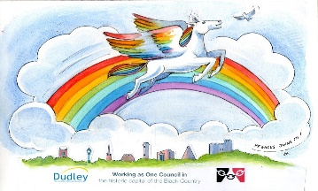

To get involved, post your rainbow pictures on social media with the hashtag #rainbowsinwindows.


https://ttrockstars.com/
Keep your score up on Times Table Rock Stars! Can you answer each question in less than 6 seconds?
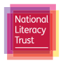
https://literacytrust.org.uk/family-zone/
Split up by age group below, you will find ideas and guidance for simple activities that will engage your children at home, while also benefiting their reading, writing and language development.
You'll be able to access free reading and writing resources, audiobooks, videos, competitions and reading challenges. Every resource is available for free, although to access some you may need to create a free account.


https://www.youtube.com/watch?v=Q3y_WE75UJs&app=desktop

On Friday 3rd April, starting at 10:30am, Green Box First Aid training are launching a Free, Live, First Aid Course for Kids. They hope to inspire children to learn some amazing life-saving skills and have a lot of fun along the way!


https://www.edinburghzoo.org.uk/webcams/

24-hour live views of the animals made available through webcams! Watch penguins, tigers, koalas and pandas eat, play and sleep. Just scroll through the cameras to find out what they are up to!

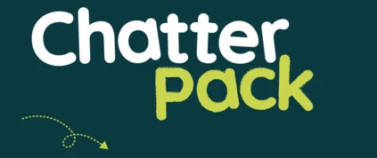
https://chatterpack.net/blogs/blog/list-of-online-resources-for-anyone-who-is-isolated-at-home

A list of free, online, boredom-busting resources including arts and culture, learn a new skill, entertainment, music, virtual tours and more!

Please take care, stay home and safe and enjoy the Easter break together with your loved ones as much as you can. I shall be in touch again on Monday 20th April when our daily School at Home learning tasks will start again.
Mrs Ghent

