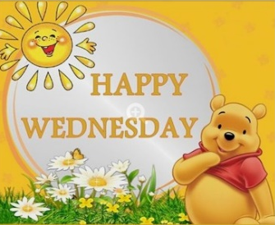
Wednesday 24th June 2020 Blowers Green at Home – Nursery
E-mail: nursery@blowers.dudley.sch.uk

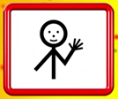
Hello Nursery!
I hope you’ve all had a super sleep and are ready to learn and play. You will find your ‘Nursery at Home’ activities below. As always, if you have any questions or would like to share your learning, please e-mail me on the address above.
Have a wonderful Wednesday
Miss Meads

Keep on Moving!
Yoga helps our bodies to become strong and flexible. It also helps us to feel calm and happy. Practise these four yoga moves. Try saying the message on each card as you do each move. The moves will become easier each time you practise.
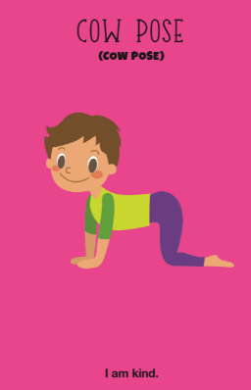
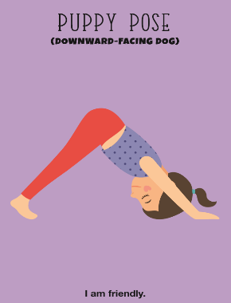
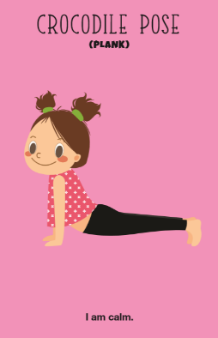
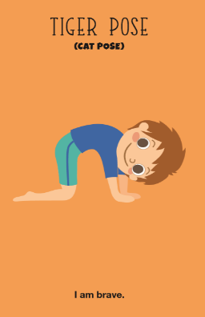

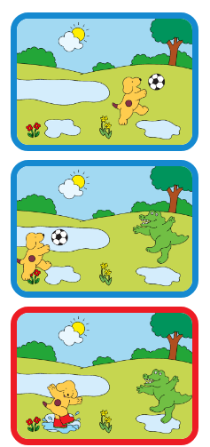
Story Time

Yesterday, we read Where’s Spot by Eric Hill. Today, you can create your own Spot story.
Click on the link below
https://www.funwithspot.com/make-a-spot-story/

Pick a scene, then add your favourite characters to create your own story. Talk about what is happening in the pictures with an adult. Then, share your story with your family.

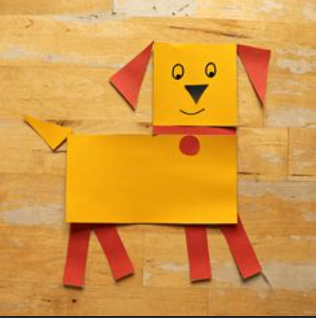
Maths - Make a Shape Puppy

Can you make your very own puppy using 2D shapes?
I made pointed ears with triangles, a long body with a rectangle and a cute square face.
I’d love to see what shapes you use. Why not email me a photograph of your puppy on nursery@blowers.dudley.sch.uk


Listening Activity
Alex the alligator is very hungry. Can you help him make a peculiar pizza using objects with the same starting sound? I’ll start you off. On goes an aaa avocado and an aaa arrow.

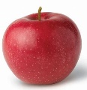
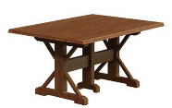

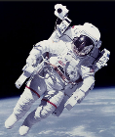
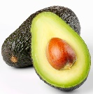
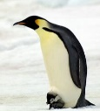


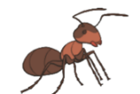
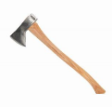

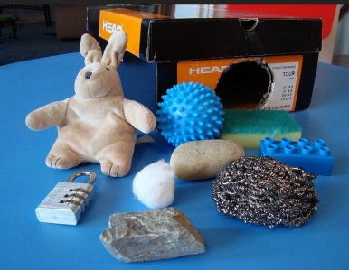
Senses Challenge
Feely Treasure Bag/Box
Play this guessing game with an adult. Feel the objects inside the bag. Can you guess what they are? Remember no peeking!

Note to parents
Choose some objects from around the house that your child is familiar with (e.g. a toy car, a soft toy, a scourer, cotton wool, a stone, a packet of crisps and some keys). Hide the objects in a large bag. Take your turn first. Put your hands in the bag and choose an object. Keep your hands in the bag as you feel the object, being careful not to look. Describe what you can feel. For example, it feels hard and smooth. I can feel one, two, three, four wheels. I think it is a car. Then pull the object out of the bag to reveal what it is. Then ask your child to take a turn. Take turns until all the objects are revealed.

To support your child, ask your child to help you name each object and put it in the bag before you play the game.

Keep practising your signs!
Click on the link below and then scroll across to the correct sign, where Mr Tumble will show you what to do.
https://www.bbc.co.uk/cbeebies/watch/playlist-something-special-really-useful-makaton-signs#playlist
hello please thank you good bye

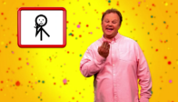

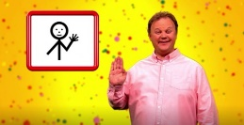
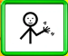
Have a great day!
Miss Meads

