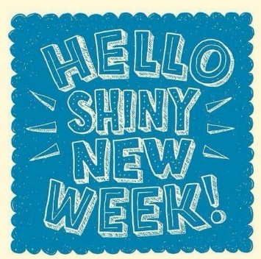
Monday 22nd June 2020 Blowers Green at Home – Nursery
E-mail: nursery@blowers.dudley.sch.uk

Good Morning Nursery!
I hope you all had a lovely Father’s Day weekend. Thank you to everyone who e-mailed me last week. Both Mrs Dhoot and I have huge smiles. We are so proud of you all!
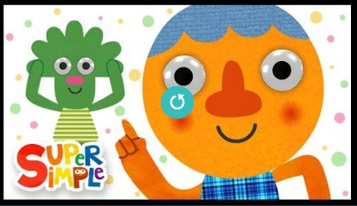
Keep on Moving!
Let’s start the day with an action song. Join in with the action song Head Shoulders Knees and Toes.
https://safeyoutube.net/w/DLKL



Number Dance
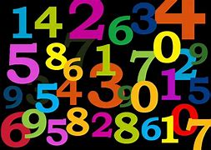
Have fun with numbers today. Use some paper or card to make number cards 1 to 6. Spread them out on the floor. Now, put on your favourite tune. When the music stops you have to stand on a number. Look at the number and jump that number of times. Then repeat but with a different way of moving, you could clap or hop.
Note to Parents
To support your child begin with numbers 1 to 3. To challenge your child, add a few larger numbers. If your child chooses the same number each time, this is fine as they are practising what they know. However, you could try taking that number away to challenge them.

Phonics
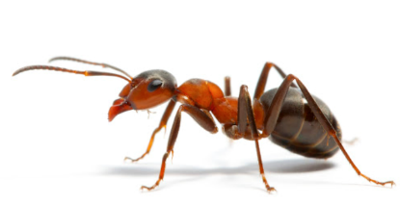
When Mrs Dhoot and I were weeding the nursery garden, we found lots of ants. Ant starts with the aaa sound. Go on a sound hunt today. How many objects can you find that begin with a.

I found, avocado, ackee, animals and apple. I wonder what you will find.

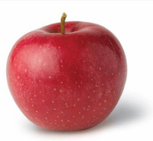
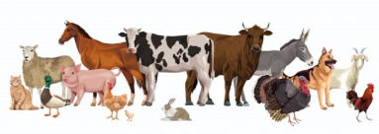



Reception and Nursery Challenge

Each week I am going to set you a ‘Ready for School and Nursery’ challenge. We love to wear our wellies outside and our pumps for PE. So, this week I would like you to learn take off and put on your own shoes.
Helen Keller Day
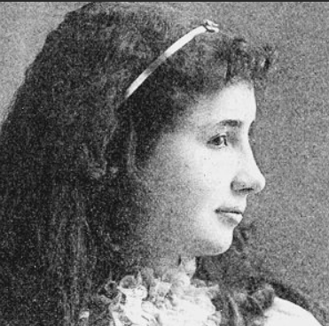
This Friday is a special day to remember the birthday of Helen Keller. Helen Keller was born a long time ago in the USA. As a child she became blind and deaf. This meant she lost two of her senses; her sight and her hearing. Cover your eyes and ears. How does it feel?
Helen Keller grew up to love a challenge. As a child, she made her own sign language so that she talk to her friend. She went to college and even wrote a book! So, to remember Helen Keller, I am going to set you a senses challenge each day.

It’s Time to Sign

The first challenge is to learn four Makaton signs. We have a week to practise and Mr Tumble is going to help us.
We are going to learn to sign hello, please, thank you and goodbye.

Click on the link below and then scroll across to the correct sign where Mr Tumble will show you what to do.
https://www.bbc.co.uk/cbeebies/watch/playlist-something-special-really-useful-makaton-signs#playlist

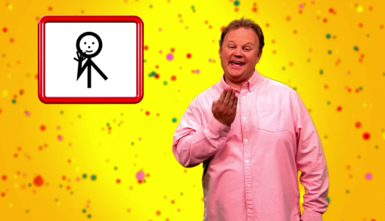


hello please thank you

goodbye

To help you remember, try and make the sign every time you say the word.

Have a fabulous day
Miss Meads

