
Thursday 18th June 2020 Blowers Green at Home – Nursery
E-mail: nursery@blowers.dudley.sch.uk

Good Morning Nursery!
You will find your ‘Nursery at Home’ activities below. Wishing you all a lovely day!

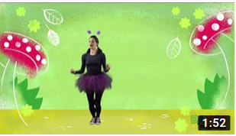
Keep on Moving!
Enjoy learning to dance like your favourite bugs and creepy crawlies!
https://safeyoutube.net/w/7UuL

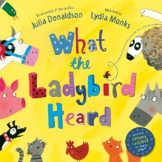
Share a Story – What the Ladybird Heard
Draw your favourite animal from the story. Can you make the animal sound?
https://safeyoutube.net/w/rvWK

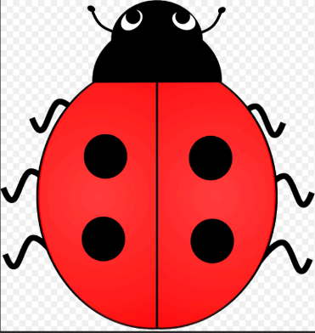
Number Time
Join in with the ladybird rhyme today.
Ladybird, ladybird on the tree,
Fly down here and sit with me,
Rest on my hands I’ll count your spots,
1, 2, 3, 4 polka dots!

Roll a Ladybird
You will need a dice, some paper and pencils for this number game.
First, draw a big circle for a body. Then, draw a small circle for a head.
Now roll the dice. Look at the dice pictures below to see what you can add to your ladybird. You can only add one feature at a time.

 |   You will need 6 legs
 |   You will need 2 antennae
 |   You will need 2 eyes
 |   You will need 2 wings.

Play the game with an adult or sibling. Take turns to roll the dice. Who will finish their ladybird first?

Make a Minibeast
Make your favourite minibeast. There are lots of things around the house that you could use such as, kitchen roll tubes, paper plates, egg boxes, yogurt pots and cereal boxes.

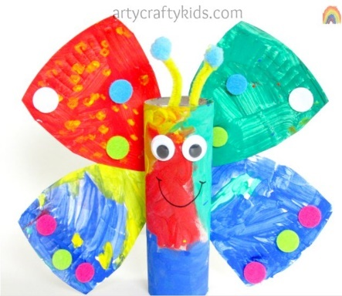
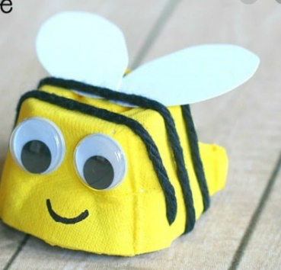
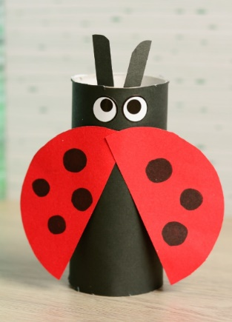

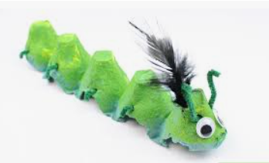
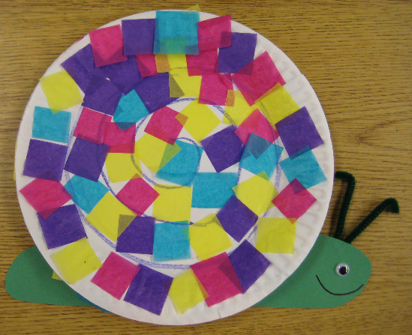
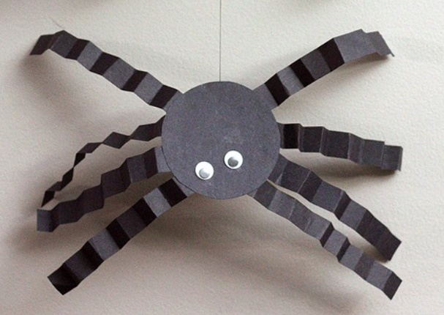

Phonics
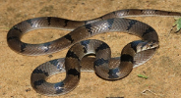
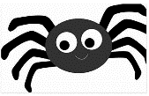

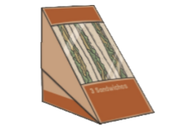
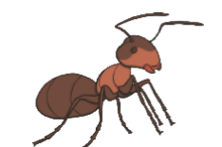

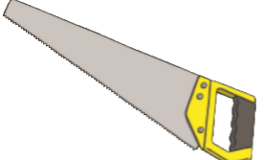

Can you make a silly soup using objects with the same starting sound? I will start you off. In goes a sss spider and a sss snake.

Have a lovely Thursday
Miss Meads

