
Wednesday 17th June 2020 Blowers Green at Home – Nursery
E-mail: nursery@blowers.dudley.sch.uk

Good Morning Nursery!
You will find your ‘Nursery at Home’ activities below. Don’t forget to e-mail me your drawings of yourself for our class poster.

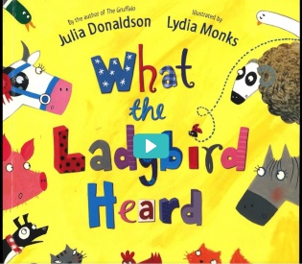
Share a Story
Today’s story is about a quiet but very clever ladybird. Join in with this rhyming story as you find out what the ladybird heard.
https://safeyoutube.net/w/rvWK

Did you know?
Ladybirds go to sleep in winter. They huddle together to keep warm.
Ladybirds are a type of beetle.

In the summer, ladybirds live on bushes, trees and flowers.
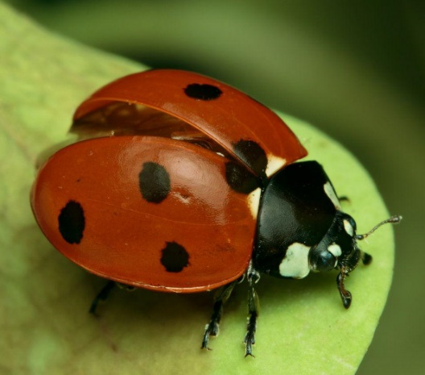

Ladybirds have two antennae.

Ladybirds have six legs.
Ladybirds have two pairs of wings.
Ladybirds lay lots and lots of eggs.

Ladybird Maths
Choose the counting tab, then the counting out tab to have fun counting spots onto the ladybird.

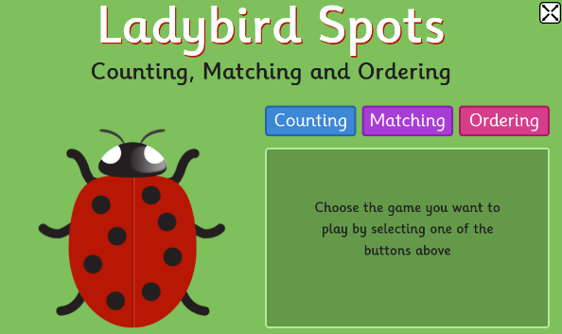
Challenge
Choose the ordering tab. Count the spots and put the ladybirds in order.

https://www.topmarks.co.uk/learning-to-count/ladybird-spots

Let’s Go to the Dough Disco!

If you don’t have any dough, here is a simple way to make play dough using warm water. I would stay away from adding food colouring as it does get messy!
https://www.google.com/search?q=simple+play+dough+recipe&oq=simple+play+&aqs=chrome.1. 69i57j0l7.6429j0j9&sourceid=chrome&ie=UTF-8#kpvalbx=_b67HXuijMfPqxgOC7pPoCA45
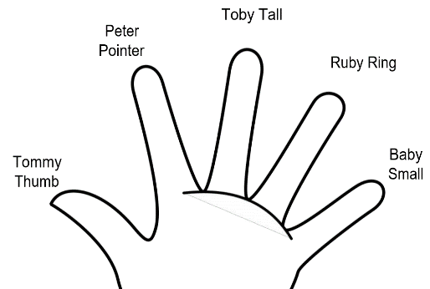
Get your dough and let’s go!
Wave your hands and say hello!

Say hello to your fingers, wiggling as you go.
Now put on one of your favourite tunes.

This was one is another of your favourites.
https://safeyoutube.net/w/8vRJ

Now, do these moves to the music with your dough. Remember, if don’t have any, just use your invisible dough.
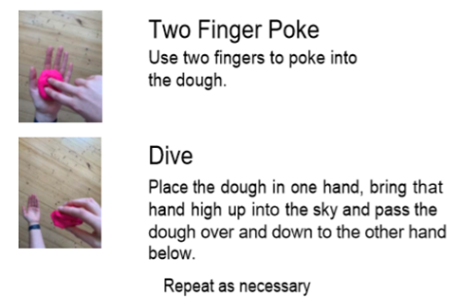
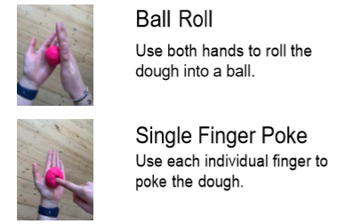

Make a minibeast

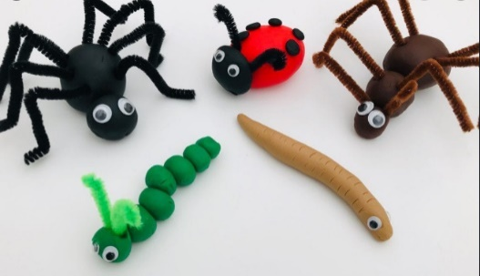
Now, get creative and use your play dough to make your favourite minibeasts.

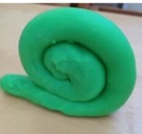
It doesn’t matter what colour you use, and you can use objects from around the house to add details. Sticks make great legs and leaves make fabulous wings.


I Hope you have had a great day!
Miss Meads

