 Good Morning Year 5 

The first lesson is maths.
Today we are going to practise using a formal written method for short division.
To refresh your memory on how to apply the formal written method for short division please see the video below.
https://safeYouTube.net/w/BZ6K
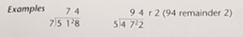
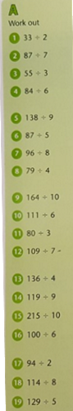 | 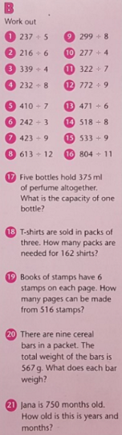 | 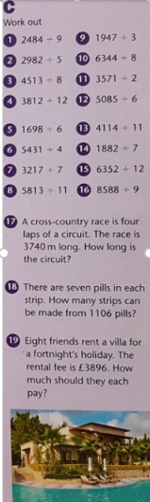

Our next lesson is English.
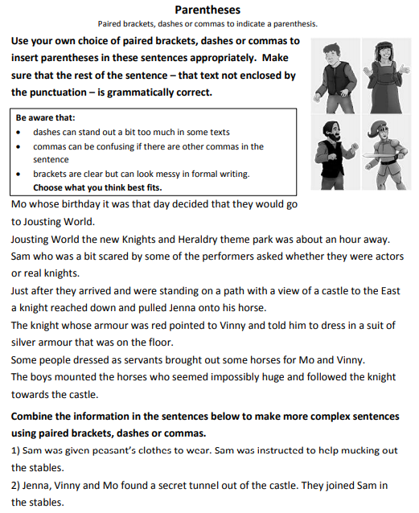

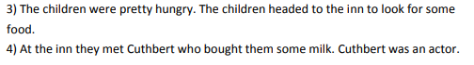

The final lesson is P.E.
Today I would like you to choreograph a routine using the robot dance.
Watch the video below of a fantastic street dancer performing the robot.
https://safeYouTube.net/w/OZ6K
Notice:
- How they move.
- The tempo they move with the tempo of the music.
- Which body parts they decide to move and when.

Now I would like to create your own routine to this soundtrack.
Remember to move with the tempo of the music, if the music is quick you will be moving quicker. If the music holds a long beat, you will be moving slower.
https://safeYouTube.net/w/SZ6K

Remember to have time to yourself and to do something you enjoy. Also complete your daily reading.
Maths answers
- 16r1  - 12r3  - 18r1  - 14  - 15r3  - 17r2  - 12  - 19r3  - 16r4  - 18r3  - 26r2  - 15r4  - 34  - 13r2  - 21r5  - 16r4  - 47  - 14r2  - 25r4  - 19r1 | - 47r2  - 36  - 84r3  - 29  - 58r4  - 80r2  - 47  - 51r1  - 37r3  - 69r1  - 46  - 85r7  - 78r3  - 64r6  - 59r2  - 73r1  - 75ml  - 54  - 86  - 63g  - 62yrs 6 months | - 276  - 596r2  - 564r1  - 317r8  - 283  - 1357r3  - 459r4  - 528r5  - 649  - 793  - 1785r1  - 847r3  - 374  - 268r6  - 529r4  - 954r2  - 935m  - 158  - £487

English answers


