 Good Morning Year 5 
I Hope you had a lovely day yesterday.

First up, we have maths.
Today we are going to be practising multiplying 4 digits by 1 digit.
Steps to success
Multiply the ones by the multiplier.
Write the ones in the ones column below.
Carry over the tens under the bottom line.
Multiply the tens by the multiplier.
Write the tens answer in the tens column.
Multiply the hundreds by the multiplier.
Write the hundreds answer in the hundreds column.
Multiply the thousands by the multiplier.
Write the thousands answer in the thousands column.

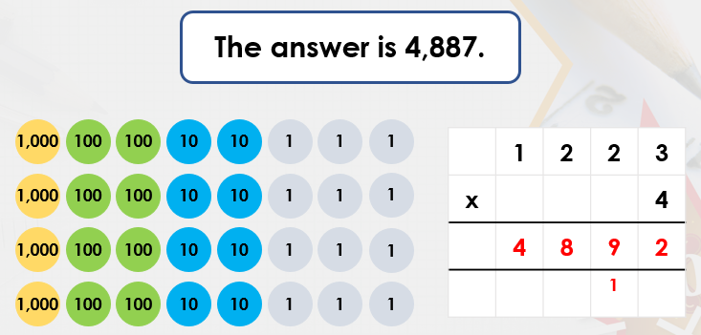
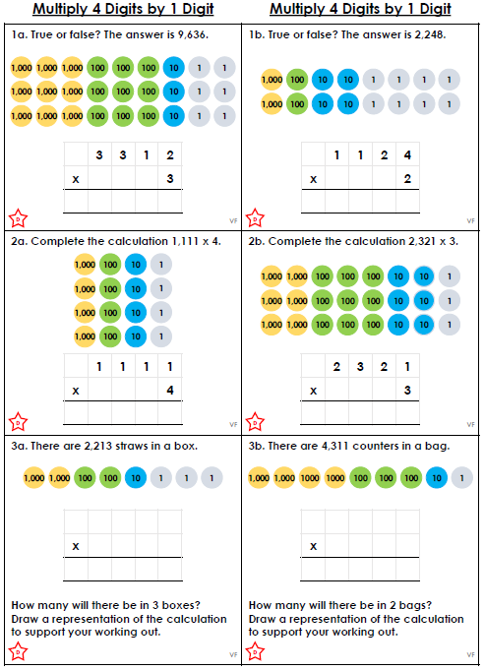
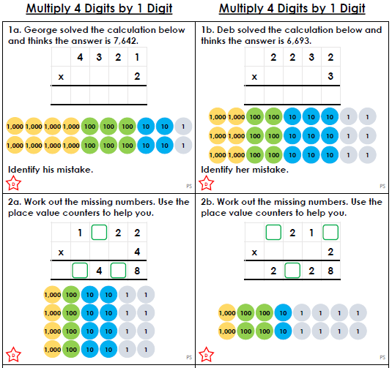

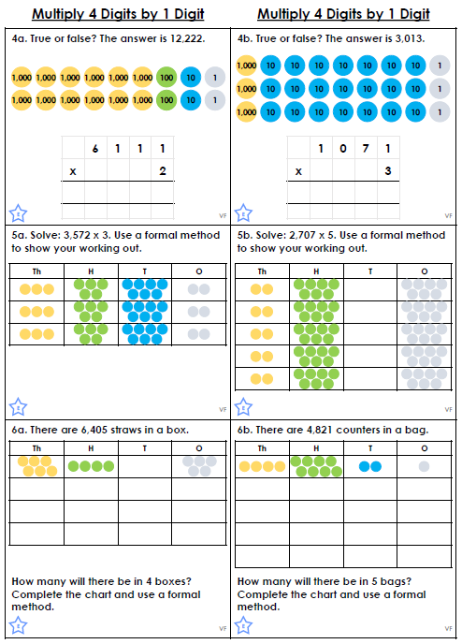
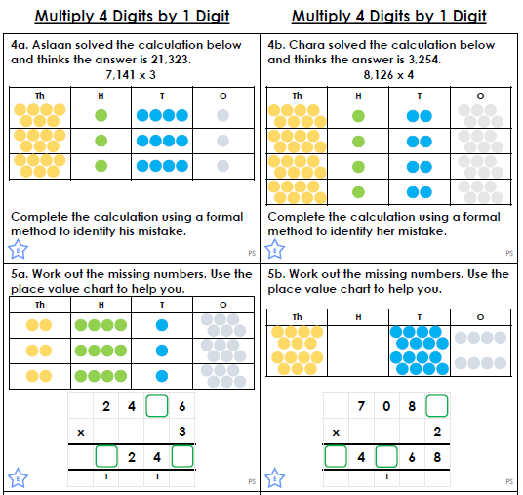
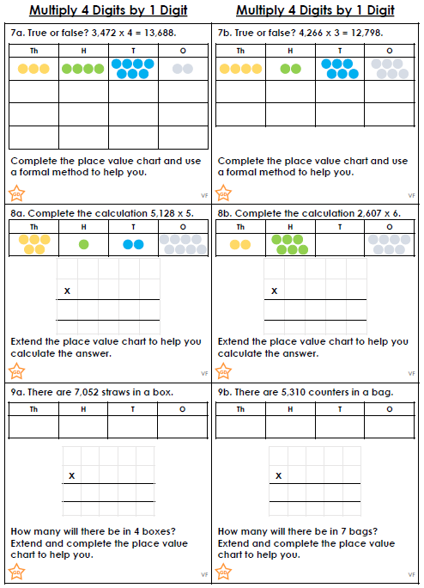
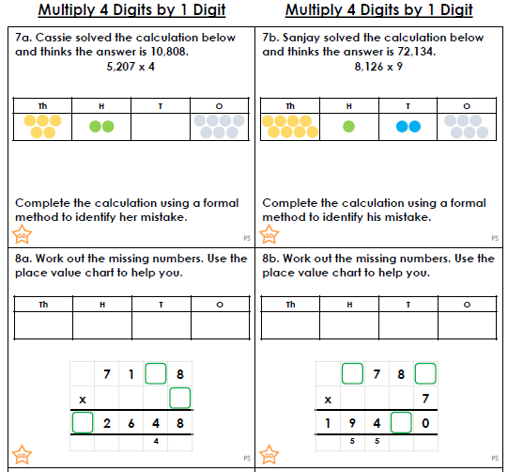

Our next lesson is English.
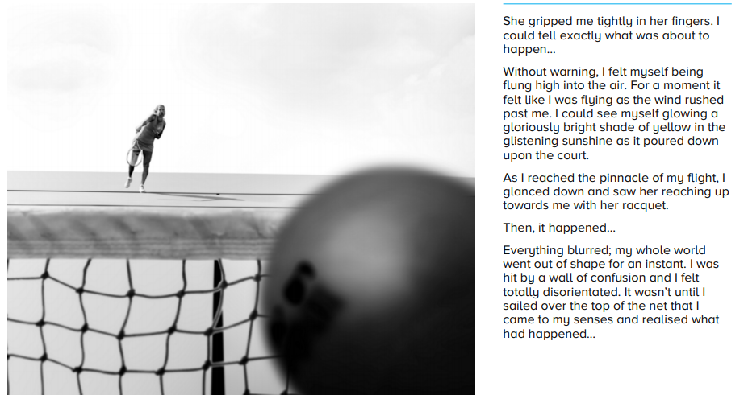
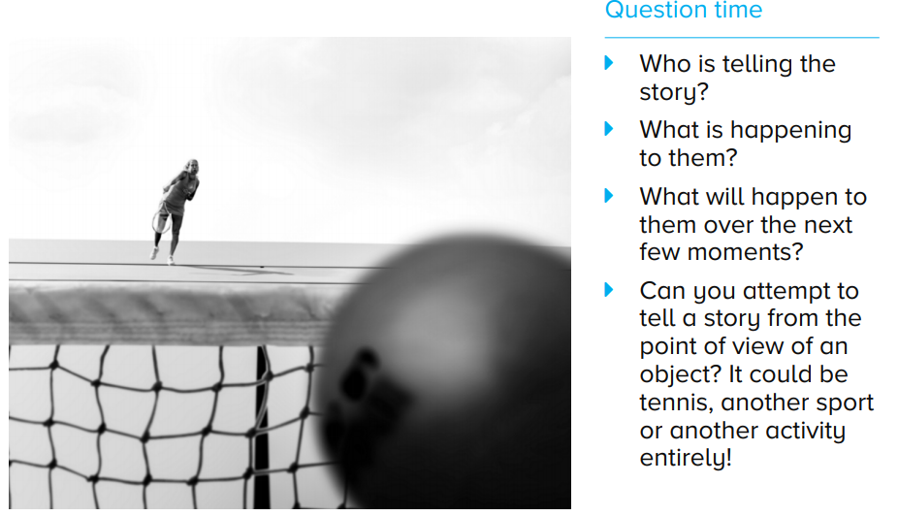

Challenge


Next is handwriting
Practise these joins in your book.
attached | available | average
awkward | bargain | bruise

Our final lesson is science.
Today we are going to be revisiting Earth and Space. I was really impressed with your hard work last week with Earth and Space. So, today I would like to test your knowledge. Click on the link below to answer the Earth and Space quiz.
https://www.educationquizzes.com/ks2/science/earth-moon-and-sun/
After this, look at what you answered incorrectly. Research this question and write the fact in your book.

Maths answers


