 Good Morning Year 5 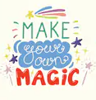
How are you all? Did you have a good weekend? I hope you did and I can’t wait to hear all about it.

Let’s start our Monday morning by joining Joe Wicks for P.E.

Now for Maths!
Today, we are going to round numbers to the nearest 10, 100, 1000, 10 000 or 100 000.
When rounding:
To the nearest 10, look at the ones column
To the nearest 100, look at the tens column
To the nearest 1000, look at the hundreds column and so on.
If the number is 5 or more, you round up.
If the number is less than 5 you round down.
Here's an example to help you.
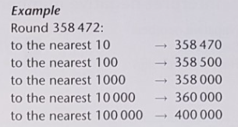
Choose your chilli challenge below.
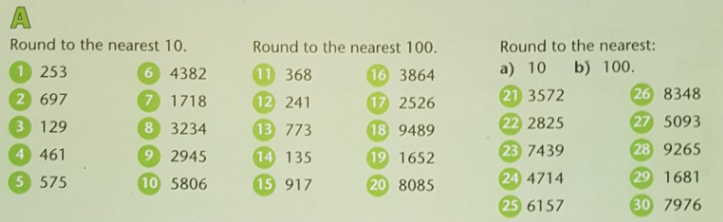
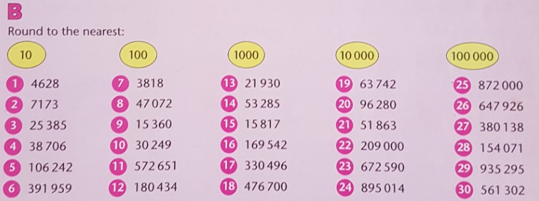
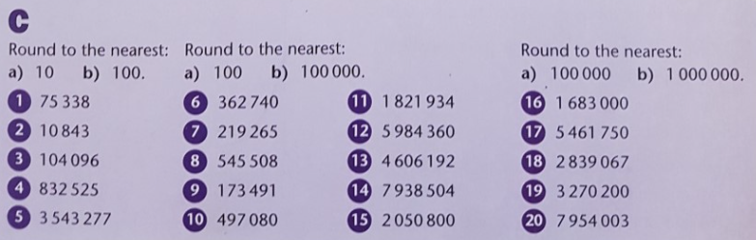

Challenge
The weight of the items below has been rounded to the nearest 100g and 1000g. What could the actual weight be for each? There are lots of possible answers.
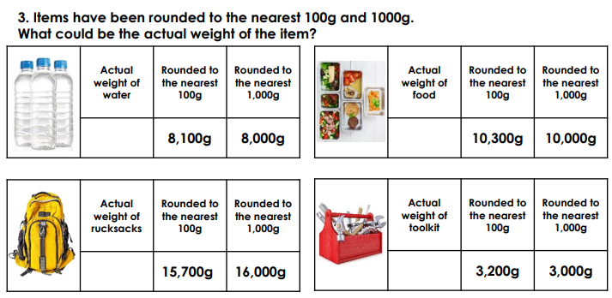

Our next lesson is English.
Include the correct relative clause in the sentences below.
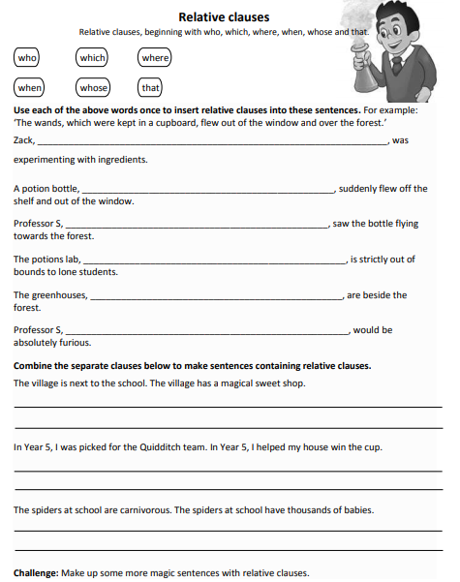

Our final lesson history.
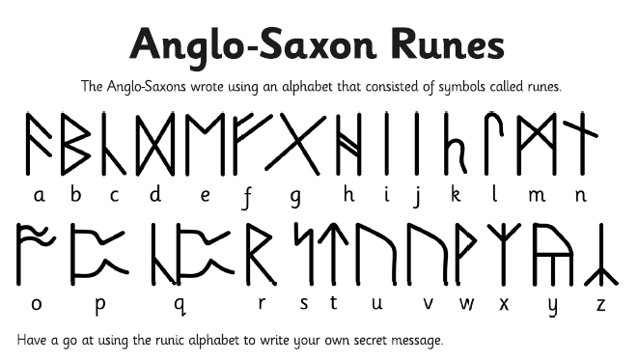
Why don’t you try and write your name in runes!
Now see what else you can find out about the Anglo – Saxon Runes and write down 5 facts!

I would love to see or hear of any work that you have completed. Hope you have a lovely day and remember to complete your daily reading.

Maths answers below.
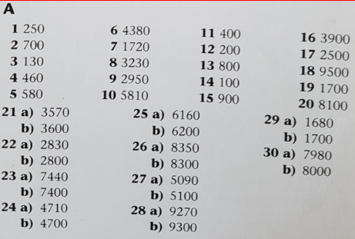
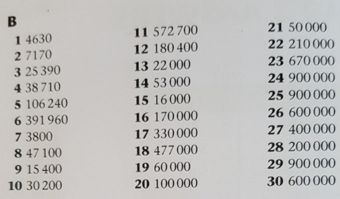
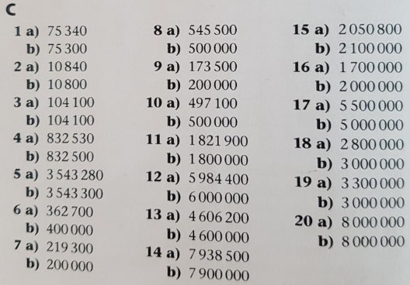
Challenge
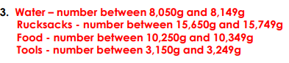

English answers


