
Tuesday 16th June 2020 Blowers Green at Home – Nursery
E-mail: nursery@blowers.dudley.sch.uk

Good Morning Nursery!

I hope you have all had a fantastic sleep. You will find your ‘Nursery at Home’ activities below. As always, if you have any questions or would like to share your learning, please e-mail me on the address above.

Have a terrific Tuesday

Miss Meads

Keep on Moving!

We learned all about spiders yesterday. Let’s join Andy on an undergrowth adventure to meet some more tiny creatures.
https://www.bbc.co.uk/programmes/p06tmry2

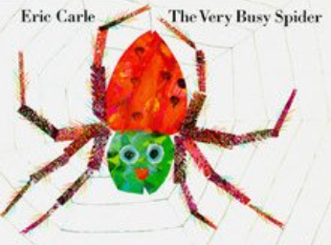
Story Time
The Very Busy Spider by Eric Carle
Listen carefully to the story. Can you remember who wanted to play with the very busy spider? Who wanted to play first? Who wanted to play last?
https://safeyoutube.net/w/JvPK

Phonics
Sound hunt
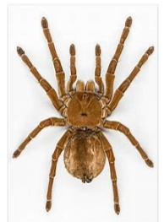
Spider starts with the sss sound. Go on a sound hunt how many objects can you find that begin with the sss sound.
I found sock, scissors, sun, star, sandwich, sausage and sandals. I wonder what you will find.

Minibeasts – What can you see?
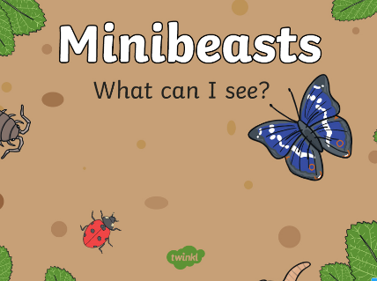
Yesterday, you went on a spider adventure but who else might be hiding in your garden?
Play this game with an adult. Look through the binoculars. What can you see?
You will find the game ‘Minibeasts – What Can You See?’ under the Nursery tab on our home learning website.
Minibeast Hunt
How many different minibeasts can you find? Use the tick sheet to help you.
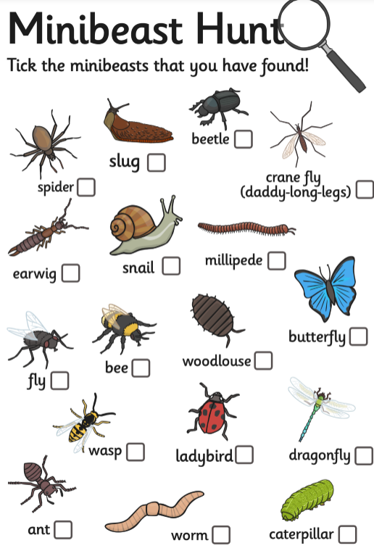

Maths
Ask an adult to help you to draw a web.
Now draw some spiders. How many spiders can you fit on your web?

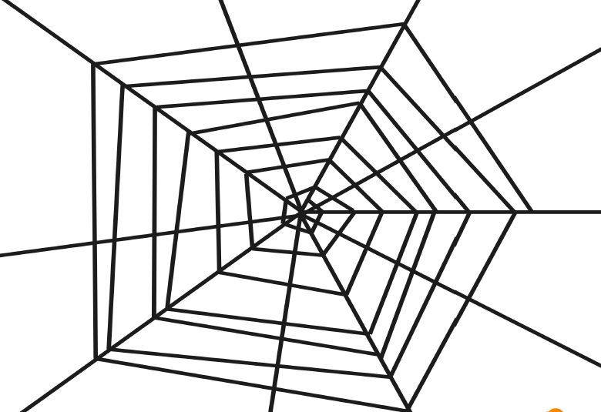
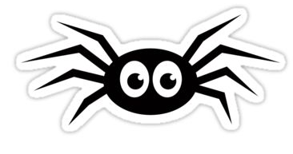


Have a terrific Tuesday
Miss Meads

