
Monday 15th June 2020 Blowers Green at Home – Nursery
E-mail: nursery@blowers.dudley.sch.uk

Good Morning Nursery and welcome to a brand new week. I hope you have all had a lovely weekend.

Nursery at Home Poster
Mrs Dhoot and I are missing nursery and all of you very much. Many of you may be missing playing and learning with your friends in nursery too. I thought it would be lovely to make a class poster. I would like you to draw a picture of yourself. Take a photograph of your picture and e-mail it to me. I will put all your pictures together to make a poster. Mrs Dhoot and I, will also add a photograph to show you what we are up to at school. I will put the poster on our home learning page on Tuesday 23rd June.

Note to parents
Choose one of the following links to watch a short drawing lesson.
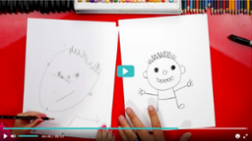

How to draw a person for preschool.
https://safeyoutube.net/w/v8IK

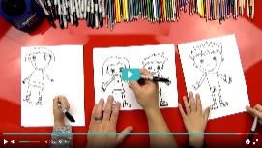
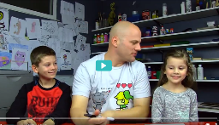
How to draw a boy or a girl.
https://safeyoutube.net/w/ZzPK

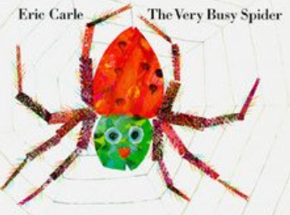
The Very Busy Spider by Eric Carle
Today’s story is all about a spider, a very busy spider!
https://safeyoutube.net/w/JvPK

Rhyme Time
Don’t forget to practise your Rhyme Challenge rhymes today. Try Incy Wincy Spider today.
If you know all the words, learn this extra verse.

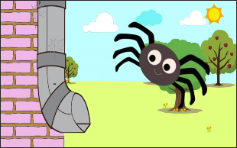
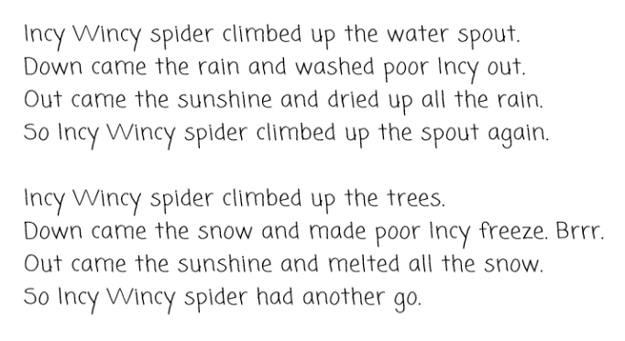

Spider Adventure

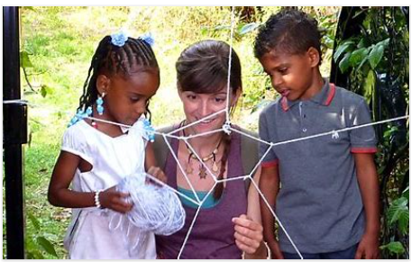
Click on the link below to learn some fascinating facts about spiders with Jess and her friends.
https://safeyoutube.net/w/C9MK

Go on a spider adventure around your home. Don’t forget spiders like to live inside and outside. Look carefully for webs. There’s a spider in my garden who likes to spin her web on my washing line. I have to be really careful not to disturb her when I peg out my washing.

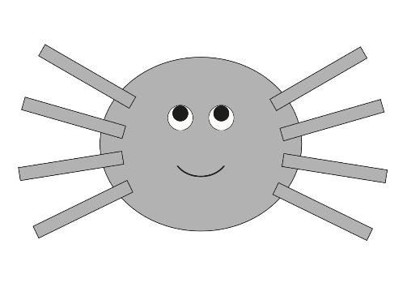
Spider Shape Picture

Can you make a spider shape picture? I can see a huge, round body and lots of long legs. What shape do we need for his body? How many long legs does your spider need?

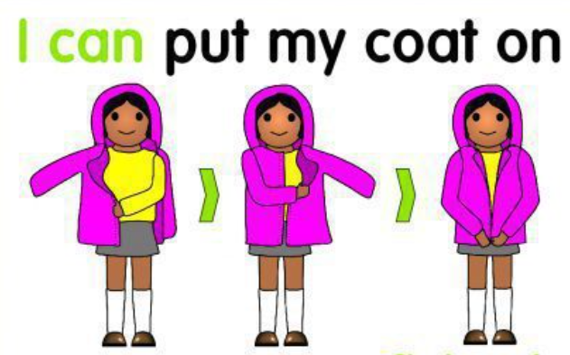
Return to School and Nursery Challenge
Each week I am going to set you a ‘Ready for School and Nursery’ challenge. In Reception and Nursery, we love to have fun learning outside. So, this week I would like you to practise putting on and fastening your coat. Keep practising, I know you can do it!

Have a fabulous day

Miss Meads

