
Friday 12th June 2020 Blowers Green at Home – Nursery
E-mail: nursery@blowers.dudley.sch.uk

Happy Friday to you all. Well done for working so hard this week. Mrs Dhoot and I are very proud!
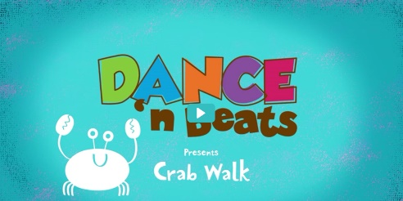
Keep on Moving !
Let’s warm up, have some fun and learn how to do the crab walk.

https://safeyoutube.net/w/Be8K

Making our Mark

Today, we are going to make lots of bumpy movements just like the ocean. Don’t worry if you find the moves tricky, just have fun practising.

Grab two tea towels to wave in both hands, find a space and put on your favourite tune.




- Make two arch movements (like rainbows), one with each hand. Keep moving your arms from side to side.

- Make two under bumps, one with each hand. Keep moving your arms from side to side.



Challenge Move
- Make a big arch movement using both arms. Keep moving your arms from side to side. Now try it the other way.

To finish, do the same movements on a large sheet of paper or with chalks on the ground. You could use ocean colours such as blue and green.

Try to move across the paper with your bumps to make a wavy ocean.

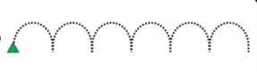

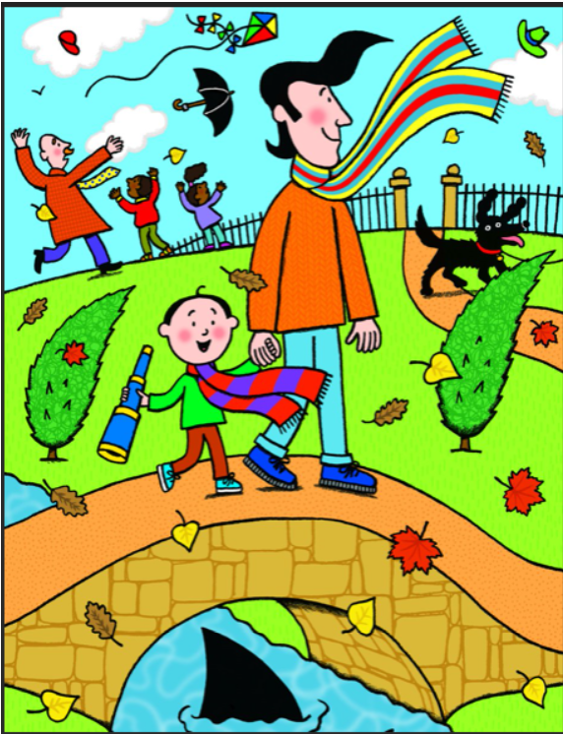
Share a Story –
I hope you have all enjoyed Shark in the Park on a Windy day.
https://safeyoutube.net/w/Mu7K

Look at the picture. What can you see?
Can you spot what Timothy Pope saw through his telescope? Is there anything missing?

What did he see first, next and last?

Challenge Question
Why did Timothy’s dad call Timothy a hero at the end of the story?

Listening Activity
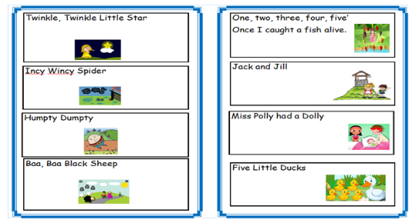
Don’t forget to practise your rhyme challenge rhymes. Try Jack and Jill today. Can you remember all the words?

Listening Challenge - New words to old songs
Choose your favourite rhyme and have a go at changing some of the words.
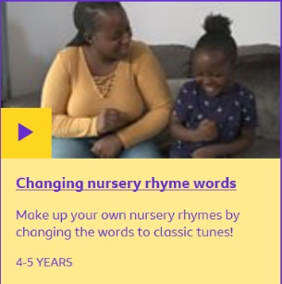
Note to Parents
Click on the link below to watch how families have fun changing the words to their favourite songs.
https://www.bbc.co.uk/tiny-happy-people/changing-nursery-rhyme-words/zrmggwx

Make a sea creature
Why not get crafty over the weekend. You could make your own sea creature. Here are some ideas.
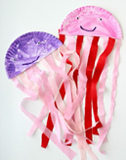
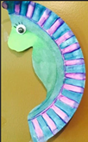
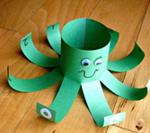
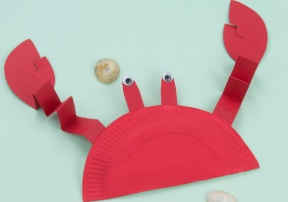
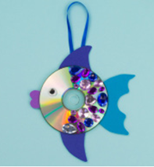

Have a lovely weekend!
Miss Meads

