
Thursday 11th June 2020 Blowers Green at Home – Nursery
E-mail: nursery@blowers.dudley.sch.uk

Thank you for all your e-mails. Mrs Dhoot and I have enjoyed reading them all. You have really made us smile.

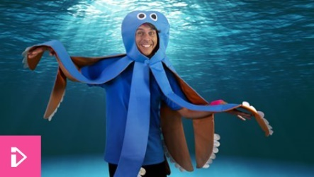
Keep on Moving !
Let’s join Andy on an underwater adventure. I wonder who we will meet on the way?
https://www.bbc.co.uk/iplayer/episode/p06tmn51/andys-wild-workouts-series-1-1-under-the-sea

Moving Fish Challenge
Note to parents
Cut two identical fish shapes out of A4 paper and bend the tails up so they are at right angles. Put the fish on the carpet in front of your child.
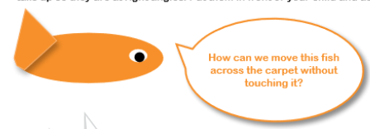

Give your child chance to think. Then, give your child another piece of paper that you can fold into a fan.
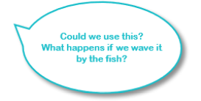
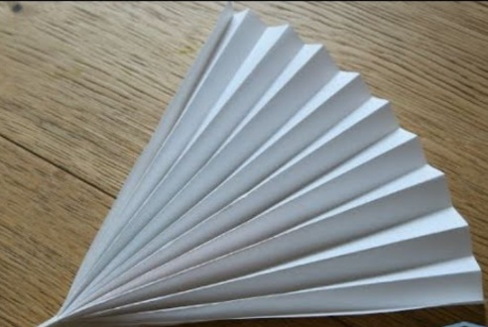

Chat to your child about what is moving the fish.

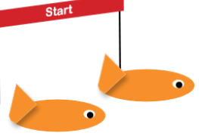
Now have a race! Who can cross the finish line first?

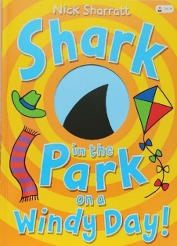
Share a Story – Shark in the Park on a Windy Day by Nick Sharratt

I hope you have all enjoyed Shark in the Park. In today’s story, Timothy Pope takes his telescope to the park again. Listen carefully to the rhyming words and look at the pictures.
What did Timothy Pope see through his telescope this time?
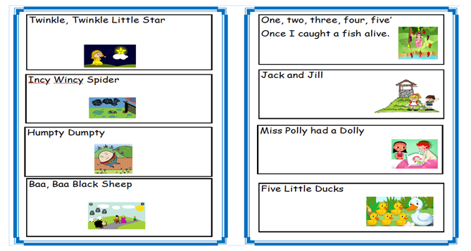
https://safeyoutube.net/w/Mu7K

Listening Activity
Don’t forget to practise your rhyme challenge rhymes. Choose one of your favourites to sing to an adult.

Challenge
Rhyming Odd One Out
Look at the pictures. What can you see? Only three of the objects have rhyming names. Can you spot the odd one out?

I have completed the first one to start you off.
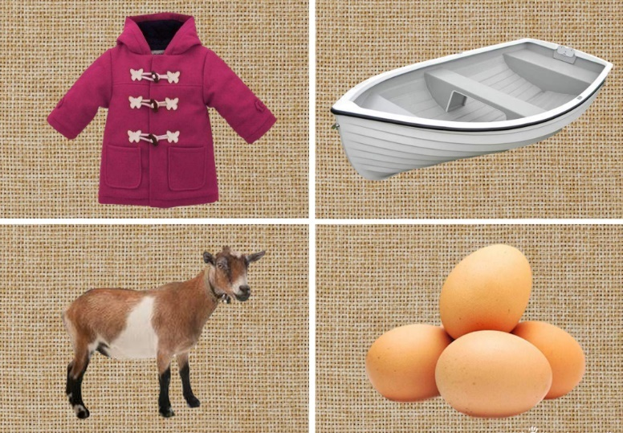

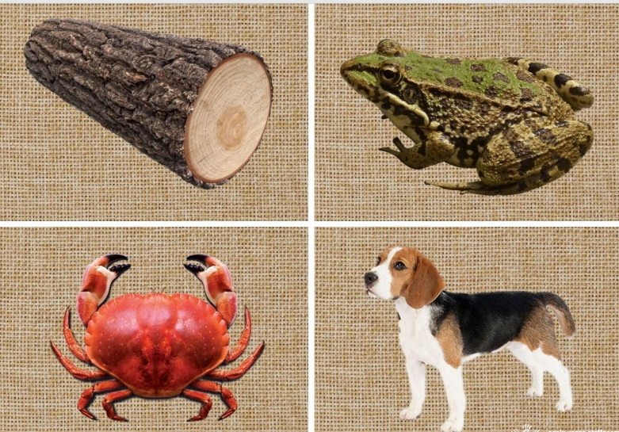
Log, frog and dog all rhyme so crab is the odd one out.
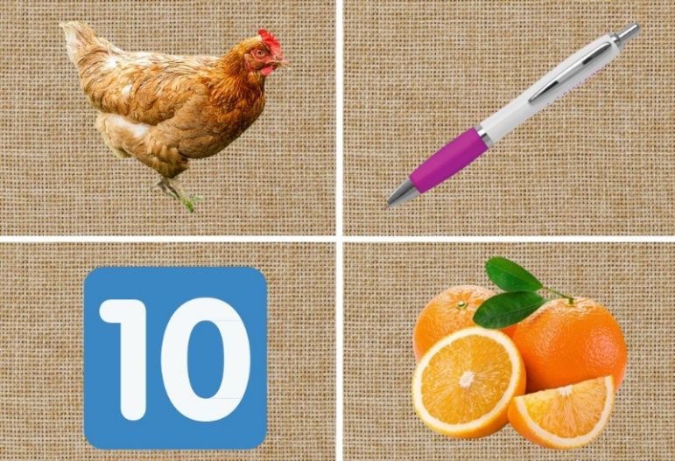
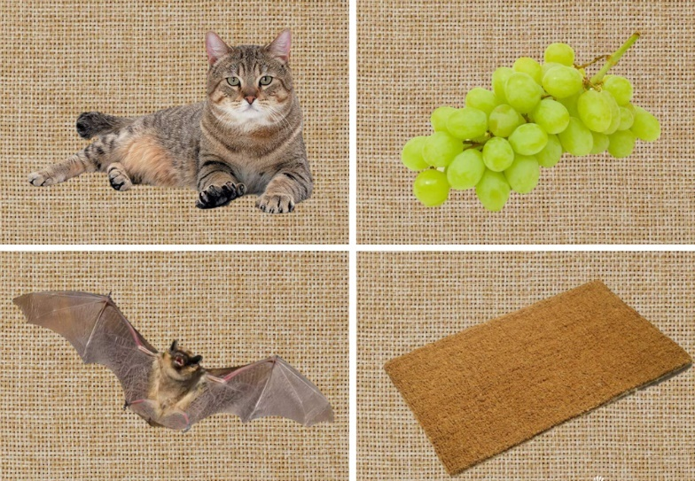

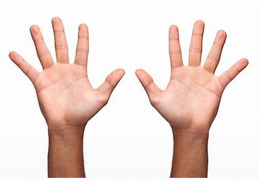
Number Time
Let’s sing a number rhyme and practise counting to 10.
https://safeyoutube.net/w/Yo7K

Ten Little Fingers
One little, two little, three little fingers,
Four little, five little, six little fingers,
Seven little, eight little, nine little fingers,
Ten little fingers on my hand.

Can you name the sea creatures? Count each sea creature in the box. How many of each creature can you find?
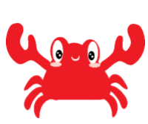
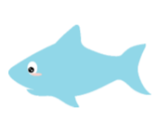


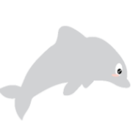
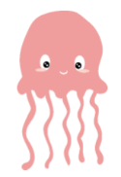

jelly fish dolphin whale shark crab sea horse




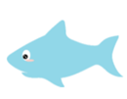


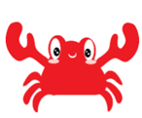
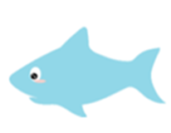

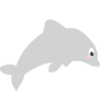

Have a lovely Thursday
Miss Meads

