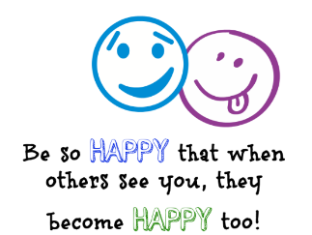
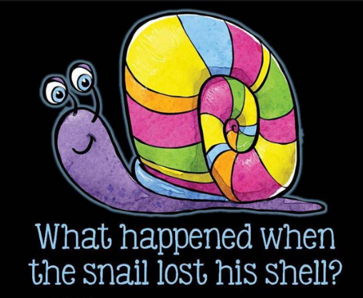
Wednesday 10th June
E-mail: reception@blowers.dudley.sch.uk
What a busy day yesterday. I hope you are enjoying these snail activities.
Challenge time
Can you count backwards from 20 to 0 ?
Send me a video and you will win 20 Dojo points.
He began to feel sluggish.

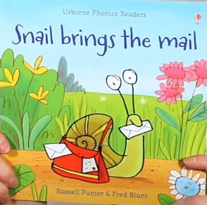
I hope you enjoy this story about a snail.
https://safeYouTube.net/w/L3qK
After listening to the story. Can you remember what words rhymed with fox
bee
snail

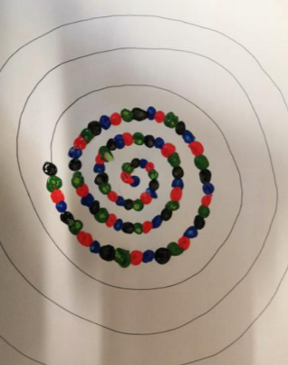
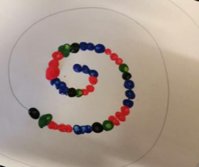
Funky Fingers Do you remember how we made a spiral pattern yesterday? Today we are making our fingers extra busy by making dots on your spiral. Make it more exciting and look at designing your spiral with more complex patterns. Carefully dot around your spiral using a cotton bud. Can you experiment with different patterns around your spiral to make a designer snail?

Spiral snacks
Can you make your own edible snails shells? You will need: Wraps, chocolate spread and a knife to spread and cut. Spread your chocolate all over your wrap. Roll up tightly. Cut into slices See the snail shells! Have fun eating some snail shells! How many did you make? Eat 1 how many do you have left?
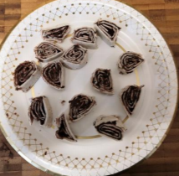
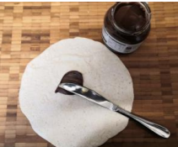
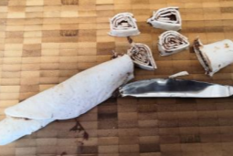
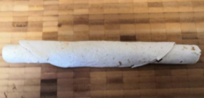
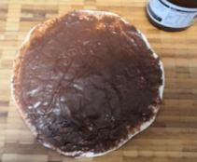

Can you write a subtraction sum every time you eat one of your shells. 10 – 1 = 9
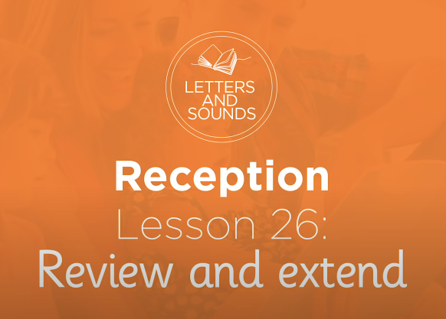
Phonics
After watching this lesson can you write your own sentence using the word rabbit, ticket, laptop or zigzag? https://safeYouTube.net/w/CgqK

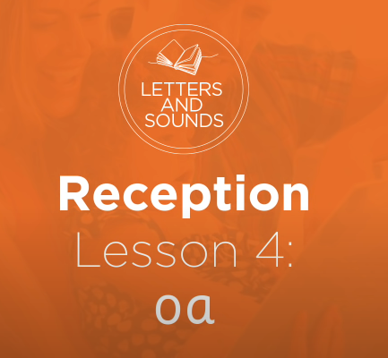
Today is the ‘oa’ sound. After watching this can you write down as many ‘oa’ words as you can? https://safeYouTube.net/w/8EsJ

Snail Craft
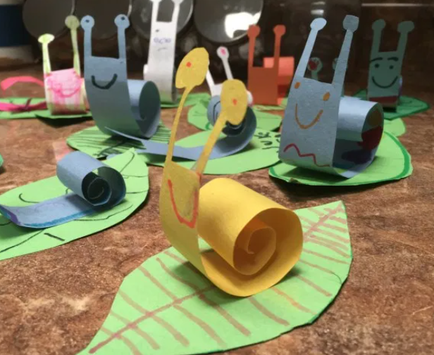
Can you make a snail out of paper?
Can you curl the paper to make a shell?
Send me a picture of your snail.

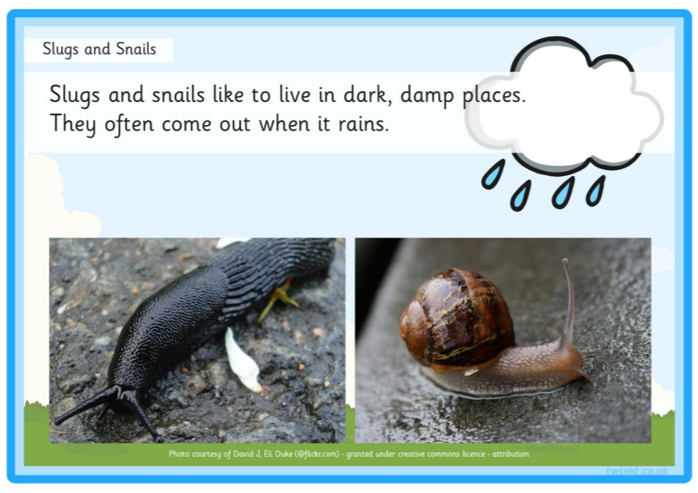
Can you read this fact about snails?
Can you find another fact about snails and make a poster.
Send me a picture and you will win 20 Dojo points.

