Tuesday 9th June
E-mail: reception@blowers.dudley.sch.uk

Good morning, what a busy day yesterday. Thank you for all the work you sent me. You are working very hard.

Challenge time
Do you know the days of the week? Email me a video, or if you have difficulty with videos just drop me an email to say you know the days of the week and you will win…
20 Dojo points.

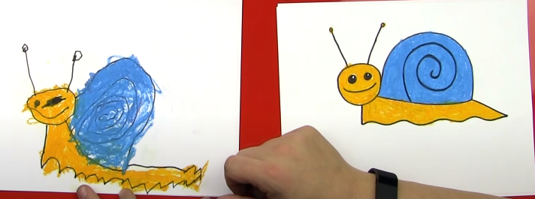
Can you draw a snail?
Watch this link and follow the steps to draw a snail.
https://safeYouTube.net/w/S1sJ
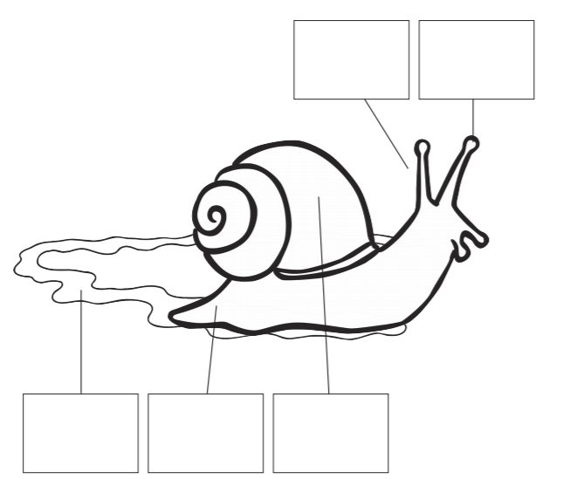
Can you label your snail? Where is the shell, foot and eye? Can you add the trail?
Storytime
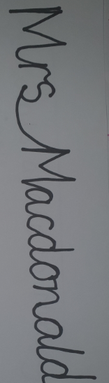
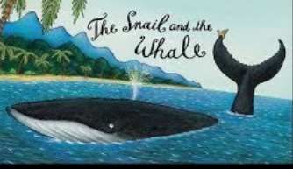
Today our story is the Snail and the Whale. If you have the book at home snuggle with an adult and read it together. If not click on the link and snuggle with your favourite teddy and listen to the story.
https://safeYouTube.net/w/NdtJ
I tried to write my name without taking my pen off the paper, like the snail wrote on the rock. I found it really hard, can you try and write your name?

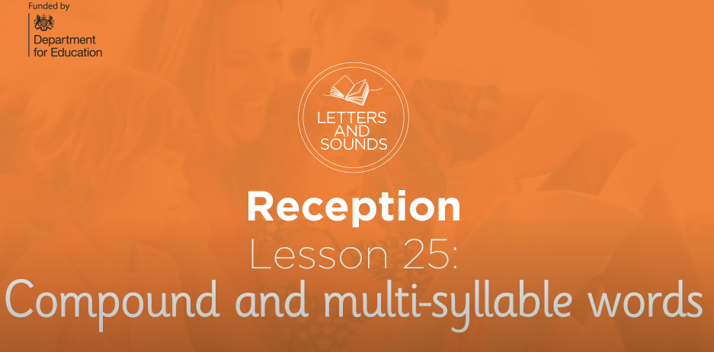
Phonics
After you have taken part in this lesson. In your books can you write as many compound words as you can? https://safeYouTube.net/w/bJsJ
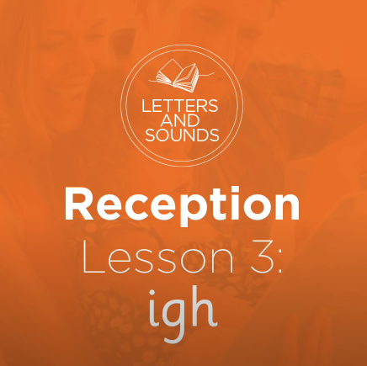
Today is the ‘igh’ sound. After watching this can you write down as many igh words as you can? https://safeYouTube.net/w/8EsJ

Number
Here is my pet snail can you remember what his favourite number is?
He is very confused at the moment, he can only eat leaves that equal the sum of 10, but the leaves have no sums on them. Can you write a sum for each leaf so the snail can have something to eat? You can use + and - .
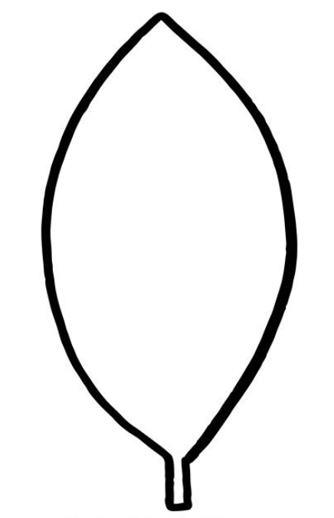

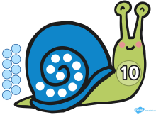

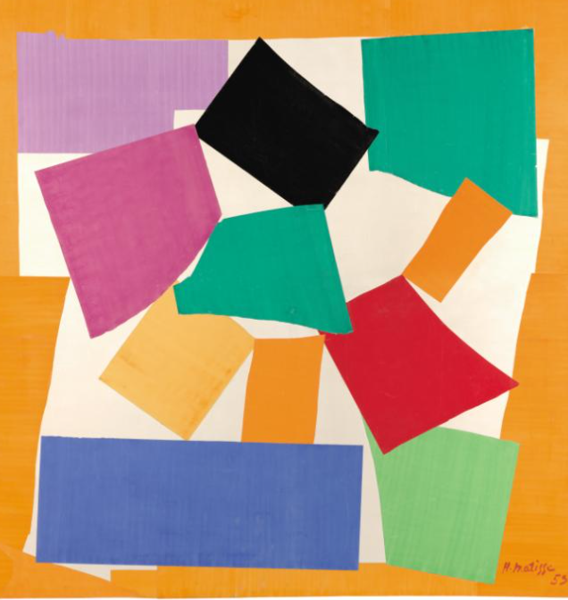
This artwork was created by a French artist called Henri Matisse.
It is called ‘The Snail’
The Snail is a collage made from pieces of brightly painted paper that have been cut out and stuck onto a canvas.
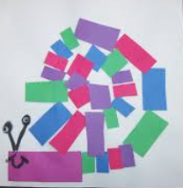
Your challenge today is to create a piece of artwork inspired by Henri Matisse.

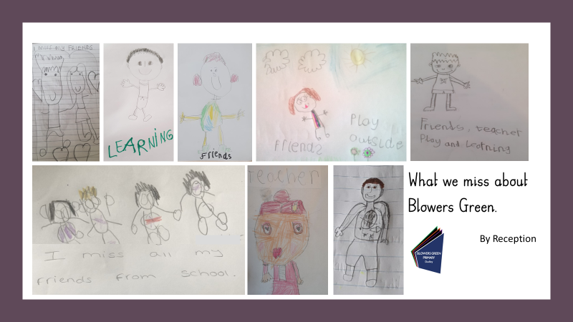
Thank you to everyone who sent in their pictures last week. Here is the poster. Can you spot your drawing?

