
Wednesday 10th June 2020 Blowers Green at Home – Nursery
E-mail: nursery@blowers.dudley.sch.uk

Good Morning Nursery,

Here are your ‘Nursery at Home’ activities for today.
Have a great day!

Miss Meads

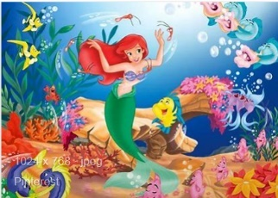
Keep on Moving !

This is my favourite Disney song. It makes me feel so happy, especially on a rainy day. So, let’s join in with Ariel and dance to ‘Under the Sea.’ Follow the link, choose a dancer and have some fun learning these dance moves.

https://www.bing.com/videos/search?q=under+the+sea+just+dance&docid=608032631507389455&mid=FCE84D7E0A086D167651FCE84D7E0A086D167651&view=detail&FORM=VIRE

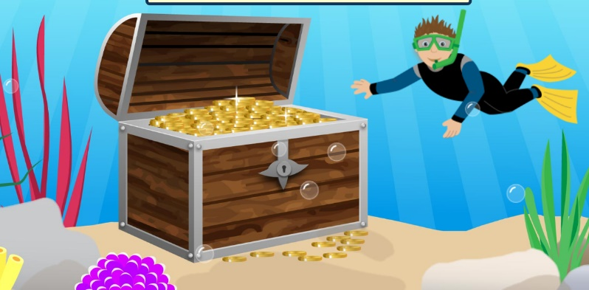
Under the sea treasure hunt

Help Ben to find the underwater treasure by counting the sea creatures.

https://www.topmarks.co.uk/learning-to-count/underwater-counting

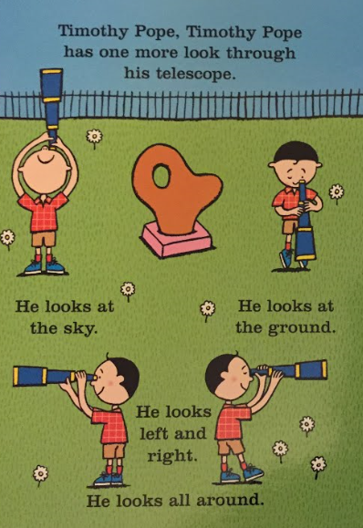
Story Time - Shark in the Park

https://safeyoutube.net/w/4iGJ

Our story this week is Shark in the Park by Nick Sharratt. Listen carefully and join in with the story. You could even use you telescope and pretend to be Timothy Pope.

My story cards are all mixed up! Can you help me put them in order? What did Timothy really see first, next and at the end.

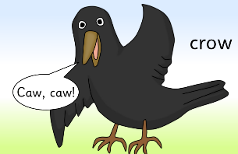
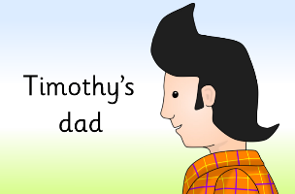
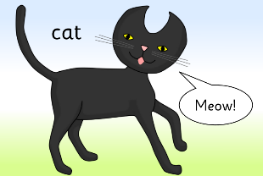

Listening Activity Rhyming Pairs
What can you see? Say the names of the objects? Can you find the rhyming pair?

I have done the first one for you.
dog and frog.

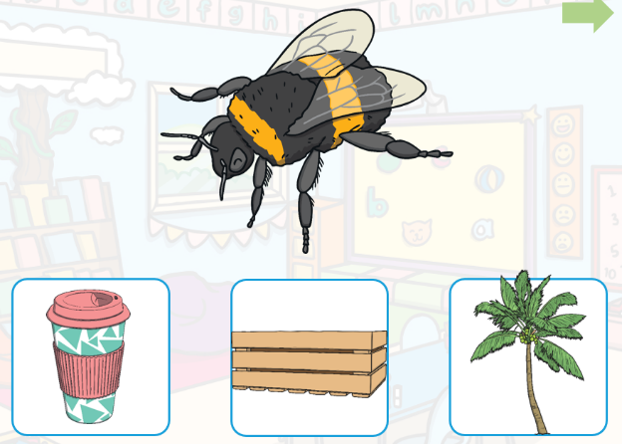
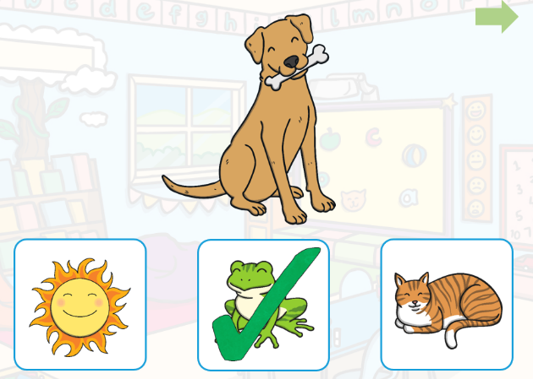

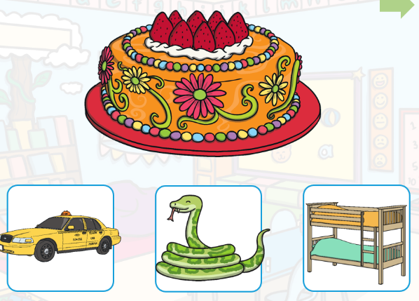
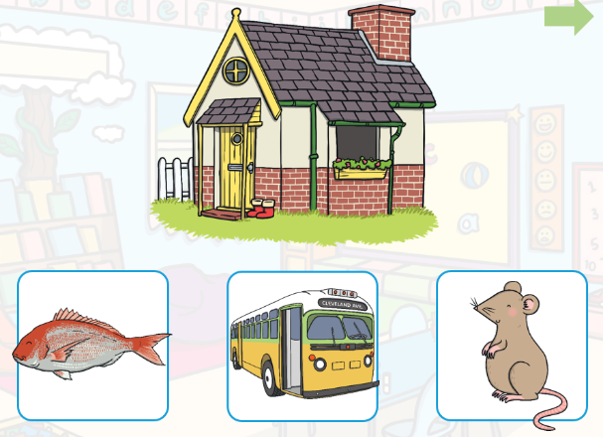

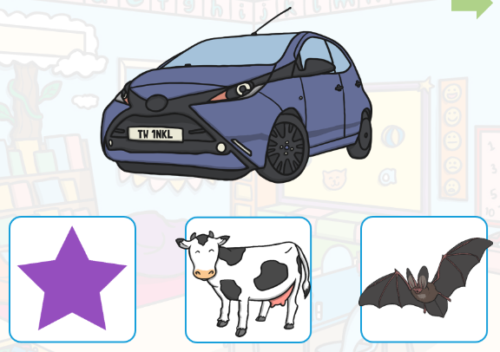
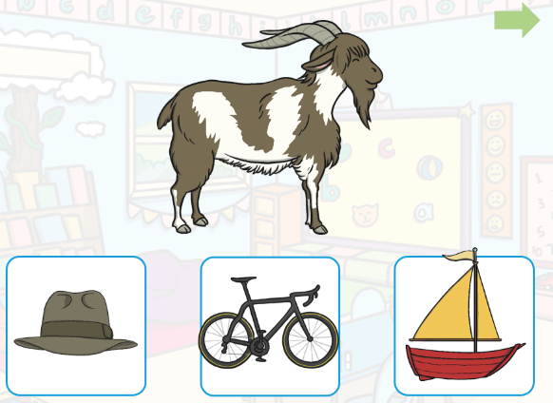

Rhyming Challenge
Go on a rhyming treasure hunt at home. Choose a simple word, for example, cat. How many objects can you find that rhyme with cat?


Have a lovely day
Miss Meads

