
Blowers Green at Home – Nursery
Tuesday 9th June 2020
E-mail: nursery@blowers.dudley.sch.uk

Good Morning Nursery,

I hope you are all safe and well. Here are your ‘Nursery at Home’ activities for today.

Miss Meads

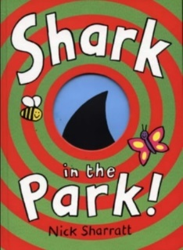
Story Time - Shark in the Park

https://safeyoutube.net/w/4iGJ

Our story this week is Shark in the Park by Nick Sharratt. Can you hear the rhyming words in the title? Listen carefully to the story today and try and join in with the rhyming words.

This is how he story begins.

Down at the park, a little boy

is testing out his brand new …toy

I said toy because I know it rhymes with boy.
I am sure you will join in with lots more.

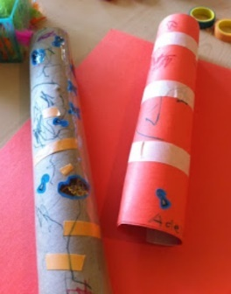
Make a telescope
You could make a telescope using cardboard tubes (kitchen roll, gift wrap or a pringles tube). Look through the telescope and see what you can see. Play I Spy. Take your telescope when you are in the garden or out for a walk. What can you see?

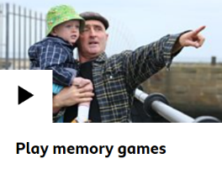
Note to Parents
This is a great opportunity to chat to your child about the things that they saw. Memory games like this are fantastic for developing your child’s language, whatever stage they are at. Click on the link below to see how memory games are a brilliant way to learn.

https://www.bbc.co.uk/tiny-happy-people/play-memory-games/zmq3382

Let’s Go to the Dough Disco!

If you don’t have any dough, here is a simple way to make play dough using warm water. I would stay away from adding food colouring as it does get messy!
https://www.google.com/search?q=simple+play+dough+recipe&oq=simple+play+&aqs=chrome.1. 69i57j0l7.6429j0j9&sourceid=chrome&ie=UTF-8#kpvalbx=_b67HXuijMfPqxgOC7pPoCA45
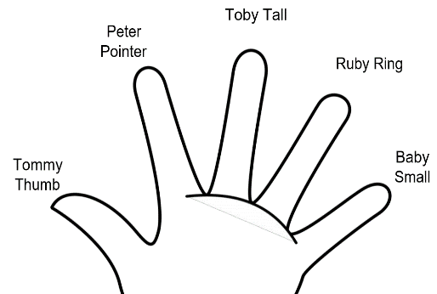
Get your dough and let’s go!
Wave your hands and say hello!

Say hello to your fingers, wiggling as you go.
Now put on one of your favourite tunes.

This was one of your favourites in nursery. ‘Can’t stop the feeling’ made us so happy!
https://safeyoutube.net/w/8vRJ

Now, do these moves to the music with your dough. Remember, if don’t have any, just use your invisible dough.
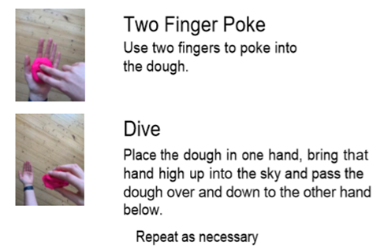
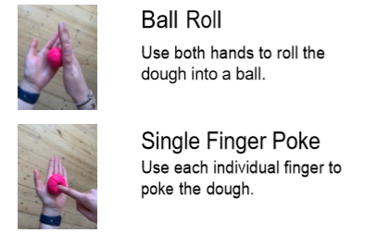
Number Time
Teach your favourite number rhyme to an adult or sibling today. Don’t forget the actions.
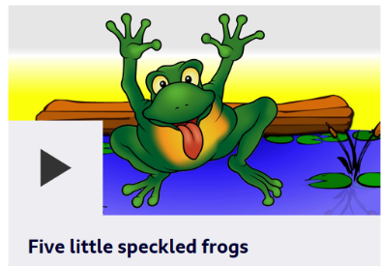
Here are some that you know.

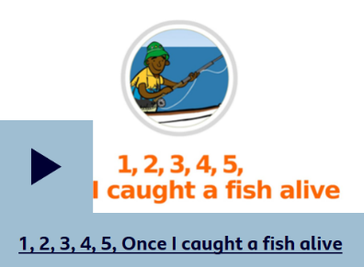
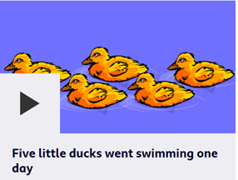

https://www.bbc.co.uk/teach/school-radio/nursery-rhymes-songs-index/zhwdgwx

Have a lovely day
Miss Meads

