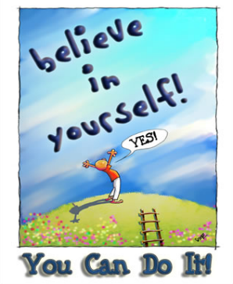 Good Morning Year 5. 

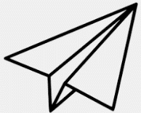To start off our day let’s do some maths.
Design and create three paper aeroplanes. For ideas on how to make different paper aeroplanes click on the video below.
https://www.youtube.com/watch?v=SpYS5WtvNvQ
Record the distance each plane flies and see which one flies the furthest.
What were the differences between the three flights? (answer in cm)
What is the overall distance of the 3 planes?

Our next lesson is English.
Read through the text below and answer the questions. Remember to use evidence from the text to back up your answers.
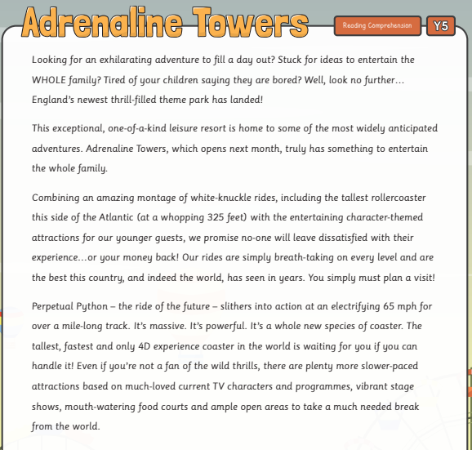
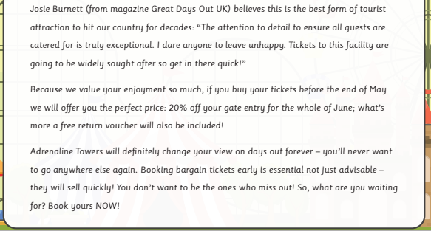
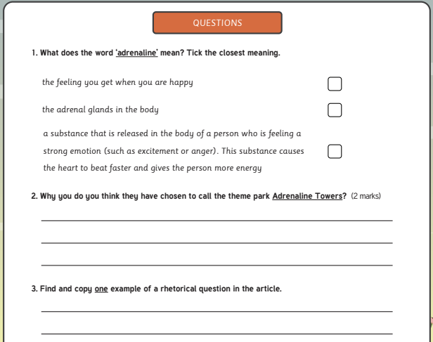
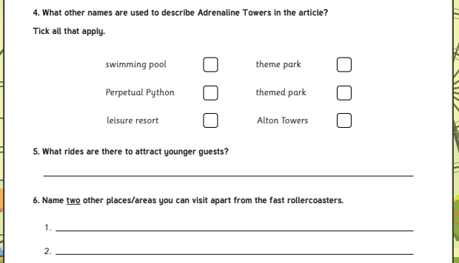
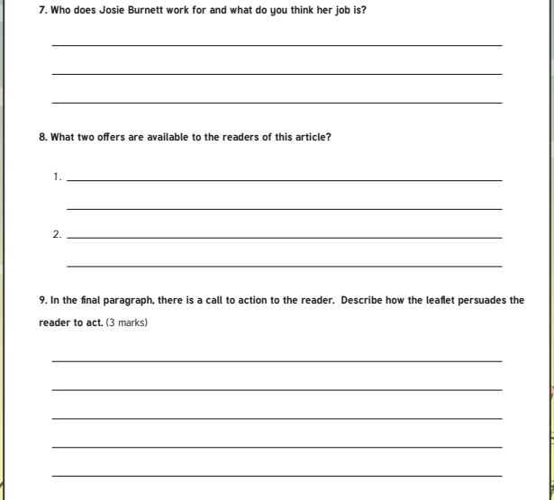
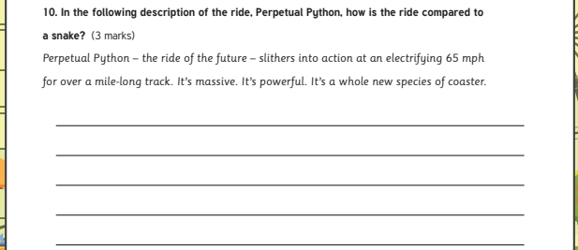

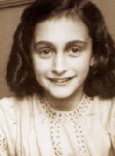 Our final lesson is history. 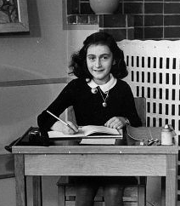
Today is Anne Frank’s birthday. If she was alive today she would be 89 years old. Anne Frank’s diary helps us understand what life was like for Jews during World War 2.
Read this biography about Anne Frank.
https://www.ducksters.com/biography/women_leaders/anne_frank.php
Create an article or a fact-file about Anne Frank so that you can educate others about her. Remember we are always looking for excellent presentation!

Remember to continue to do your daily reading and I hope you have a lovely weekend!
English answers:


