 Hello Class 5! 
Hope you are all well and staying safe.

As Thursday would usually be a singing assembly, today we are going to start off with a song.
Today you have a song to sing.
https://www.youtube.com/watch?v=sxl6UX6piNE

Our first lesson today is maths.
Today we are going to be subtracting from more than 4 digits.
Don’t forget to use the column method to help you subtract.
The following video gives you a quick reminder!
https://www.youtube.com/watch?time_continue=2&v=Zsl3QgbUfoA&feature=emb_logo
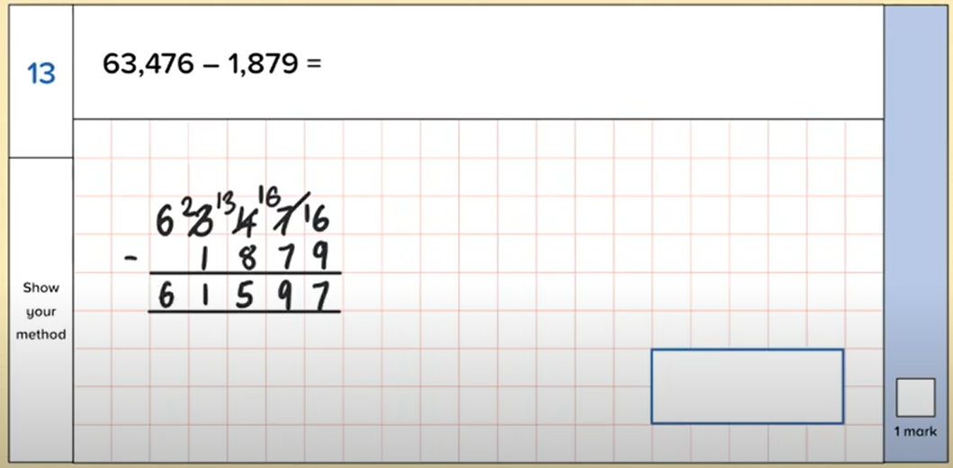
Choose your chilli challenge below.
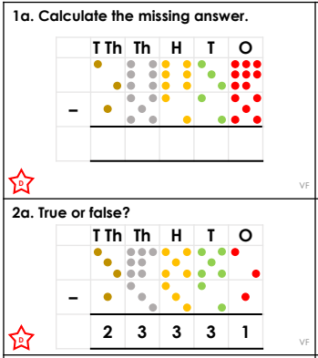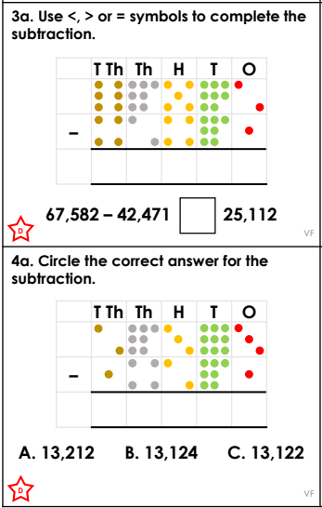
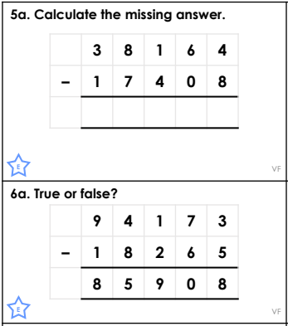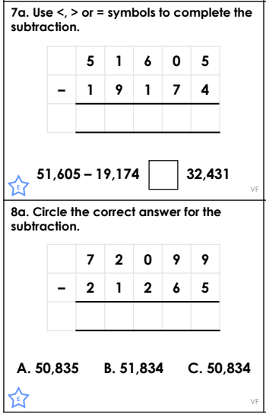
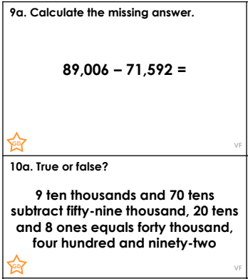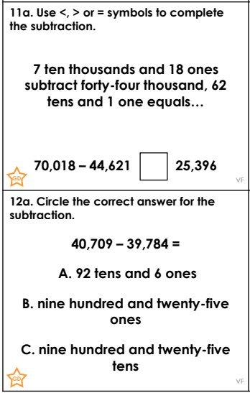
Challenge - 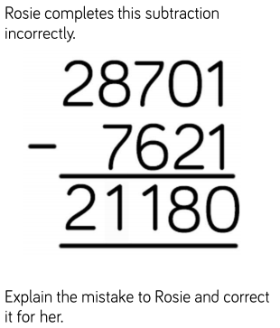

Handwriting
In your exercise book, practise these joins.

apparent | appreciate | attached
available | average | awkard

Next is English.
This is one of my favourite pictures from the book Gorilla by Anthony Browne. You should remember this book as we have used in our English lessons.
I want you to study the picture below and answer the comprehension questions below. Remember to back up your answers with evidence.
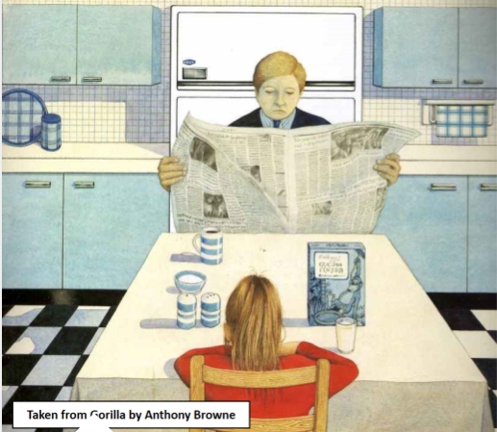
- What does the word ignored mean? Challenge - how many synonyms can you think of for the word ignored?
- How many items are on the kitchen table?
- What sort of man do you think Hannah’s father is? Why?
- Why has Anthony Browne chosen blue for the kitchen?

Our next lesson is ICT.
Log into purple mash and click onto the topics section.
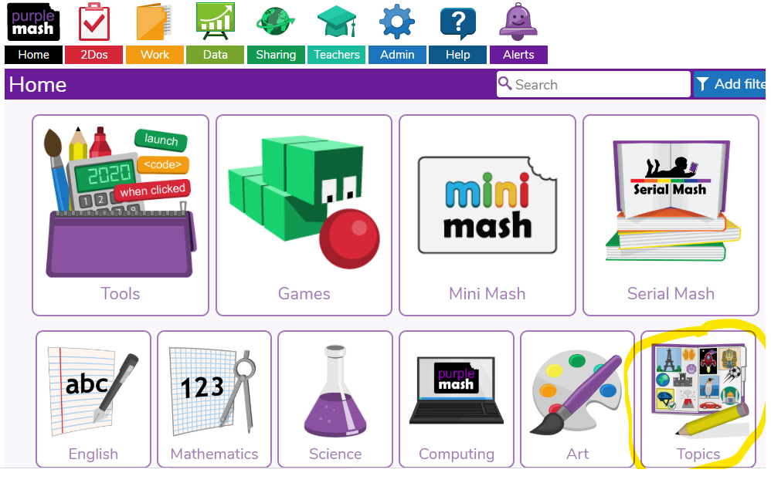
Scroll down and find the space button.
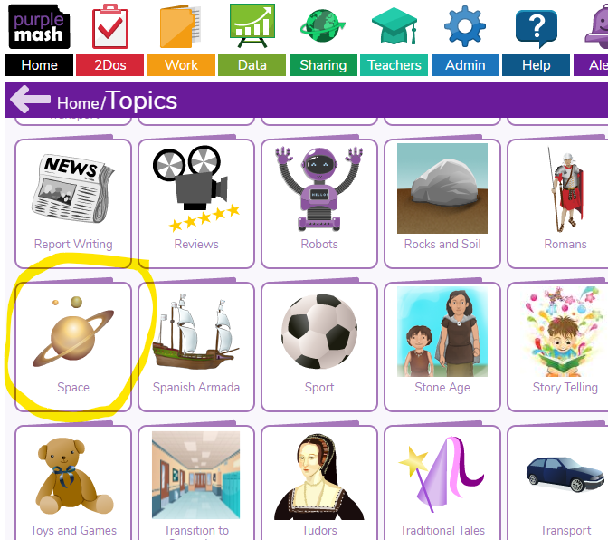
Scroll down and find the activities section. Choose one activity you would like to try and complete it. You can choose all three if you have time. Let me know if you enjoyed it.

Don’t forget, any problems, you can email me. Enjoy!
Maths answers
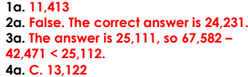 | 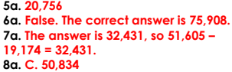 | 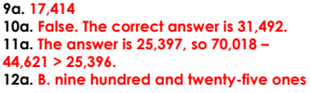
Challenge answer – Rosie did not write down the exchange she made when she exchanged 1 hundred for 10 tens. This means she still had 7 hundred subtract 6 hundreds when she should have 6 hundreds subtract 6 hundreds. The correct answer is 21,080.

