Good Morning Year 5. 
I hope you are all well. I’m so proud of you keeping up with all your home learning! You are all doing wonderfully well.

First, we have a maths lesson.
Today we are going to be revisiting addition. You may need to use a column method to help you solve the problems below.
Please choose your chilli challenge below.
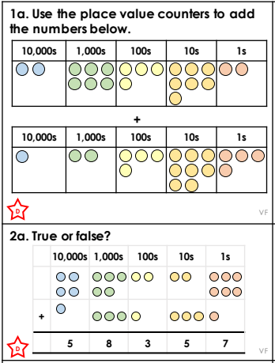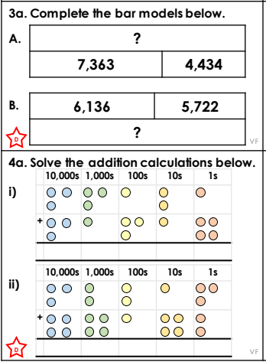
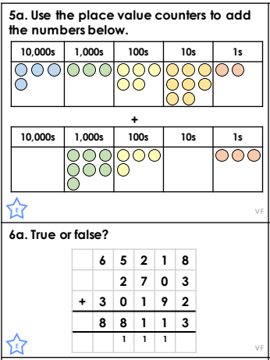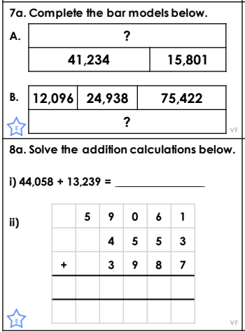
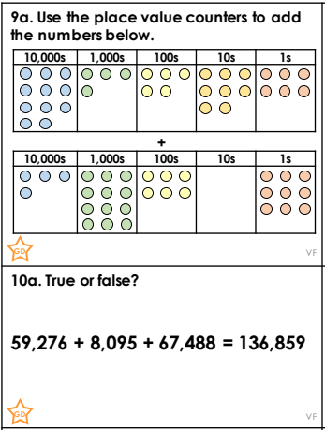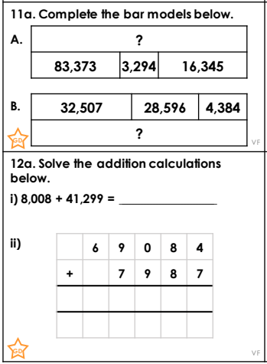

Challenge – answer one of these problem-solving questions below.
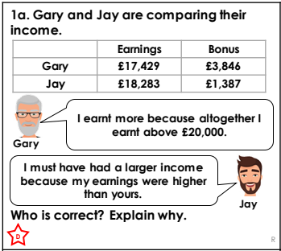 | 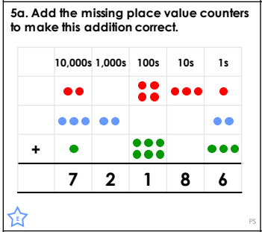

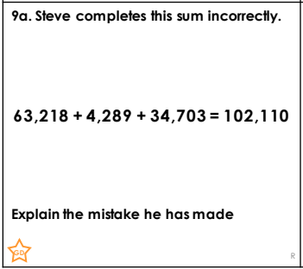

Our next lesson is English.
As you all worked very hard using suffixes yesterday. Today we are going to be looking at prefixes. Prefixes are added to the beginning of a root word to change the meaning of the word.
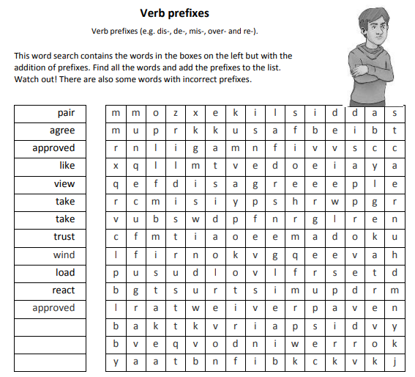
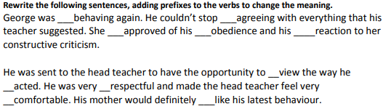

Our final lesson is science.
Last week I set you a task to create an article on about the rocket launch of Space X. So, I would like to revisit the work we did during our topic ‘Earth and Space’ today.
Firstly, I would like you to draw a diagram of the solar system. Draw the diagram from left the right. The sun should be on the far left.
Label your diagram with all the planets, the sun, the asteroid belt and comets.
Then I would like you to investigate the similarities and differences between the eight planets.
Use this website to support your learning.
https://www.youtube.com/watch?v=Qd6nLM2QlWw
The following diagram will also help:
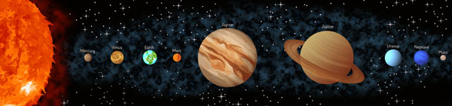
Maths answers
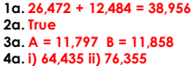 | 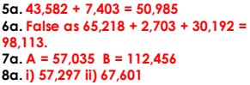 | 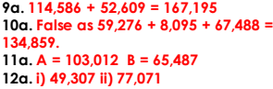
Maths problem solving answers
 | 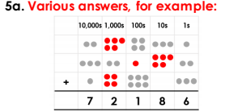 | 

English answers


