Good Morning Class 5! 

Let’s start the day with P.E with Joe Wicks. Remember to have fun doing this and let’s get our hearts pumping and get our brains switched on.

https://www.youtube.com/user/thebodycoach1

The next lesson is maths.
Today I would like you to measure the area of the smallest and largest room in your house.
To find the area of a rectangle multiply its length by its width.
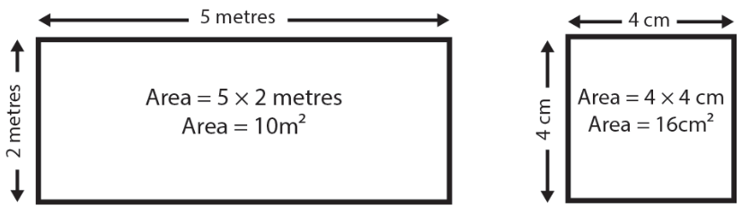
What is the area of the smallest room in the house?
What is the area of the largest room in the house?
What is the difference between the two?

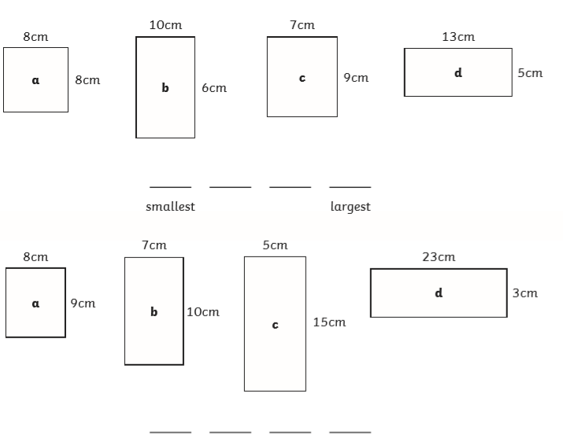
Have a go at this challenge. Find the areas of the rectangles below and then write them in order from smallest to largest (ascending order).

1.

2.

Your next lesson is English.
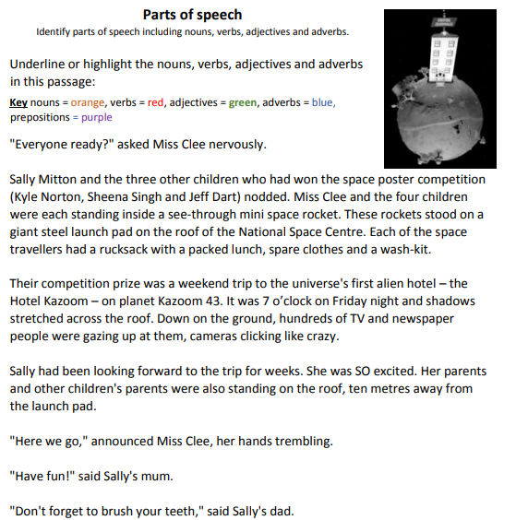

Handwriting
Practise using our learnt joins to write these word as neatly as you can. They are some of the Year 5 and 6 tricky words so you may wish to get a member of the family to test you on them.
accommodate | accompany | according
aggressive | amateur | ancient

Our final lesson is Art. 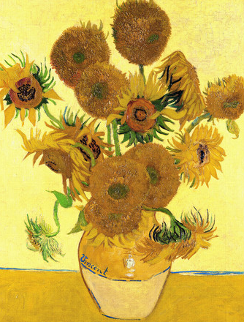
This week it is national art week so today we are going to focus on art. I would like you to sketch an item or object in your house, It could be a favourite toy, an interesting ornament, even the fruit in the fruit bowl. You can even add colour if you like. Once you have sketched it then find someone in your house to tell you 3 ways to improve your drawing. Once they have told you. Then re sketch your drawing but remember the 3 ways to improve your drawing. This should improve your drawing.
I would love to see your first and second drafts of your drawings. Email me a picture!
Remember to complete you daily reading and to take some time out to do something that you enjoy.
Don’t forget, any problems, you can email me.
yearfive@blowers.dudley.sch.uk
English answers


