Good Morning Year 5. 
Hope you all have had a nice weekend. What did you get up to? I can’t wait to hear from you all. Remember to keep me updated with your home-learning by sending emails to yearfive@blowers.dudley.sch.uk

Let’s start off the day with maths.
Today we are going to revisit roman numerals. Choose your chilli challenge below.
Red is easier
Yellow is trickier
Green is the hardest work of all!
Get those thinking caps on.
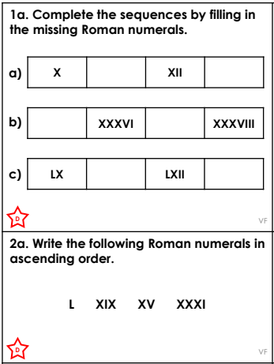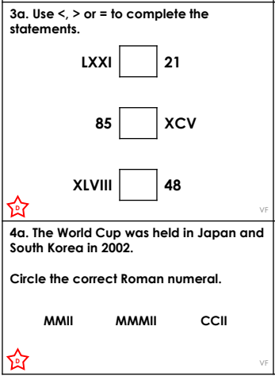
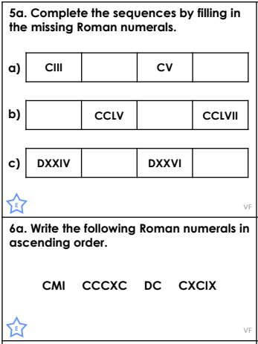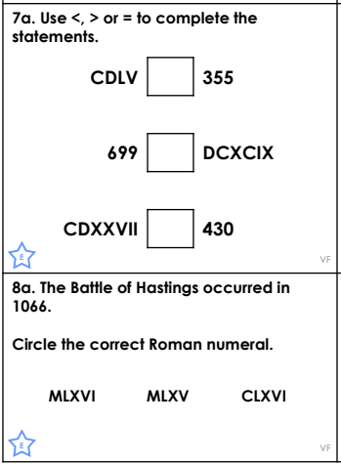
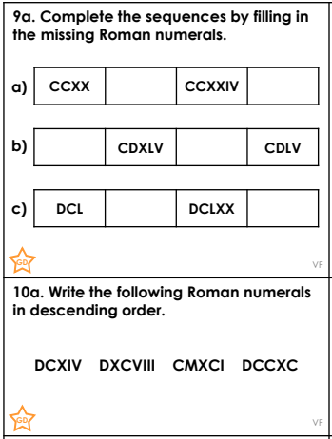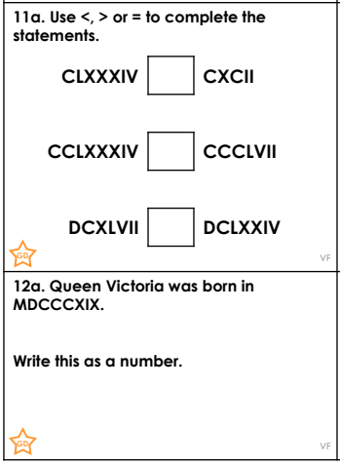
Extra challenge. Can you answer the problem-solving questions below?
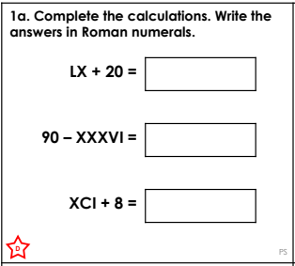 | 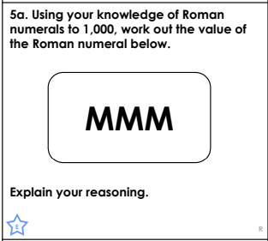 | 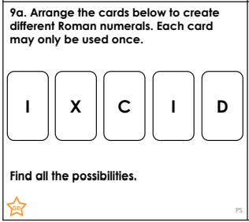

Our next lesson is English.
Today we are going to be revisiting suffixes. Suffixes are added to the end of a root word. Today you will be adding suffixes to nouns to create adjectives and verbs.
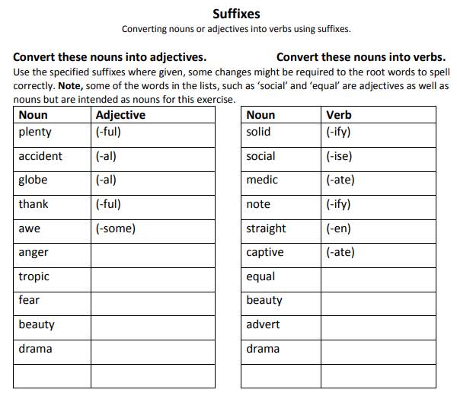
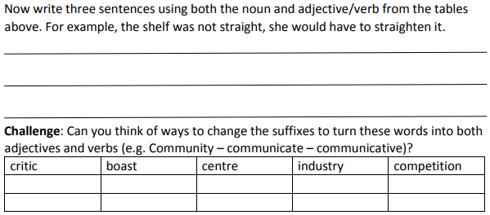

Our final lesson is geography.
Look at the map of Dudley today.
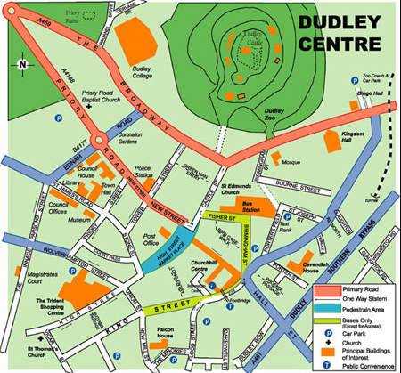
Think about how the town might have been in 1850. What kind of buildings would be there? Which streets would not have existed? What may have been there but isn’t around today? Draw a map of what it might have looked like.
As an extra challenge, can you find out three interesting facts about the history of Dudley? Write these down in your exercise books.

I am here if you need any help with anything. Remember to complete your daily reading and to go on TT Rockstars – 10 mins a day will keep your number facts sharp!

Maths fluency answers
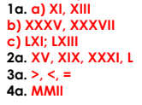 | 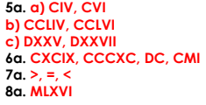 | 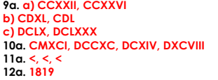
Maths problem solving questions
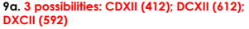

English answers


