
Monday 8th June
E-mail: reception@blowers.dudley.sch.uk

Good morning reception, I hope you all had a lovely weekend.

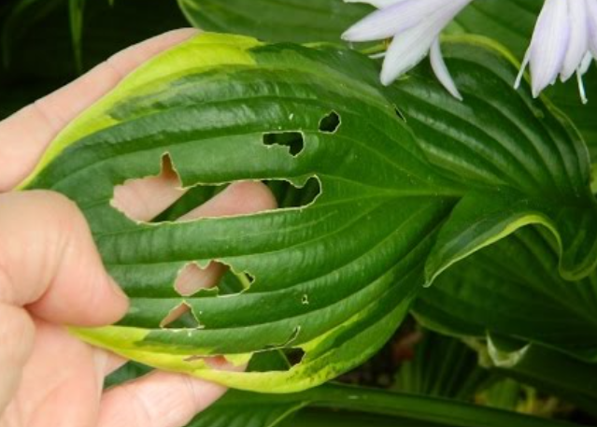
I had a very busy weekend. While I was outside trying to tidy up the garden, I noticed that something was wrong with my favourite plants. I have lots of Hostas in my garden and they normally have lovely leaves but look at these! What do you think has happened to them? After some investigation I noticed that something was eating my plants. Can you guess what it was? That’s right it was a snail.
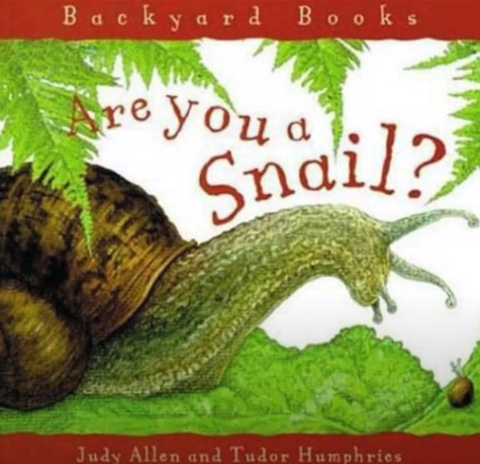
Listen to this story about snails. https://safeYouTube.net/w/4RqJ
Can you tell an adult 5 fascinating facts about snails?

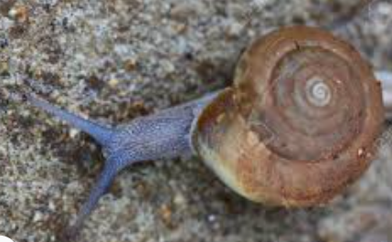
Have you ever looked carefully at a snails shell it has an impressive spiral pattern.

Can you have a go at drawing a spiral pattern. Start in the middle and get bigger and bigger. How big can you make your spiral?

Once you have mastered the skill of drawing a spiral You can now make a spiral dangler.
Can you follow these instructions?
- Get a paper circle.
- Draw a spiral.
- Colour and decorate it.
- Cut on top of your spiral line from the outside to the middle.
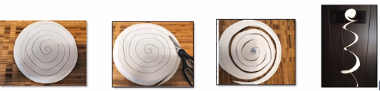
- Let your spiral dangle.

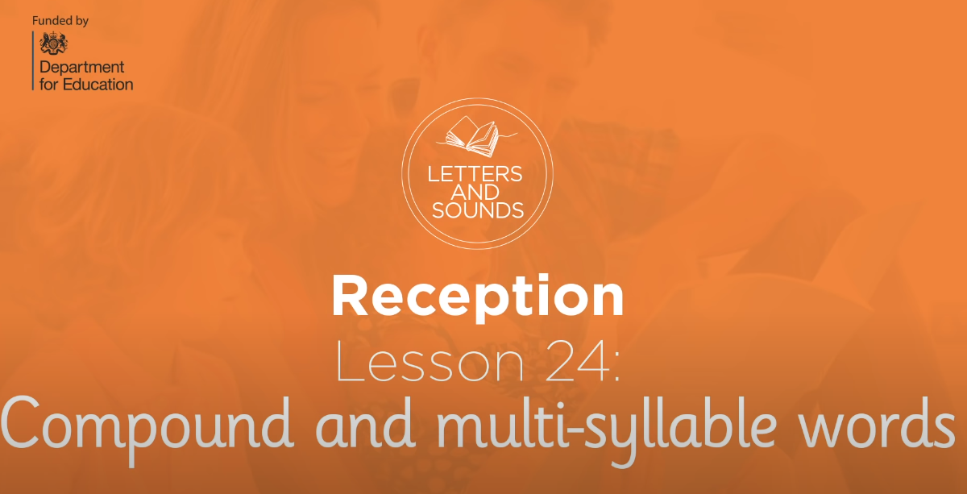
Phonics
If you know all the sounds on your phase 3 mat this is the lesson for you. Today you are learning how to read and write words with 6 sounds in them. https://safeYouTube.net/w/bOpJ

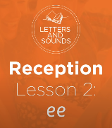
If you are finding it hard to remember all the sounds, don’t worry, why not do this lesson. Here you will be learning to read and write words with the sound ‘ee’. https://www.youtube.com/watch?v=hBFFUCraDt8

Number
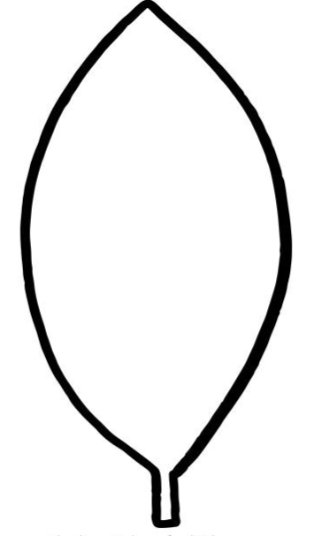
Here is my snail his favourite number is the number 10. He will only eat leaves that equal 10. Work out which leaves he can eat and colour them in. Or write down the sum.

5 + 5 =
2 + 5 =
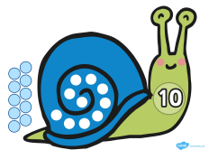
4 + 5 =
6 + 4 =
0 + 10 =
11 - 2 =
14 - 4 =
8 + 2 =
3 + 7 =
12 - 2 =


Snail hunt.
When you are outside, see if you can find any signs that a snail has been there.
Leaves that have been eaten
A silvery trail

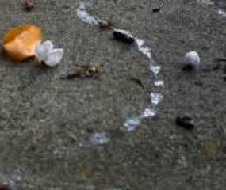
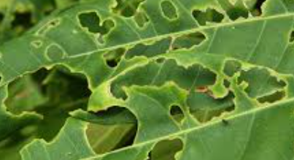
Take a photograph of it and email it to me.

