

Good morning Year 2!
I have really been enjoying reading and hearing about the special places of you and the people around you. Well done for your hard work so far this week.
I hope you are ready for another day of learning…let’s go!

First up…maths!

Yesterday, we were thinking about volume. Do you remember what volume is?

Volume is the amount in a container.

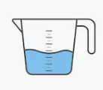
What units do we use to measure volume?

We measure volume in millilitres (ml) and litres (l).

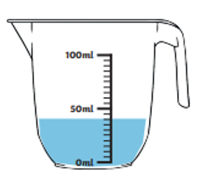
Today, we are going to think about capacity. It is easy to confuse capacity and volume, but remember….
Capacity is amount a container could hold.

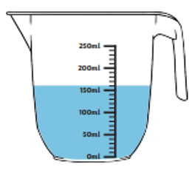
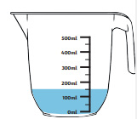
The volume of his container is 150ml, but the capacity is 500ml.
The volume of his container is 160ml, but the capacity is 250ml.
The volume of his container is 40ml, but the capacity is 100ml.

- Give yourself 5 minutes to see how many of containers with these capacities you can find in your house.
It might be a sun cream bottle, water bottle or measuring jug.

- 1 l
- 500 ml
- 250ml
- 100ml
- 750ml
Well done! Now you have found your items, can you order them from the item with the largest to the smallest capacity in 1 minute?
Send me a picture of your ordered items for 3 dojos!

- Now try this…. send me your answer for 2 dojos.
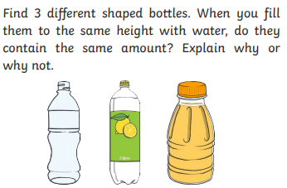
There is a super challenge below if you are in the mood!
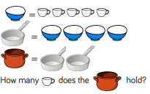

Super Challenge

This challenge is a bit of a brain stretcher… anyone who emails me the correct answer will get 5 dojos, I will be quite impressed!
Now for a little phonics
Go to https://www.phonicsplay.co.uk/ and log in using the free log in provided.
Username: march20
Password: home
Now click children, then select your phase and pick the game ‘Picnic on Pluto’. Can you feed the alien words to Obb and real words to Bob?

If you are in Miss Pylypiak-Clancy’s phonics group choose a different game in phase 6.

Our next lesson is writing
Oh look it Adil Adverb again…Can you remember what an adverb is?


That’s right!
Adverbs are words which tell you where, when, how, or how often something is done.


Yesterday, you spotted the adverbs in my sentences.
Today, I want you to change the adverb in my sentence to your own. You can add a picture like I did if you like!

For example, yesterday’s sentence was,
Isaiah ran quickly.

I can change the adverb quickly to make a new sentence.

Isaiah ran slowly.

Can you do the same for these sentences? Hmm….1 dojo for every two sentences I see I think!
- Isabelle tried hard.
- Abigail threw the ball up.
- Liam ran upstairs.
- Helen laughed nervously.
- The penguins swam yesterday.
- The lion roared daily.
- Amy tried hard to finish her homework
Last today, is RE
Some people’s special place might be a place of worship. A place of worship is where people go to carry out their religious practices together.

Below are pictures of different places of worship. How many can you name and match to the religion they belong to in 5 minutes?
Write the number, letter and capital letter that match. Send me a photo of your answers for 4 dojos!
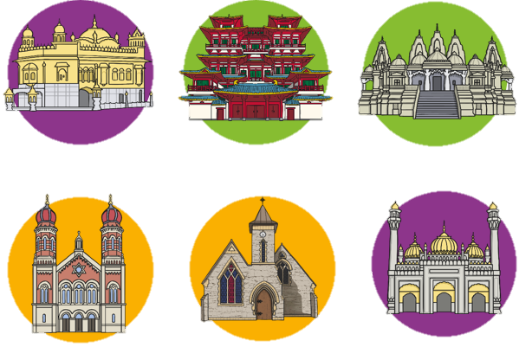
Religions
- Hinduism
- Islam
- Christianity
- Judaism
- Sikhism
- Buddhism

Places of worship
- Temple
- Synagogue
- Gurdwara
- Mandir
- Mosque
- Church
4 5 6
1 2 3

Are any of these places of worship special to you or your family?

Today, we are going to make a guide for a visitor who has never visited one of these special places before.
Pick a place of worship from above. You might pick one you go to regularly, have visited before, or you might like to research one online here https://www.bbc.co.uk/bitesize/subjects/zxnygk7.

In your guide you need to tell your visitor:
- What might they see in this place of worship?
- Are there any special items they might need to know about?
- Is there anything they need to wear or do before coming to this special place?

Please send me a picture of your visitor guides.
I will give 5 dojos for any visitor guides that are colourful and in your best handwriting.

I can’t wait to see your guides Year 2!

I can’t wait to see your visitor guides, I have no doubt I will be giving out a lot of dojos!



If you have any problems, you can email me on our Year 2 email address. Remember to practise your challenges and make sure to read today. What exercise have you been enjoying recently? I think I will go for another long walk in the park later. There are some absolutely beautiful flowers blossoming. Look at this picture I took of the flower beds!
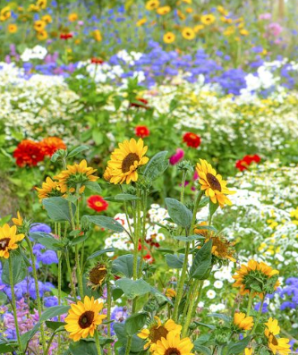
Enjoy the rest of your day!

Miss Pylypiak-Clancy

