
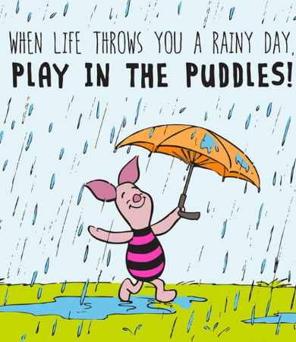
Happy Wednesday!
How are you today?
My mum is a big Winnie the Pooh fan, and these are some of her favourite quotes. I really liked Tigger when I was younger, because he always cheered his friends up! Who is your favourite character from a story? Why?

Hmm… I feel a little tired this morning. Let’s start our day with a little stretch.
Pick a cosmic yoga video here.
https://www.youtube.com/user/CosmicKidsYoga

Email me to tell me which video you think I should do!

Next up today, is maths!
So far these week, we have been practising measuring lengths. Can you remember what unit of measurement we use to measure length?

That’s right! Centimetres (cm) and meters (m)!

Do you remember when we used jugs and bottles to measure water in class?
Today, we are going to practise measuring volume,
Volume is the amount in a container.
We measure volume in millilitres (ml) and litres (l).
There are a 1000 ml in a litre.

To warm up your maths brain today, give yourself 3 minutes to find these items.
You might find things like a juice bottle, a large bottle of squash or a bottle of mouthwash. Get set… go!
- A container with a volume of less than 1 l
- A container with a volume of less than 100 ml

- A container with a volume more than 500ml, but under 1l
Send me a picture of your items for 2 dojos.

Now, if you have a measuring jug in your house, I would like you to practise measuring these volumes. There is a challenge below too.
- 200 ml 2. 500ml
3. 1 l 4. 750 ml
- 50 ml 6. 450 ml

How did you do? Which volumes were trickier to measure than other? Why?
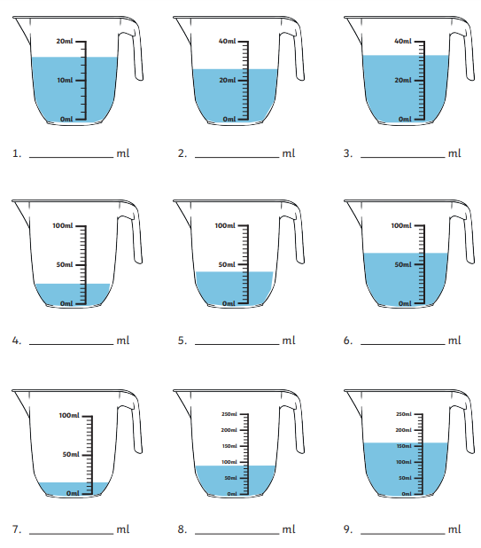
If you don’t have a measuring jug at home, try reading these scales. Remember, look carefully at the intervals… do you need to count in 1s, 2s, 5s or 10s?
Send me your answers. If you get them all right, I will give you 4 dojos!
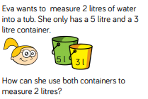
Super Challenge

Send me your answer to my super tricky challenge for 2 dojos.

Our next lesson is writing
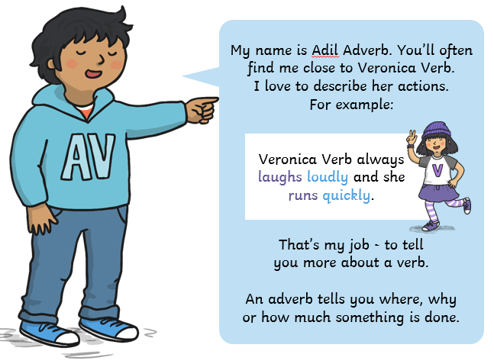
Let’s meet Adil Adverb!

Today, we are going to practise spotting adverbs.
Adverbs are words which tell you where, when, how, or how often something is done.

Here are a few tips to help you:
- Adverbs often end in the ‘ly’ suffix. For example, loudly.
- Adverbs often describe a verb (action word). For example, ‘Jessica danced merrily’.
- Adverbs describe where, when, how, or how often something is done.

Remembering my clues, find the adverbs in each sentence and write it in your books. Off you go adverb detectives!

- Isaiah ran quickly.
- Isabelle tried hard.
- Abigail threw the ball up.
- Liam ran upstairs.
- Helen laughed nervously.
- The penguins swam happily.
- The lion roared daily.
- Amy tried hard to do her homework neatly.

Email me a picture of your answers. If you are right, you will get 4 dojos!

Our last lesson today, is RE
I loved finding out about your special places yesterday.
How lucky we are to have such wonderful places we love!

Today, we are going to find out a bit more about other people’s special places. Some of our special places might be similar, or they might be very different. It doesn’t matter as our special place is personal to us and we are all different.
You are going to interview three people about their special places. This might be your adults, your siblings or you could even ring your granny or friend to ask them. You might ask them:
- What is their special place?
- Why is that their special place?
- How does their special place make them feel?


You can present their answers however you like. You could even record a video or sound clip of you interviewing them.
I would love to see or hear what you find out. So… I think 4 dojos for any work I am emailed!
Have fun reporters!

Another great day of learning Year 2!
I am loving our special places topic. Are you?

Remember, if you have any problems you can email me on our year 2 email address. Remember to work on your challenges and take some time to get some fresh air and exercise today. I think I will settle down to read a few more chapters of my book this evening. The weather has been so nice, fingers crossed I can do this outside!
Have an amazing day!
Miss Pylypiak-Clancy


