
Blowers Green at home – Nursery
Friday 5th June 2020
E-mail: nursery@blowers.dudley.sch.uk

Good morning Nursery,

I can’t believe it’s Friday already. What a busy week we have had! Below are your ‘Nursery at Home’ activities for today.

Have a fantastic Friday and a wonderful weekend!

Miss Meads


Keep on Moving!
Every little cell in my body is happy!
As it is Friday, let’s join in with one of happy action songs.
https://safeyoutube.net/w/BK3E

Listening Time Sound Odd One Out
Name the objects in the set and listen carefully to the first sound. One of the objects has a different first sound. Can you find the odd one out in each set? The first one is done for you.

 | 
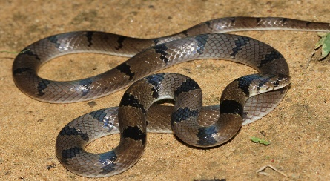 | 

 | 
 | 

 | 
 | 

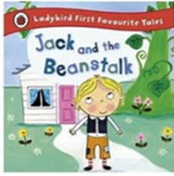
Jack and the Beanstalk
Our story this week is Jack and the Beanstalk. If you have missed the story or would like to read it again, click on the link below. Can you join in with he giant? Can you say what happens next?
https://safeyoutube.net/w/eidI


Making our Mark – Draw or paint a beanstalk
You will need paper (the bigger the better) and some green crayons or felt tips. If you are using paint, try mixing blue and yellow.
Draw or paint wavy lines on your paper. Then add some leaves to fill in the spaces.
Note to parents
Paint alongside your child and chat about what you are doing.
To support your child, draw a wavy line for them to follow. However, if your child enjoys free mark making then this is great too.
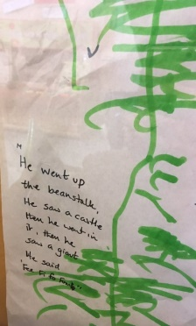
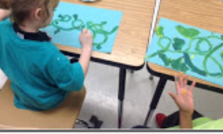

Maths
Choose a shape from the train to complete the pattern.

Click on the link below to play the game. Begin with level 1.

https://www.topmarks.co.uk/ordering-and-sequencing/shape-patterns

Have a happy and safe weekend!


Miss Meads

