
Blowers Green at home – Nursery
Thursday 4th June 2020
E-mail: nursery@blowers.dudley.sch.uk

Good morning Nursery,

Below are your ‘Nursery at Home’ activities for today. Once again, thank you for all the fantastic e-mails and photographs. It is super to see you having fun and learning at home!

Have a great Thursday!

Miss Meads

Keep on Moving
Jumping Beans
Today, we are going to move like beans in this fun action and listening game.
Here are the actions
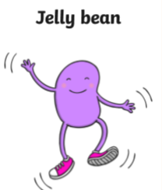




Jump on the spot. Run on the spot. Wobble like a jelly. Curl up very small
on the ground.
Note to Parents
Begin with three different types of bean and practise the actions with your child. Then, play some music to dance to. When the music stops, call out a bean type. Your child should listen carefully and then move like that bean. Play the game for about five minutes changing the bean type. As your child gets used to the game, stop the music more often to speed the game up.

Beanstalk Finger Gym
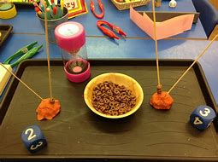
You will need a ball of dough, some spaghetti and some Cheerios or pasta tubes.

Now choose an activity
- Put on your favourite song and thread the Cheerios onto the spaghetti beanstalk. Do this for one minute. Who made the tallest beanstalk?
- Roll a dice and add the correct number of Cheerios onto the spaghetti beanstalk. Do this for two minutes. Who made the tallest beanstalk? Count the check.
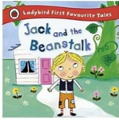
Jack and the Beanstalk Band
Our story this week is Jack and the Beanstalk. Today, we are going add some sounds to the story as we listen to it. Use a pan for a drum and two or three household objects for drumsticks.

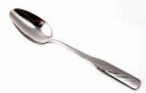
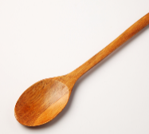
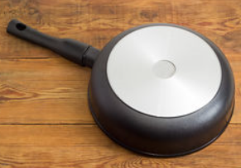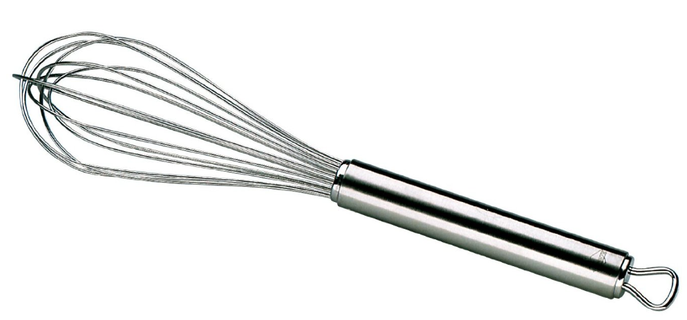

Note to Parents
Use the objects to explore making different sounds with your child. What sound might the giant’s footsteps make? What sound could you make for Jack racing down the beanstalk? What sound might the beanstalk make as it crashes down?
Choose a sound each to add to the story as you listen to it.
https://safeyoutube.net/w/eidI

Make a Junk Giant
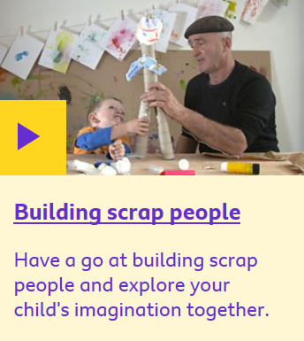
Get creative and make your very own junk giant. You could use paper, card, food packaging and tubes. Watch this video for some great ideas.
https://www.bbc.co.uk/tiny-happy-people/building-scrap-people/zm3d8xs

I’d love to see your creations. You can email any photographs on nursery@blowers.dudley.sch.uk

Have a lovely day!


Miss Meads

