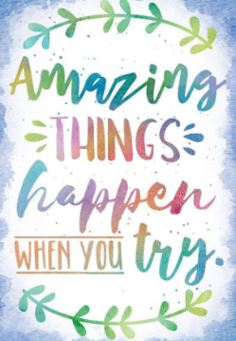
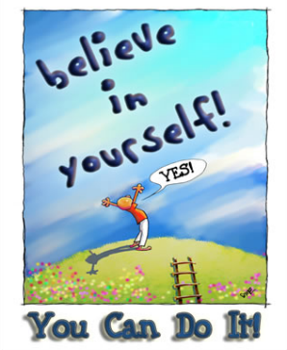
Good Morning Year 3.
I cannot believe that it is Friday already! How is another week already over? They go by so quickly!


As it’s Friday let's start the day with a dance. I love dancing with Oti. So, I would like to start with that. Remember just try your hardest and have fun!
https://www.youtube.com/user/mosetsanagape

After that, we have maths.
We are going to revisiting angles. You will need 2 sticks and some string or elastic bands.
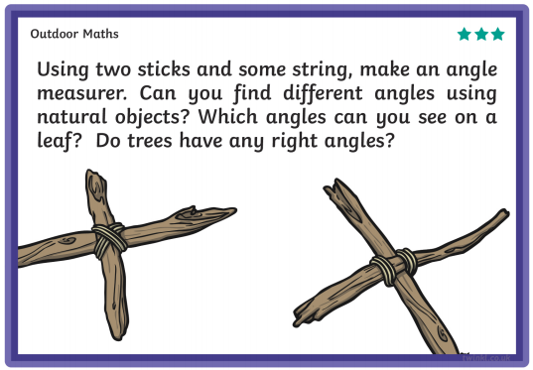
Draw or take pictures of the angles that you found. What type of angles are they?
Our next lesson is English.
Look at the picture below and answer the comprehension questions underneath. Remember to answer in full sentences.
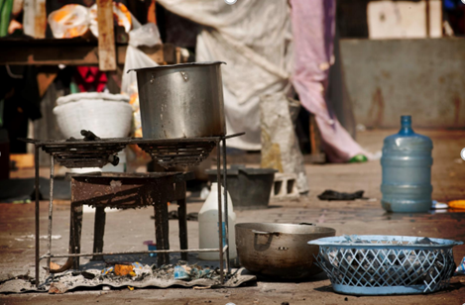
What can you see in the picture?
What do the people in the camp use this equipment for?
There are pots on the cooker. What does this tell us?
What do you think is stored in the blue bottle?
Do you think it's easy to keep the cooking equipment clean at the camp?
Does this picture look like your kitchen at home?
Do you think you would like cooking outdoors all the time?
There are no people in the picture. Where might they be?
What question would you ask about the camp?

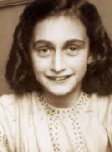 Our final lesson is history. 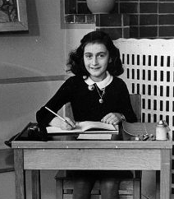
Today is Anne Frank’s birthday. If she was alive today, she would be 89 years old. Anne Frank’s diary helps us understand what life was like for Jewish people during World War 2.
Read this biography about Anne Frank.
https://www.ducksters.com/biography/women_leaders/anne_frank.php
Write 5 questions you would ask Anne if she was alive today.
Challenge – Can you write a question that you would as her Father Otto.

Don’t forget to practise all of your challenges today!
Remember to continue to do your daily reading and I hope you have a lovely weekend!
Mrs Martin


