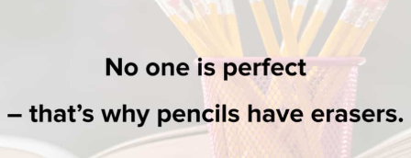
Good Morning Year 3.
I hope you are all well, I’m so proud of you keeping up with your all your home learning!
Can you believe that we are now half way through the week? I have been into school. It is so weird without my lovely Class 3 there, but I have enjoyed seeing lots of friendly facea. I hope that you have continued to work really hard though. From your emails, I can tell that lots of you have been.

Our first lesson today is P.E. Start your day by completing some Cosmic Kids yoga. Find a yoga video that you would like to do today.
https://www.youtube.com/user/CosmicKidsYoga

The second lesson is maths.
Today we are going to be looking revisiting parallel and perpendicular.
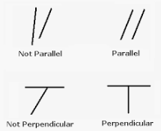
Are you able to find 5 examples of parallel lines and 5 examples of perpendicular lines in your house? Either draw and label what you have found or take a photograph to show me!
Challenge – Challenge someone in your house and see who can find the most in 1 room.

Our next lesson is English.
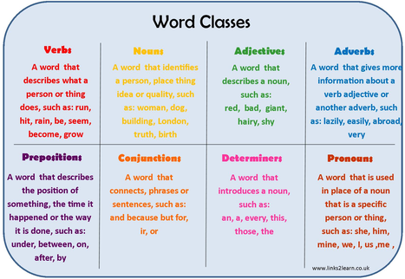
You have all worked really hard when writing speech. Today, I would like you to identify word classes in speech.
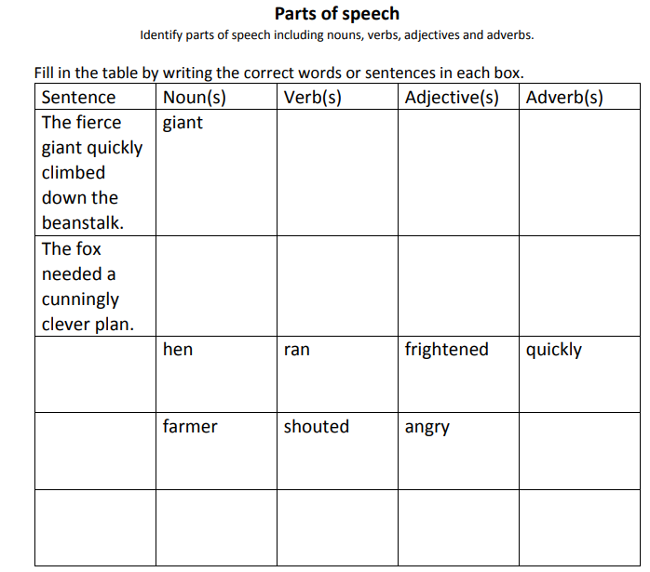
Challenge - In lessons you all try hard to deepen the moment. Can you make these sentences even better by adding an expanded noun phrase?

 Our final lesson is science. 
As you will remember one of our science topics was light.
First, write 5 facts that you remember from our science lessons.
Now, I want you to write the meaning of opaque, translucent and transparent.
Finally, I want you to find items in your house that are opaque, translucent and transparent. Create a table or a list to write down what you find.

Fantastic learning today Year 3!

Remember to have fun, go outside and play or read your favourite book and continue to complete your daily reading. Don’t forget you also have your challenges to work on!
Any problems send me an email and I will help!
Have a great day.
Mrs Martin


