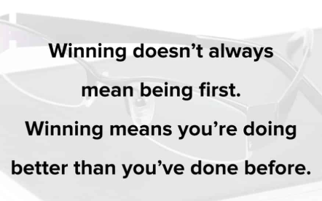
Good Morning Class 3!

How are you all? I miss you all very much but I love being sent your work or a message telling me what work you have done so keep them coming. Lots of you are earning Dojos so I am going to be stocking up on my prizes soon too!


The first lesson is P.E with Joe Wickes. Remember to have fun doing this and let’s get our hearts pumping and get our brains switched on.

https://www.youtube.com/user/thebodycoach1

The next lesson is maths.
Today you are going on a letter hunt. You will need a timer and empty hands.
Set your timer to 5 minutes. In 5 minutes find as many items as possible that begin with the letter a.
Count how many you find.
Next in 5 minutes find as many items as possible that begin with the letter b.
After that in 5 minutes find as many items as possible that begin with the letter c.
- How many items did you find in total?
- Add together the amount of items from a and c.
- Subtract b from a
- Multiply a and b
- Multiply b and c then subtract a
Challenge - Which letter of the alphabet do you think would give the most items? Estimate how many items you think you would find? Now go and check if you right.
Let me know if you guessed it right or not.

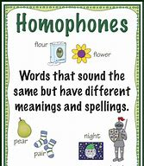
Your next lesson is English.
Today, we are going to revisit homophones.

their there they’re
Add in the correct word.
- “Please don’t argue when your cousins visit” said mum. “_______________ going to be here soon.”
- The boy moved the box over __________
- The children put on ___________ coats.

Write a sentence using each of these homophones correctly.
- where wear
- knight night
- so sew

Handwriting
Practise using our learnt joins to write these.
moaning | moonlight | monstrous
mountain | magnificent | maintain

Our final lesson is Art.
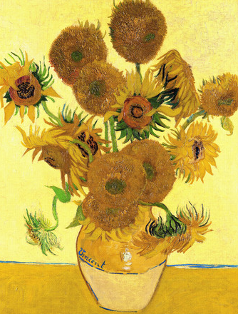
This week it is national art week so today, we are going to focus on art. I would like you to sketch something in or outside of your household that interests you. You can even add colour if you like. Once you have sketched it, ask someone if your house to tell you something that they like about it and also something that you can improve, a bit like when your teacher gives you a target. This is how artists get better.

Once your picture is completed, email it to me so that I can see what you have been doing. I might even send some to Mrs Macdonald as she LOVES art.

Remember to complete you daily reading and to take some time out to do something that you enjoy.
Don’t forget, any problems, you can email me.

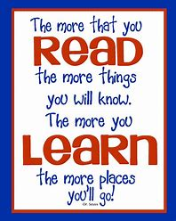
Mrs Martin

