Good Morning Year 3. 
I hope you all had a nice weekend. What did you get up to? I had to do lots of tidying this weekend and I even baked a delicious chocolate cake with George and Harry. They always make such a mess! It looked like a flour bomb had gone off in the kitchen! Mr Martin said that we were the messiest bakers EVER! Do you like baking? What is your favourite type of cake? I can’t wait to hear from you all.

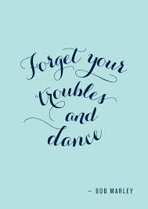

I am in the mood for a dance today so I’m going to dance to one of my favourite Just Dance songs. I hope you will join in with me and Move it, move it!
https://www.youtube.com/watch?v=ziLHZeKbMUo



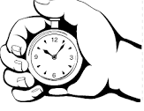After that, we have maths.
Today, we are going to be looking at time. I want to mix maths and P.E together today. You will need a stopwatch or a timer, paper and some space.
Use a stopwatch to time yourself doing 10 burpees. Have 5 attempts and record the times.
If you have forgotten how to do a burpee. The link below will remind you how.
https://www.wikihow.life/Do-a-Burpee

- What was the fastest time?
- What was the difference between the fastest and the slowest time?
- Can you order your time from largest to smallest?
- Can you beat your fastest time?
- Add together you fastest time and your slowest time.
- Subtract your fastest time from your slowest time.

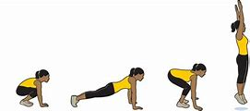

Our next lesson is English.
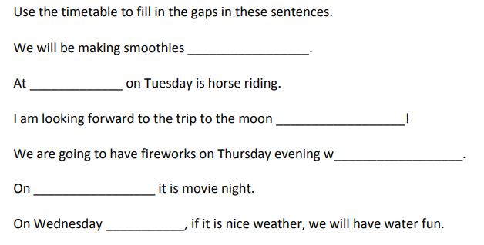
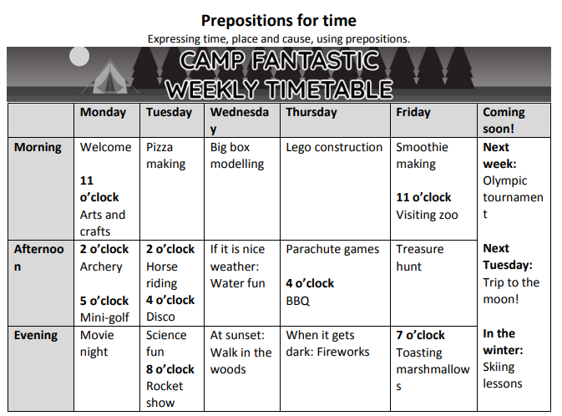
Today we are going to be revisiting prepositions. Have a look at the Camp Fantastic’s weekly timetable and complete the missing words in the sentences.
Next up is geography.

Today is World Oceans Day, so I would like you to write down all names of the oceans and the continents.
Then I would like to write down all the name of the countries that you can remember and which continent they belong to.
I will give extra dojo points to the children that can name the capital cities of the countries they have remembered.

Challenge - draw a picture of a world map and label all the oceans, continents, countries and cities that you can remember.

Finally, I would like you to do a bit of art.

I want you to create an underwater scene picture. You might collage it, paint it, sketch it. You can do it any way you choose!
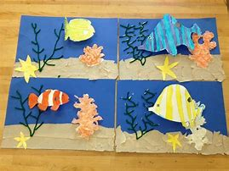
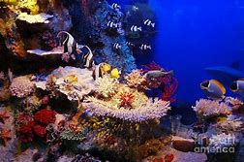

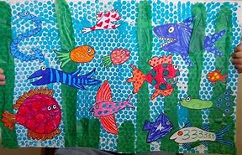

I am here if you need any help with anything. Remember to complete your daily reading and to go on TT Rockstars…we need to get our points close to our rival class….Year 4!

Have a lovely day!
Mrs Martin



