
Thursday 4th June
E-mail: reception@blowers.dudley.sch.uk
Good morning reception. I am so happy with all the videos and pictures of your work that you have sent in. You are all working so hard.

Poster challenge.

I thought it would be nice to make a class poster about what we all like about Blowers Green. Draw a picture of yourself and write one word underneath. That word needs to be what you like and miss about Blowers Green for example, the word could be friends, fun or learning. Take a photograph of your picture and email it to me. I will then put all your pictures together and you will find the poster on Tuesday’s home learning page. Take your time with your drawing so your friends will be able to tell it’s you.

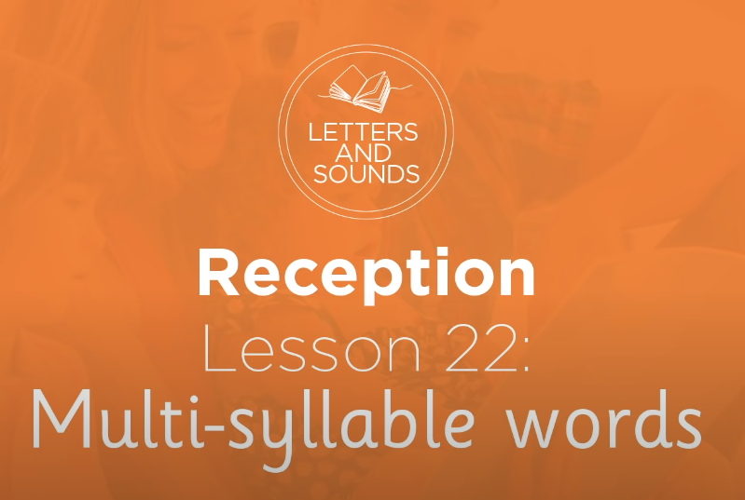
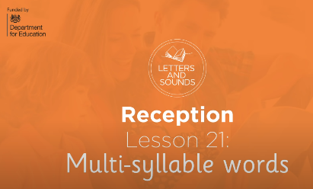
Phonics
I hope these ‘Letters and Sounds’ lessons are helping you remember all the phonemes and how to blend them together to read words. I have been sent some lovely videos of you all working hard watching the lessons. Keep up the good work.
https://safeYouTube.net/w/zMoJ
Writing
Can you help me? I am trying to write some sentences, but I keep spelling some words wrong. Look at this sentence. Can you write it so all the words are spelt correctly.

I wet to teh market.
I woz in the baf.

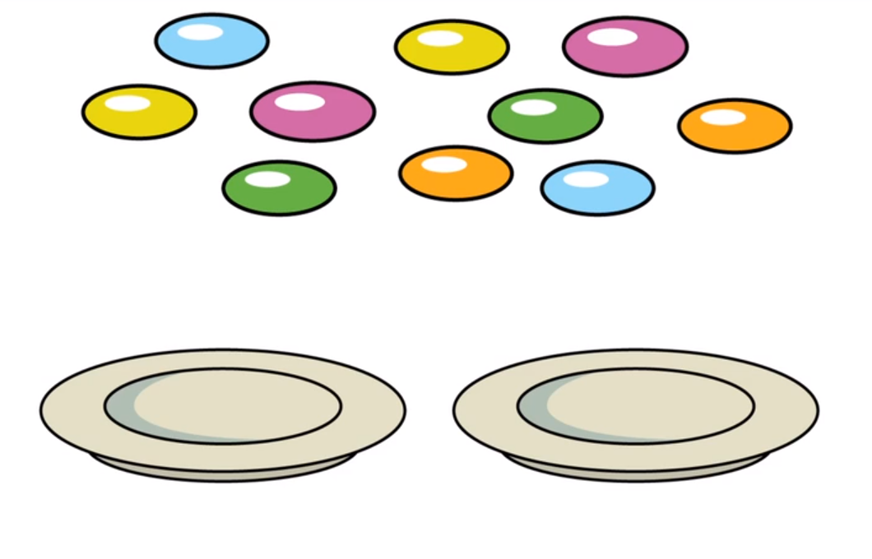
Number Challenge
Can you count the smarties? How many are there? Share out the smarties between the two plates. How many smarties does each plate have? By sharing the smarties, you have found half of 10.

For this number challenge game, you need two plates and something to count. This could be cubes, coins or sweets. I found some wotsits, my favourite crisps. I counted out 2 wotsits and then I shared them between 2 plates.
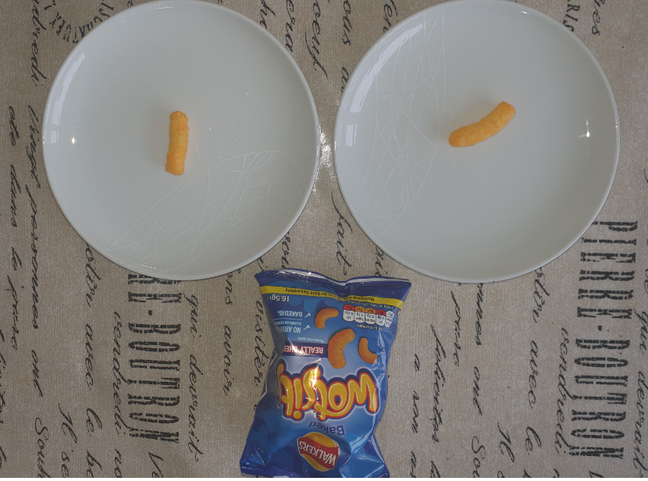
Can you find half of these numbers? Half of 4 is ____
Half of 6 is ____
Half of 8 is ____
Half of 10 is ____
Half of 2 is 1

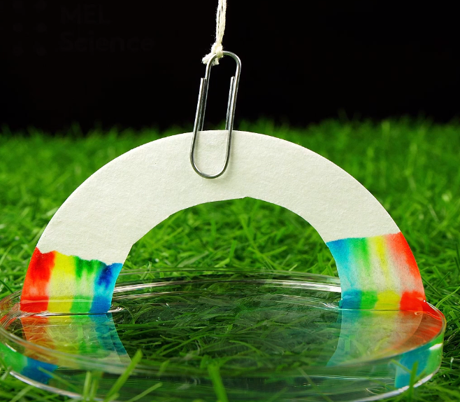
Investigation
Is it possible to grow a rainbow at home?
https://safeYouTube.net/w/iopJ
Equipment: paper towel, water-based markers, water, dish, paper clip, thread.
Use some markers to draw the beginnings of a rainbow on a paper towel. Use a paper clip and some thread to suspend the paper towel above the dish. With the addition of water, your rainbow begins to inch towards the sky!
Talk about the colours you see and why you think it is happening.
I can’t wait to see a picture of your home-grown rainbow.

I hope you have a lovely day. Don’t forget to send me your picture for the poster.
Mrs Macdonald

