Wednesday 3rd June 2020
Good morning Class 5! Keep up the good work, I’m really looking forward to seeing many of you next week!

Today’s Tasks:
Maths
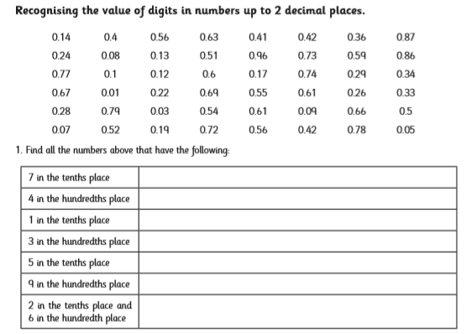
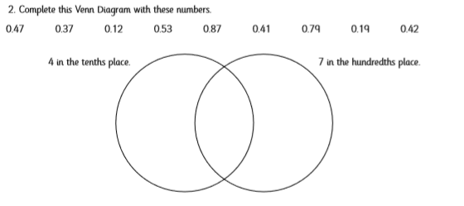

English


Use this image a stimulus for a story. Make sure you develop the action in your sentences to build tension and pace within your narrative.
DT
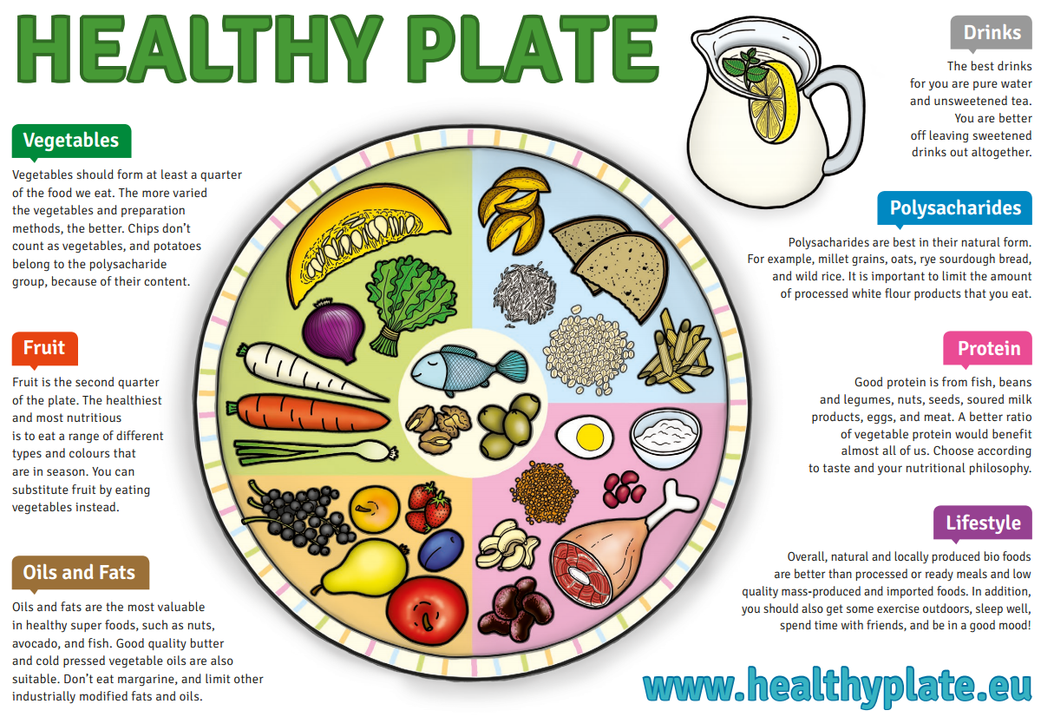
Design your own healthy balanced food menu. You could draw a ‘healthy eating plate’ for one of your meals or create your own folding menu. There is an example healthy eating plate below.

