
Blowers Green at home – Nursery
Wednesday 3rd June 2020
E-mail: nursery@blowers.dudley.sch.uk

Good morning Nursery,

Below are your ‘Nursery at Home’ activities for today. As always, you can e-mail me any questions you might have on the e-mail address above.

Have a wonderful Wednesday!

Miss Meads

Keep on Moving!
Let’s dance to ‘I Gotta Feeling’. Get the whole family involved and have some fun learning these dance moves.
https://family.gonoodle.com/activities/i-gotta-feeling

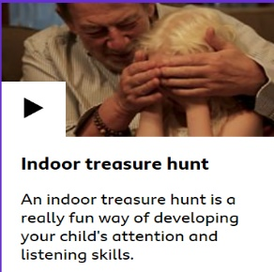

Listening Time – Treasure hunt
Note to Parents
This video explains how to play the game.
https://www.bbc.co.uk/tiny-happy-people/indoor-treasure-hunt/zv73vk7

The game can be played inside or outside. Ask your adult to hide a toy or teddy for you to find. If you are far away from the toy, your adult will say colder. As you get nearer, your adult will say warmer. When you find the toy, it’s your turn to hide the toy for your adult to find.

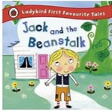
Share a Story
Our story this week is Jack and the Beanstalk. If you missed it on Tuesday or would like to listen again, click on the link below. What words do you remember? Try and join in with the story this time.
https://safeyoutube.net/w/eidI

Don’t forget to practise your ‘Rhyme Challenge’ rhymes!

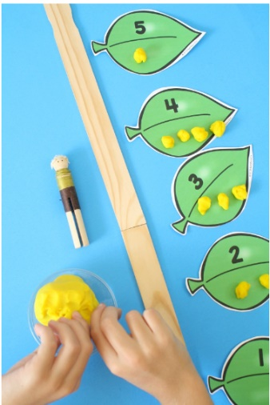
Counting with Jack and the Beanstalk
Note to parents
You will need;
- 5 leaves numbered 1 to 5. You could use real leaves or make some out of paper.
- Some objects to count. Making small play dough balls is excellent for developing finger strength.
- A toy to climb the beanstalk. If you make large leaves your child could climb the beanstalk themselves!

Help your child to put the leaves in number order.
Ask your child to count the correct number of objects onto each leaf. Finish by helping the toy climb the beanstalk counting as you go.

To support your child
Begin with numbers 1 to 3.
Add the correct number of dots to each leaf for your child to count onto.

To Challenge your child
Encourage your child to put the leaves in number order.
Use numbered leaves to 10.

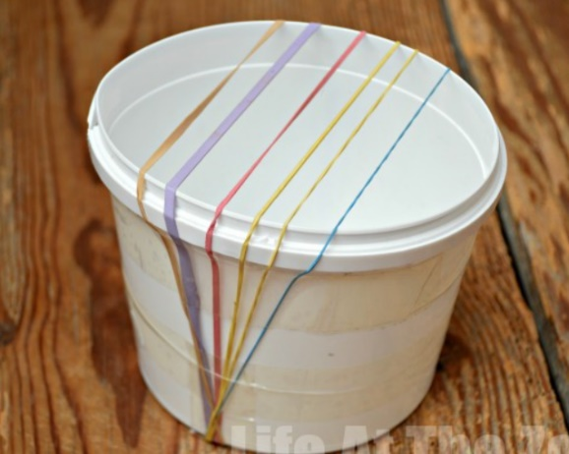
Make a Harp
Use a box, plastic tub or yogurt pot and some rubber bands to make your very own harp.
Then, have fun playing along to your favourite songs and rhymes.

You could even use different thicknesses of elastic bands to see how it changes the sounds made.

Have a lovely day!


Miss Meads

