Blowers Green Primary: School at Home Year 4
Friday 5th June 2020
E-mail: yearfour@blowers.dudley.sch.uk
Good morning Class 4!
Friday today! Our last day of home learning for this week before your weekend begins. I hope you all have a wonderful weekend.
But before the weekend starts, here are your ‘School at Home’ tasks for today. Again, any links and resources which will help you to complete your home learning are also in this document.
Mrs Ghent
P.S
Remember, to keep practising your times tables up to 12x AND you also have your challenges to work on too!
Subject | Task |  | Link/Resources
Literacy | Task 1: Spellings  I hope you have been practising your 10 spellings for this week!  Have one last practise now and then test yourself – can you get 10/10? If you want to you can e-mail to update me on how you have done! |  | Practise your spellings one last time before testing yourself in your Blue Home Learning Book.    Good luck!
Numeracy | Task 1: See below – Rounding Numbers  Complete the questions below. You may choose to answer the ★, ★★ or ★★★ questions or all 3 if you can! |  | Rounding Numbers  Watch the video clip on the link below to remind yourself of how to round numbers accurately:  https://www.bbc.co.uk/bitesize/topics/zh8dmp3/articles/zpx2qty  To round a number to the nearest 100, look at the tens column. If the tens digit is 5 or more, round up. If the tens digit is 4 or less, round down.  - The tens digit in 3281 is 8. So we round it up to 3300.  - The tens digit of 3216 is 1. So we round it down to 3200  Scroll down for your questions. You may choose to answer the ★, ★★ or ★★★ questions or all 3 if you can!  Show your working in your Blue Home Learning Book.
French |  | See below:  French Colours   | 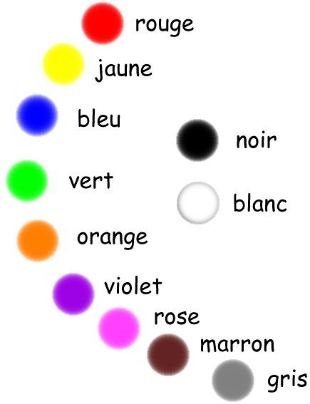  Before half term, you refreshed your knowledge of colours in French.  How many can you remember this week?  Activity below…
Numeracy Task 1:

Rounding Numbers - ★

On the following page:

★★

★★★

French Activity:

French Colours

How much can you remember from before half term?

Activity on the following page…

