Blowers Green Primary: School at Home Year 4
Tuesday 2nd June 2020
E-mail: yearfour@blowers.dudley.sch.uk
Hello again Class 4,
I hope you had a good first day back to home learning yesterday and are ready for your tasks today. Are you enjoying the books we have looked at so far on Purple Mash?
Also, thank you to all the children who have been emailing me with their work so far, it is lovely to see so many of you working so hard and continuing your learning at home.
Now, to get started with our home learning for today! As always, if you have any problems just email: yearfour@blowers.dudley.sch.uk and I will be happy to help!
Mrs Ghent
P.S
Remember, to keep practising your times tables up to 12x AND you also have your challenges to work on too!
Subject | Task | Link/Resources
Literacy | Task 1: Purple Mash – Serial Mash | Remember Chapter One from ‘Around The World In 80 Minutes’ yesterday?  If not, re-read the chapter again now.  Today we are going to think about: What inventions have shaped the world?  Think of as many different inventions as you can and create an information leaflet about these different inventions.  Scroll Down to use the Writing template if you would like to.  Log-in to Purple Mash using the RM Unify tab on the Blowers Green website: https://www.blowers.dudley.sch.uk/links.htm  Once you have arrived at the Home page, click:  ‘Serial Mash’  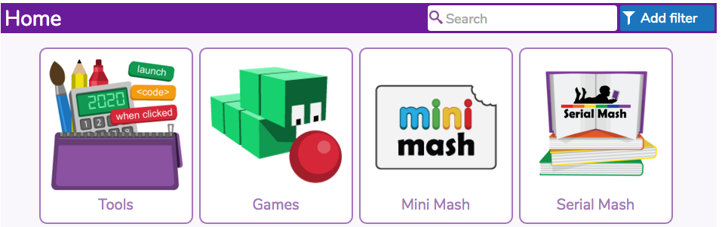  Then click on, ‘Emeralds’  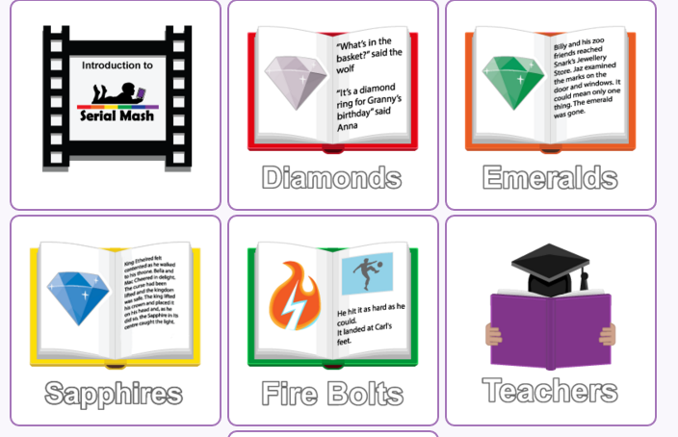  Next, click on the book called, “Around The World In 80 Minutes”.
Numeracy
Numeracy | Task 1: See below – Maths Mat  Complete the questions below.  Can you complete all the questions? | Maths Activity Mat  Complete the questions below.  Can you complete all the questions correctly?
Health and Wellbeing  - See activity below |  | You CAN!  There are ten statements below that all start with ‘I can’. Think about all the things you CAN do. There are a few examples to help you get started.

Numeracy Task 2:

Maths Activity Mat

Literacy Task:

What inventions have shaped the world?
On following page…

Foundation Subject Task 1:

You CAN…
On the following page…

