Blowers Green Primary: School at Home Year 4
Monday 1st June 2020
E-mail: yearfour@blowers.dudley.sch.uk
Good Morning Class 4 and welcome back!
I hope you all had a lovely half term! I hope you were able to relax, have fun and enjoy the wonderful sunshine we had!
We are now in the month of June, what month of the year are we in now? How many months are there in the whole year? Can you remember how many days are in the month of June? Quick little warm up for you this morning!
Now, to get started with our home learning for today! As always, if you have any problems just email: yearfour@blowers.dudley.sch.uk and I will be happy to help!
Mrs Ghent
P.S
Remember, to keep practising your times tables up to 12x AND you also have your challenges to work on too!
Subject | Task | Link/Resources
Literacy | Task 1: Purple Mash – Serial Mash | Log-in to Purple Mash using the RM Unify tab on the Blowers Green website: https://www.blowers.dudley.sch.uk/links.htm  Once you have arrived at the Home page, click:  ‘Serial Mash’  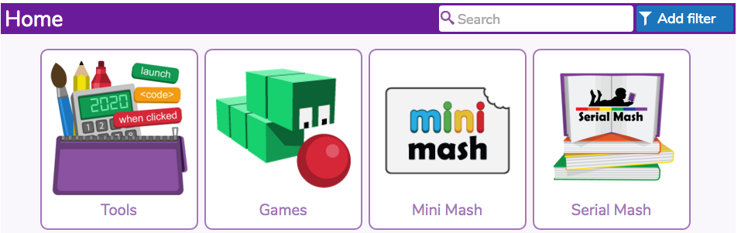  Then click on, ‘Emeralds’  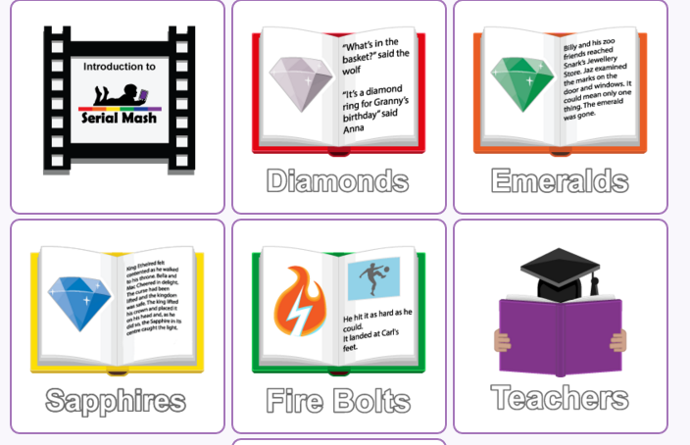  Next click on, ‘Around The World In 80 Minutes’ (It is the book at the top, 3rd on the right).  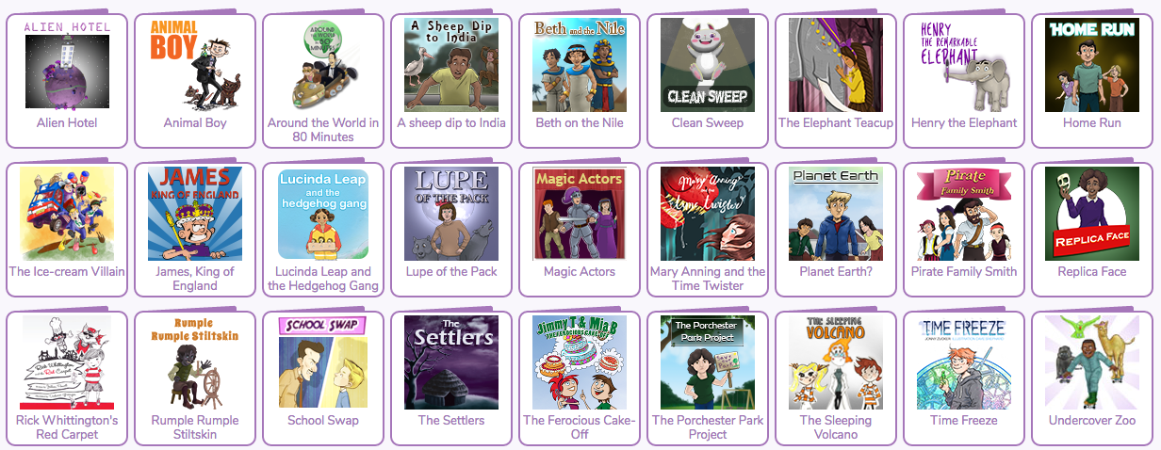  Today we are going to read Chapter One. Click on Chapter One, read and enjoy! Ensure you read carefully as once you have read Chapter One I would like you to click on: “Chapter One Quiz”  Good luck and please let me know how you do!  yearfour@blowers.dudley.sch.uk  Also! If you like to carry on reading the rest of ‘Alien Hotel’ please feel free to do so!
Numeracy | Task 1: Maths Warm Up! | Quick warm up to get you started with Numeracy for today:
Numeracy | Task 2: See below –  Complete the questions below.  Complete the questions below. You may choose to answer the ★, ★★ or ★★★ questions or all 3 if you can! | Cryptic Clues – Roman Numerals  Use your knowledge of roman numerals to solve the secret messages…  Scroll down for questions.  You may choose to answer the ★, ★★ or ★★★ questions or all 3 if you can!
History Timeline  - See activity below   |  | Significant Kings and Queens  Look at the timeline below.  Follow the timeline from the past all the way up to now (present day).  Take note of all the significant Kings and Queens  Choose a King or Queen to research and tell me 5 of your favourite facts about them.

Numeracy Task 2:

Cryptic Clues – Roman Numerals
Cryptic Clues – Roman Numerals

Foundation Subject Task 1:

Significant Kings and Queens



