
Blowers Green at home – Nursery
Tuesday 2nd June 2020
E-mail: nursery@blowers.dudley.sch.uk

Good morning,

It was great to see your half term news yesterday. You have been busy! Below are your
‘Nursery at Home’ activities for today.

Have a great Tuesday!

Miss Meads

Keep on Moving!
Here is a challenge for you to try today.

Bounce a ball 5 times. Do 10 star jumps. Throw 5 rolled up socks into a hoop, bucket or bowl.
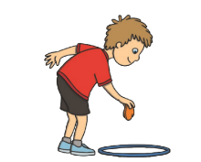



Ask and adult to time you and then try and beat your time. You could have a race with a sibling and see who finishes first.

Let’s Go to the Dough Disco!
Note to Parents
Dough Disco is a fun activity, using play dough, which helps to develop children's fine motor muscles and pencil grip.


Here is a simple way to make play dough using warm water. I would stay away from adding food colouring as it does get messy!
https://www.google.com/search?q=simple+play+dough+recipe&oq=simple+play+&aqs=chrome.1. 69i57j0l7.6429j0j9&sourceid=chrome&ie=UTF-8#kpvalbx=_b67HXuijMfPqxgOC7pPoCA45



Click on this link to go to the dough disco. Don’t worry if you don’t have any dough. You can use your invisible dough instead.
https://safeyoutube.net/w/thtI

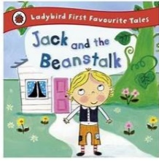
Share a Story
Today’s story is one of my favourites. Its all about a little boy who planted some beans and then, something magical happened…
https://safeyoutube.net/w/eidI
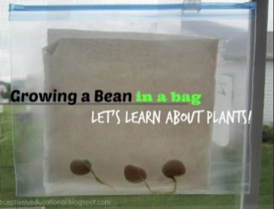
Grow a Bean in a Bag
You will need cotton wool balls or kitchen paper, a resealable freezer bag and some beans, any type will grow.
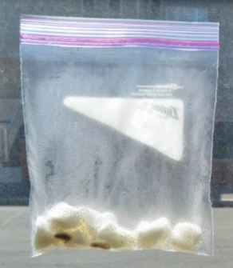
- Dip your cotton balls into water and place them all the way across the bottom of the bag.
- Count out 4 beans and drop them in your bag. Make sure they have space to grow.
- Seal your bag tight to hold in the moisture.
- You could even tape your bag to the window where the beans will get lots of light.
This activity can be done in a clear plastic cup too but you will need to keep moistening the cotton wool.
Check your beans every day to see how they change.
Note to Parents
Soak the beans overnight before planting to speed up the growing process.

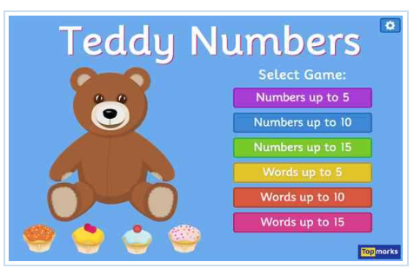
Teddy Numbers
First, sing ‘Once I Caught a Fish Alive.’ Don’t forget to count your fingers as you sing along.

Have fun counting cakes to give to a very hungry teddy. Remember careful counting. Use one number name for each cake.
https://www.topmarks.co.uk/learning-to-count/teddy-numbers
To support Your Child
Begin with numbers up to 5.
Read the number with your child and count the cakes together.

To challenge your child
Choose a game with larger numbers.

Have a safe and happy day!
Miss Meads

