
Blowers Green at home – Nursery
Monday 1st June 2020
E-mail: nursery@blowers.dudley.sch.uk

Good morning Nursery,
Welcome back to ‘Nursery at Home’. Well summer has definitely arrived! I hope you are all enjoying the sunshine and have had a safe and happy half term break.

Miss Meads


Keep on Moving!
Let’s begin the day with an action song.
https://safeyoutube.net/w/CQMH

Rhyme Time
Remember to keep practising your ‘Rhyme Challenge’ rhymes.
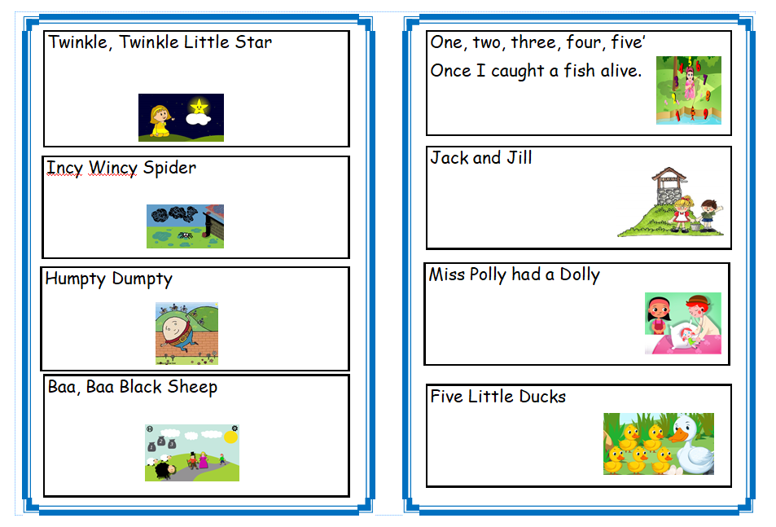
Follow the link below and you will find animated videos and lyrics for all the rhymes in our challenge.
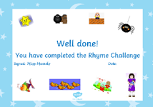
https://www.bbc.co.uk/teach/school-radio/nursery-rhymes-a-to-z-index/z4ddgwx
When you can sing all the rhymes by yourself. You are ready for your first Rhyme Challenge Certificate! Ask an adult to contact me so I can e-mail your certificate to you.

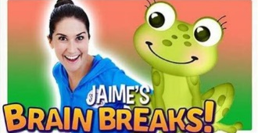
If you have completed your Rhyme Challenge, follow the link to sing ‘The Little Green Frog.‘ I have also attached the words at the end of this document to help you.
https://safeyoutube.net/w/P0MH

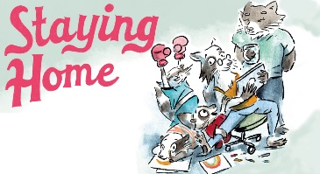
Share a Story
I am so proud of you all for staying safe at home for so many weeks. Today’s story is all about a family, who, just like you have had to stay at home.
You will find the story under the Nursery tab on our home learning website.
https://www.dudleyacademiestrust.org.uk/hiddenarea/blowers-green-primary-school-at-home

Half Term News

This is a great opportunity for a chat with your child. Talk to your child about what they have enjoyed doing over half term. Help your child to draw or paint a simple picture.


At home…
AA
At home, my family and I celebrated my son’s birthday. It was a hot, sunny day so we had a party in the garden.

I can’t wait to find out what you did.

Have a lovely Monday!

Miss Meads


