
Blowers Green Primary: School at Home - Reception
Monday 1st June
E-mail: reception@blowers.dudley.sch.uk
Good morning Reception. I hope you all had a good week. Molly and I had lots of fun in the sun. Our sunflowers seeds have started to grow.

We are in a new month. It is now June. Can you remember the months of the year? Send me a video of you saying the months in order and you will win 20 Dojo points. https://www.youtube.com/watch?v=5enDRrWyXaw


Can you remember this dance called move and freeze? Copy the moves, but don’t forget to stop when the song says freeze. https://www.youtube.com/watch?v=388Q44ReOWE

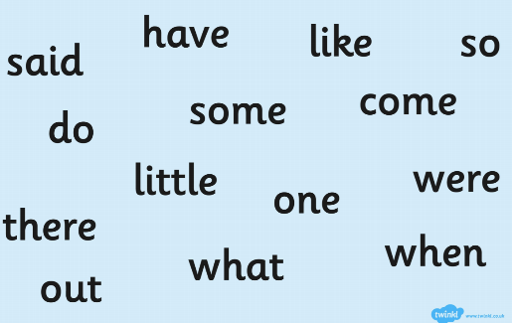
Tricky Words
Here are some new tricky words to learn. Can you find any of these words in your reading book?

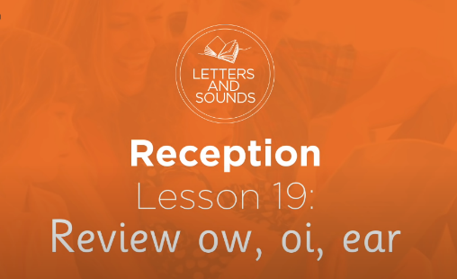
Phonics
Some of you are having difficulty using your phonemes when reading. Here is a ‘Letters and Sounds’ lesson. It is 20 minutes long, but I think it will help some of you blend words together. Let me know if you enjoy it. https://www.youtube.com/watch?v=9W4WiN3NeE4
Writing
Write a sentence to tell me what you did last week. Try and write it all on your own. Don’t forget to sound out the words. Use the sound mat if you need to. Make sure you put a capital letter and full stop at the end.
Can you read my sentence?
I cut the grass and planted flowers in the soil.

Number

Before half term we were counting to 20 in twos. Can you remember? Send me a video of you counting in twos. If you get to 20 you get 20 Dojo points.


This week we are going to practice counting in 5s.

https://www.youtube.com/watch?v=EemjeA2Djjw
When things are grouped into 5 it is quicker to count.
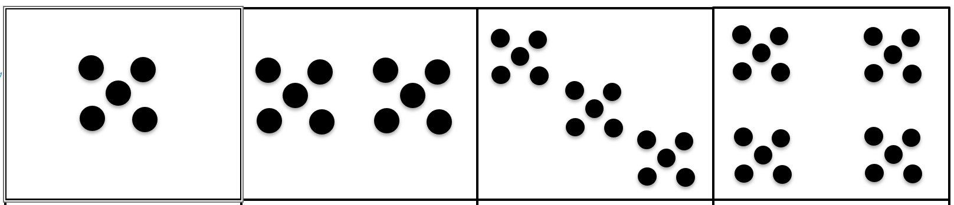

5 | 10 | 15 | 20

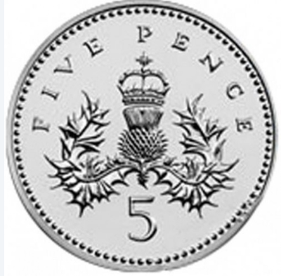
You can even count 5p coins. Have you got any in your house? Find them and see if you can count how many you have.

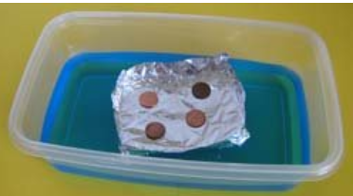
Experiment
In this easy science experiment, you will be designing a tin foil boat that will hold the greatest number of 5p coins. We are having a competition to see whose boat can hold the most 5ps. Send me a picture of your boat holding the coins.


