To all in the Early Years,
Just a quick note from all the staff here at Blowers Green to thank you once again for your efforts and enthusiasm to complete home-learning activities over the past weeks. You have amazed us with your perseverance and resilience in these challenging times. We all hope you have a relaxing and fun-filled half-term holiday. Enjoy yourselves but most importantly stay safe! Fingers crossed the sun shines for us. 🤞🌞
Teachers will not be setting daily home learning over the half-term break but we have included some ideas and links to activities below that might be nice to share as a family or to keep you entertained if the need arises! Take a look and have fun!

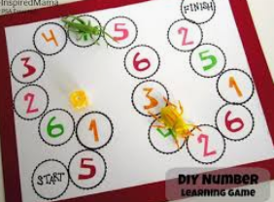
Board games are fun for all the family. If you don’t have one at home, you can make one from pen and paper.

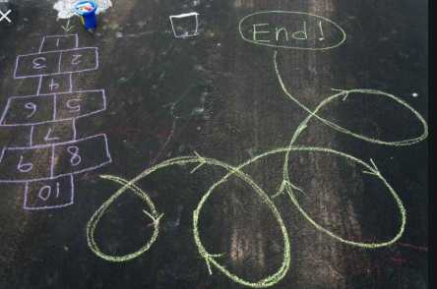
Make an obstacle course on the floor with your chalks. Let all the family have a go. Who can complete it the quickest?

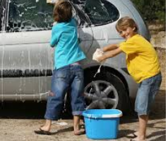
Let the children help around the house. You could even let them help you to wash your car.

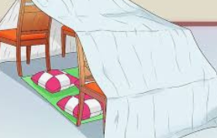
Build a den with blankets and furniture. It could be a castle for King, a reading den or even the cave for the Gruffalo.


Have a family movie night. Let the children make tickets for the show. Encourage them to make their own snacks for the movie.

Save all the boxes and bottles and see what you can turn them into.
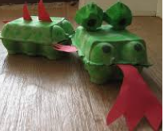
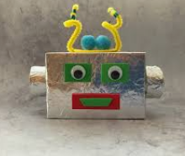
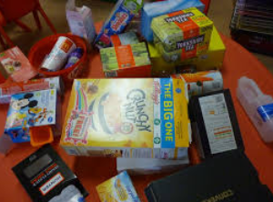



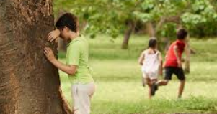
Play hide and seek this can be done inside or outside.


Websites
Cosmic Yoga https://www.youtube.com/user/CosmicKidsYoga

Andy’s Wild Workouts. https://www.bbc.co.uk/iplayer/episode/p06tmnbs/andys-wild-workouts-series-1-3-mountains


Change 4 Life have lots of ideas for indoor and outdoor activities https://www.nhs.uk/change4life/activities

You could make playdough. Here is a simple way to make play dough with using hot water. I would stay away from adding food colouring as it does get messy. https://www.google.com/search?q=simple+play+dough+recipe&oq=simple+play+&aqs=chrome.1.69i57j0l7.6429j0j9&sourceid=chrome&ie=UTF-8#kpvalbx=_b67HXuijMfPqxgOC7pPoCA45


This website has lots of games and activities for the children to play. It also has lots of stories for the children to listen to.
https://www.bbc.co.uk/cbeebies/stories


This website is good for the children to watch and practise their drawing skills. https://www.youtube.com/user/ArtforKidsHub

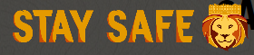
Online Safari! - Longleat Safari Park has a virtual safari, so you can see some of the world’s most amazing animals for you to see from the comfort of your own home!


Happy Eid!
May this holy occasion bring you and your families joy, peace and prosperity. Wishing all those celebrating, a very happy and blessed Eid

